Step-by-step guide to submit a manuscript for the Thematic Issue January 2027

- Go to https://journals.mmupress.com/index.php/jclc
- Login or register username & password
- Click Submission
- Click Instruction for Authors
- Make a new submission
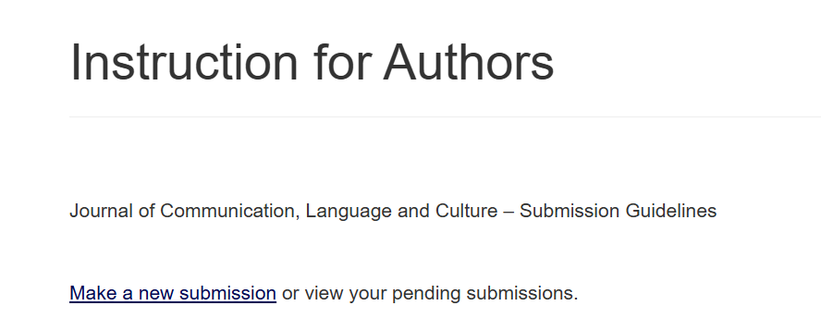
- Choose – Thematic Issue Jan 2027
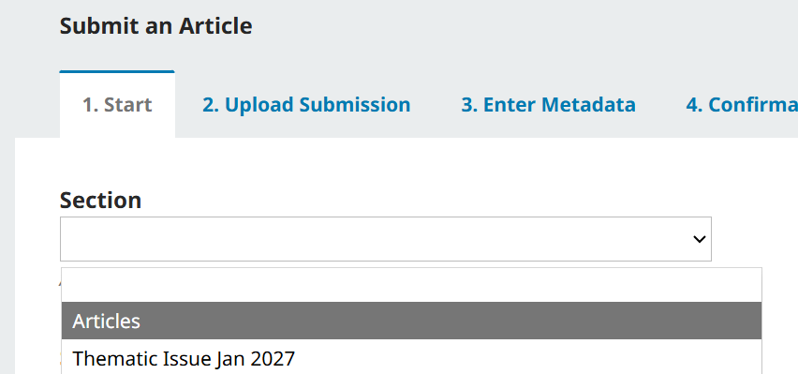

- Then, fill in all the related information until you reach:

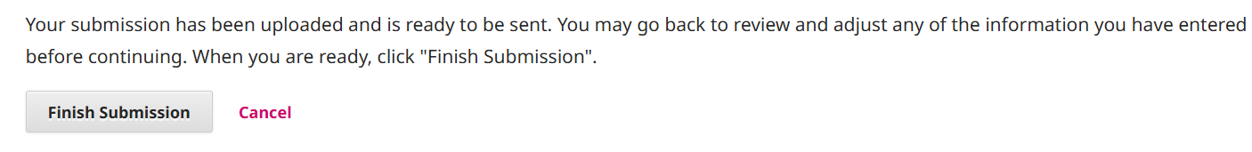

- Submission complete



