Title of Article (Book Antiqua, Bold ,18 pt)

Name of Author (Book Antiqua, 11 pt)
Affiliation (Faculty of Applied Communication, Multimedia University, Malaysia (full address, Book Antiqua, 11 pt)
Email (Book Antiqua, 11 pt)
ORCID iD: 0009-0002-6781-5741 (Book Antiqua, 11 pt)
(Corresponding author) (Book Antiqua, 11 pt)

Abstract (Book Antiqua, Bold, 12 pt)

Please present a single paragraph abstract here that outlines the problem/issue, methods, key findings and implications of the paper. Abstract must not be more than 200 words, in one single paragraph. There should not be any references or footnotes in the abstract. (Book Antiqua, 11 pt)

Keywords: List 5 – 7 keywords here – separated by a colon
Received XXX, 2024 Accepted XXX, 2024 Published July, 2025

Level 1 Headings are for main headings such as Introduction, Background, Literature Review, Methods, Results, Discussion, Conclusion (Book Antiqua, Bold, 12 pt)
The main paragraph text appears here. (Book Antiqua, Bold, 11 pt)

Level 2 Headings are for subsections of Level 1 Headings such as Interviews, Survey etc. (Book Antiqua, Bold, 11 pt)
The main paragraph text appears here. (Book Antiqua, Bold, 11 pt)

Table 1 (Book Antiqua, Bold, 11 pt)

Respondents’ Demographics [illustration text and caption, Book Antiqua font size 10]

Person | Age
Lina | 45
Malini | 36
Chris | 34
Razak | 25
Salim | 40

Figure 1 (Book Antiqua, Bold, 11 pt)

Journal Cover
[illustration text and caption should be left centred, font size 10

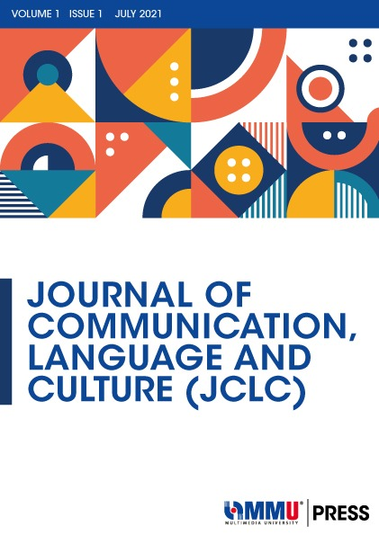

]

Acknowledgement (Book Antiqua, Bold, 12 pt)
The authors wish to acknowledge the support given by Multimedia University Malaysia for the facilities provided in completing this research. (Book Antiqua, 11 pt)

Funding (Book Antiqua, Bold, 12 pt)
Source of funding (Book Antiqua, 11 pt)

Author Contribution (Book Antiqua, Bold, 12 pt)
(Book Antiqua, 11 pt)

Conflict of Interest (Book Antiqua, Bold, 12 pt)
No conflict of interests were disclosed. (Book Antiqua, 11 pt)

Ethics Statement (Book Antiqua, Bold, 12 pt)

Our publication ethics follow The Committee of Publication Ethics (COPE) guideline. https://publicationethics.org/
If your work involved human subjects, please include a statement here confirming that the relevant informed consent was obtained from those subjects:
If your work involved animal experiments, please include a statement here of the ethics permission or animal licenses. If animals were used but ethical approval was not required, a clear statement should be included stating why this approval was unnecessary.
If your work involved data collected from social media platforms, please include a statement here confirming that a) informed consent was obtained from participants or that participant data has been fully anonymized, and b) the platform(s)’ data redistribution policies were complied with.

References (Book Antiqua, Bold, 12 pt)

References should be formatted according to the Publication Manual of the American Psychological Association (7th edition), using Book Antiqua, 11-point font. (Book Antiqua, 11pt)

Author Biography (Book Antiqua, Bold, 12 pt)

Dr. Aisha Rahman is a Lecturer at Multimedi University. Her research focuses on health communication strategies and the use of digital media in public health campaigns. She can be contacted at email: aXXX@xxx.xxx.xxx.

