Title of Article (Book Antiqua, Bold ,18 pt)

Name of Author (Book Antiqua, 11 pt)
Affiliation
Email
ORCID iD: 0009-0002-6781-5741

(Corresponding author)

Abstract (Book Antiqua, Bold, 12 pt)

Please present a single paragraph abstract here that outlines the problem/issue, methods, key findings and implications of the paper. Abstract must not be more than 200 words, in one single paragraph. There should not be any references or footnotes in the abstract. (Book Antiqua, 11 pt)

Keywords: List at least 3 keywords here
Received XXX, 2024 Accepted XXX, 2024 Published July, 2024

Level 1 Headings are for main headings such as Introduction, Background, Literature Review, Methods, Results, Discussion, Conclusion (Book Antiqua, Bold, 12 pt)
The main paragraph text appears here. (Book Antiqua, Bold, 11 pt)

Level 2 Headings are for subsections of Level 1 Headings such as Interviews, Survey etc. (Book Antiqua, Bold, 11 pt)
The main paragraph text appears here. (Book Antiqua, Bold, 11 pt)

Table 1 (Book Antiqua, Bold, 11 pt)

Respondents’ Demographics [illustration text and caption, Book Aintiqua font size 10]

Person | Age
Lina | 45
Malini | 36
Chris | 34
Razak | 25
Salim | 40

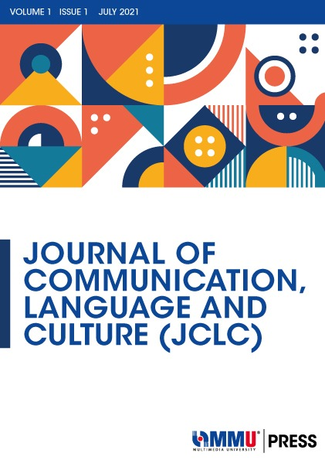

Figure 1 (Book Antiqua, Bold, 11 pt)

[illustration text and caption should be centered, font size 10]

Acknowledgement (Book Antiqua, Bold, 12 pt)
Institute and/or source of funding (Book Antiqua, Bold, 11 pt)

References (Book Antiqua, Bold, 12 pt)
(Book Antiqua, 11pt)

References should be listed here using the 7th edition of the Publication Manual of the American Psychological Association – APA 7th edn, (Book Antiqua, 11pt)

.

