**A Textual Analysis of Creative Multimedia Approaches in Tamil Movie Title Posters**

Komalata Manokaran

latagurl88@gmail.com

Universiti Malaya, Malaysia

ORCID iD**:** 0009-0002-6781-5741

Ong Shyi Nian

ongsn@um.edu.my

Universiti Malaya, Malaysia

ORCID iD**:** 0000-0002-7639-4662

*(Corresponding Author)*

## Abstract

Creative multimedia refers to integrating different media elements, such as text, graphics, audio, video, animation, and interactive elements to convey a message, tell a story, or evoke emotions in a visually compelling and engaging way. Formation of Tamil movie titles is a crucial process of moviemaking because the director intends to reveal the essence of the movie itself, like a title of a journal article. Tamil cinema, also known as Kollywood, has faced a lot of controversies, and one of them is choosing the title of a film. These days, directors concentrate on movie titles with creative ideas to reach audiences. Therefore, this study intends to 1) analyse creative multimedia approaches in Tamil movie title posters and 2) reveal the meaning and storyline of the film from Tamil movie title posters. This descriptive qualitative study used Tamil movie titles (English version posters) using purposive sampling from the production’s official pages. The data support the findings of the formation of Tamil movie titles collaborating with creative multimedia approaches using textual analysis. Lately, directors or designers have been using creative multimedia approaches to attract the audience’s interest in the movie’s title from pre-production until release. The study disclosed that symbols and creative multimedia approaches became interesting domains to keep the titles intact. The findings help to extract the storyline by inserting creative multimedia into the titles so that the audience can presume the storyline, which attracts their attention and draws them into the theatres.

**Keywords**: creative multimedia; textual analysis; Tamil movie; titles; posters

**Received** 31 July 2023 **Accepted** 3 September 2023 **Published** 31 January 2024

**Introduction**

Tamil cinema, popularly known as Kollywood, has a rich history of producing visually captivating movie title posters. In recent years, advancements in multimedia technology have allowed filmmakers to experiment with creative approaches in designing title posters. Creative multimedia in naming Tamil movies combines visual elements, typography, colours, and graphics to design visually appealing and attention-grabbing movie posters. Tamil movie posters are known for their vibrant and creative designs, often incorporating unique and artistic word-formation techniques. There are five basic elements of multimedia: text, images, audio, video, and animation. For example - text in fax, photographic images, geographic information system maps, voice commands, audio messages, music, graphics, moving graphics animation, full-motion stored and live video, and holographic images (Hu et al., 2020).

Many industry technicians, including the director, music director, director of photography, and graphic designers, play vital roles in promoting the movie's title even before the movie's release. In this digital world, creative multimedia plays an important role, and many movies are sold with significant margins in the global entertainment business using the title poster post the responses received from the digital viewership, which crosses millions. Today, in the digital world, decoding the storyline even before the movie release has become a sensational task for Youtubers to grab the viewers' attention and increase their viewership. This study aims to explore and dissect various multimedia techniques employed in Tamil movie title posters, showcasing how these approaches enhance the visual appeal and communication of the movie's theme to reach the audience even before the big screen release so that they are hooked by the title, would continuously promote the movie via digital media, and create a huge global demand.

**Research Objectives**

This current research has two main objectives.

i. To analyse the creative multimedia approach used in Tamil movie title posters.

ii. To explore the use of textual analysis to decode the movie’s storyline using creative multimedia approaches in the Tamil movie title posters

**Research Questions**

The current research has two main research questions based on the research objective.

i. What creative multimedia approaches are used in Tamil movie title posters?

ii. To what extent can textual analysis decode the movie’s storyline using creative multimedia approaches with the Tamil movie title posters?

**Literature Review**

**Definition of Creative Multimedia**

Creative multimedia is a language of the digital world to convey messages to people in a creative way. Creative multimedia is the art of telling a story. According to Haarlem Campus (2023), creative multimedia is about telling stories that resonate with people. It can be with an article or podcast, with light brushstrokes on an empty canvas or with dialogue – in the end, it is all about sharing information with others in a way that is unique to the people. It is also about taking ownership and innovating the media produced, a core part of entrepreneurship. For example, a newspaper article, a video or podcast, a

billboard advertisement, a design on a T-shirt, or a blog post – all of these have an essential component of media: storytelling. Telling stories is the oldest form of media. The earliest humans communicated through stories using sticks and stones to show where food was. The creators share wisdom and ideas through stories; even the most straightforward message, like “I believe!” has a story. It tells something that the creator wants to get across.

**The Differences between Traditional Media, Communication Media, and Creative Multimedia**

Communication media, traditional media, and creative multimedia are all related to different forms of conveying information and messages, but each has distinct characteristics and purposes (Akar, 2011, p.11), as shown in Table 1 and Figure 1.

**Table 1**

*The Differences between Communication Media, Traditional Media, and Creative Multimedia*

| **Medias** | **Descriptions** | **Examples** |
| --- | --- | --- |
| *Traditional media* | Traditional media refers to the conventional forms of mass communication before the advent of digital technology. These forms of media primarily include print, broadcast, and outdoor media. Traditional media usually offers one-way communication, where the sender conveys information to a passive audience without much interactivity. However, the rise of digital technology has led to the integration of traditional and digital media in various ways. | Newspapers, magazines, radio, television, billboards, posters, and direct mail. |
| *Communication media / new media* | It is a channel or tool for transmitting information and messages between individuals, groups, or organisations, including traditional and digital methods. It is a broad term encompassing all communication forms: one-way (e.g., broadcasting) or interactive (e.g., social media). | Print media, broadcast media, digital media, social media, emails, telephone calls, video conferencing. |
| *Creative multimedia* | Creative multimedia integrates various media elements, such as text, graphics, audio, video, animation, and interactive components, to create engaging and interactive content. This content is often designed for digital platforms and can be used for entertainment, education, marketing, communication, and more. Creative multimedia takes advantage of the capabilities of digital technology to deliver dynamic and immersive experiences. | Interactive websites, mobile apps, video games, multimedia presentations, virtual reality experiences, and augmented reality applications. |

**Figure 1**

*Communication Media, Traditional Media, and Creative Multimedia*





Communication media is the overarching term that encompasses all methods of conveying information, whether traditional or digital. Traditional media refers specifically to the conventional forms of mass communication, whereas creative multimedia combines various digital elements to create interactive and engaging content. As technology evolves, the boundaries between these categories can blur as new forms of communication and media emerge (Alzubi, 2022).

**Creative Multimedia Approaches in Tamil Movie Title Posters**

According to Wi et al. (2020), a movie poster is more than just an image; it is a well-planned marketing and promotion tool designed to represent the full content of the film. It has the advantage of containing rich visual elements about the movie, such as background, characters, and typography. Table 2 shows some creative multimedia approaches that can be used in designing Tamil movie title posters.

**Table 2**

*Creative Multimedia Approaches in Tamil Movie Title*

| **Creative Multimedia Approaches** | **Descriptions** |
| --- | --- |
| *Typography* | Experiment with various fonts and typography styles to create an eye-catching title for the movie. Different fonts can evoke emotions and convey the movie’s genre or theme. |
| *Hand Lettering* | Incorporate hand-drawn lettering or calligraphy to add a personal and artistic touch to the movie title. |
| *Visual Elements* | Use visual elements relevant to the movie's plot or genre to enhance the title's meaning and make it visually appealing. For example, if it is a romantic movie, include heart-shaped elements; for an action movie, use bold and dynamic visuals. |
| *Colour Palette* | Choose a colour scheme that complements the movie’s theme and creates a harmonious and attractive poster. Colours can convey emotions and set the tone for the movie. |
| *Illustrations and Artwork* | Integrate illustrations or artwork that represent vital elements of the movie, such as characters, settings, or significant scenes. |
| *Photo Manipulation* | Use photo manipulation techniques to blend images or create surreal effects that amplify the movie’s visual impact. |
| *3D Effects* | Incorporate 3D effects to make the movie title pop and give it a sense of depth. |
| *Texture and Patterns* | Apply texture overlays or pattern backgrounds to add depth and visual interest to the poster. |
| *Creative Layout* | Experiment with different layouts and compositions to present the movie title uniquely and engagingly. |
| *Visual Effects* | Add visual effects like glows, shadows, or reflections to make the title stand out and create a sense of excitement. |
| *Motion Graphics* | Consider creating animated movie title posters with motion graphics that add dynamism and interactivity to the design. |
| *Iconography* | Use symbolic icons or elements representing the movie’s theme or story to reinforce the title’s meaning. |

**How Is Creative Multimedia Related to Movie Posters?**

Creative multimedia can be related to movie posters by integrating various digital elements to enhance the visual appeal and interactivity of the poster. Movie posters are traditionally static images used for promotional purposes, but in the context of creative multimedia, they can be transformed into dynamic and engaging pieces of content. Creative multimedia can be related to movie posters in various mediums, such as *interactive elements.* Creative multimedia allows for incorporating interactive elements into movie posters, including clickable buttons, animations, or augmented reality (AR) components. For instance, a user might be able to scan the poster with a smartphone app to see a short trailer or access additional information about the movie.

Apart from that, *animated posters* refer to creative multimedia movie posters that feature animations as subtle motion effects or more complex animated sequences instead of a static image. This animation can help dynamically convey the movie’s mood, theme, or key scenes. Creative multimedia movie posters might include *sound effects or background music* that plays when a viewer interacts with the poster, and it can create a more immersive experience and enhance the emotional impact of the poster.

*Augmented Reality (AR) technology* can superimpose digital content onto the real world when viewed through a smartphone or AR glasses. Creative multimedia movie posters could utilise AR to provide additional layers of information, interactive games, or even 3D elements related to the movie. Creative multimedia posters could feature *QR codes or Near Field Communication (NFC)* tags that viewers can scan with their smartphones to access exclusive content, behind-the-scenes footage, or promotions related to the movie.

*Social media integration* allows viewers to share the poster on their social networks, increasing the reach of the movie’s promotion. Creative multimedia helps the movie posters to have a *dynamic content update*, which plays a vital role, especially during the pandemic. Movie posters can be updated with new content remotely with creative multimedia. This could include changing images, videos, or other elements as new trailers or promotional materials are released.

In more advanced scenarios, creative multimedia movie posters could integrate with *virtual reality technology components*, allowing users to immerse themselves in a virtual environment related to the movie. The application of creative multimedia to movie posters is an evolving field incorporating new technologies and ideas. This approach aims to engage viewers more dynamically and interactively, ultimately enhancing the promotional efforts for the movie. A poster is a multimedia communication mode because it incorporates and ‘integrates’ the images and words of a multimedia presentation.

**Film Culture: India**

India exports 1,000 films every year, second to the United States. Southeast Asian countries (the largest importers) and countries with large Indian populations import movies in over 20 languages from the industry (Lee et al., 2013; Stephanie et al., 2012). Regional films like Tamil in Madras and Bengali films in Calcutta have helped India’s film industry grow, according to Virdi (2017). Other regional film industries produce Assamese, Bhojpuri, Gujarati, Kannada, Malayalam, Marathi, Punjabi, and Telegu films. In 2013–2014, 1966 films were made in 36 languages, including 349 Telegu, 326 Tamil, and 263 Hindi films, according to the India International Film Tourism Conclave (IIFTC). Film censorship and tax filings are handled by the Films Division of India (FDI), while the Film and Television Institute of India (FTII) has trained filmmakers since 1961. The 1975-founded National Film Development Corporation (NFDC) promotes India at international film festivals. India’s soft power is Bollywood, according to Roy (2012). The Indian government’s soft power diplomacy relies on Bollywood’s global appeal. In the 21st century, Ganguly (2010) praises the soft power in Indian cinema. Bollywood’s soft power in attracting worldwide viewers, particularly for its creativity and digital special effects technology, and it is proven by the releases of Pan India movies such as Bahubali (original in Telugu), RRR (original in Telugu) Leo (original in Tamil), Pathan (original in Hindi), which grossed Rs 1000 crores worldwide. The movie 'Jawan', starring Shah Rukh Khan, was undoubtedly one of the best films of 2023. The film's VFX, crafted by Red Chillies VFX, played a pivotal role in its success, contributing to its global earnings of over Rs 1100 crore.

In the post-liberalisation era, most 21st-century Bollywood filmmakers have focused on modern design and visual modification to build a global Bollywood image. Location, product exposure, and DFVx have greatly influenced the visual design of new Bollywood films (Schaefer & Karan, 2012). O'Neill (2013) claims that Bollywood has impacted international representation through audience attitudes, values, and beliefs. Bollywood films have challenged Western conceptions of India's realism, which sounded clichéd to overseas audiences. In the 1990s, Bollywood reinvented national film with new theatrics (Prasad, 2008). Virdi (2017) thinks Indian cinema has permeated the international market, especially in the West, but popular Indian films, except for Slumdog Millionaire, have failed to become transnational phenomena. Indian global cinema emphasises national identity, unlike Western international cinema. Thus, Indian movies should question its predominance (Virdi, 2017).

Bollywood accepts Hollywood since transnationalism is the finest method to promote India’s culture and compete with foreign markets. According to Virdi, Bollywood is still relevant to popular Indian movies. Gehlawat (2010) states that Bollywood has influenced films worldwide and nationally. Bollywood has adapted to global tastes thanks to production teams, scriptwriters, directors, and producers. Local viewers accepted Indian cinema’s transformation due to this adaptation’s veiled plot and narrative changes. Indian cinema’s worldwide market expansion has been recognised by most countries, especially non-Western cultures, including Africa, Eastern Europe, and the Middle East (Virdi, 2017). The economy benefits most from international Indian films.

According to Mooij (2006), Bollywood’s masala approach distinguishes it from Hollywood and other film industries. According to Ganti (2004), Indian movies’ masala combines music, romance, action, humour, and drama to appeal to the broadest audience. According to O’Neill (2013), Bollywood’s ‘masala’ genres merge, colonise, and transcend local or different cultural perspectives. Transnationalism develops labourers’ skills and technology, which affects Indian film. According to Sengupta (2005), Mumbai is known for transnational collaboration on digital technology products like visual effects, streamlined finance alternatives, and global audience share. The Indian film industry used cosmetics and camera techniques before the DVFx revolution in the 1960s. Over 15 languages have visual effects in Bollywood and regional cinema. *Jaganmohini* (1978) and *Mr. India* (1987) were India’s first visual effects films. Visual effects were in the 1995 Telegu film *Ammoru*. DVFx is used in Shankar’s films. *Anniyan* (2005) shows hell with DVFx. *Robot* (2010), directed by S. Shankar and starring Rajnikanth, was a hit internationally. He used DVFx in I, the movie (2015). India’s most expensive films, *Baahubali*: The Beginning (2015) and The Conclusion (2017), had the finest DVFx. Over two years, 15 labs and 600 visual effects artists used $28 million in digital visual effects technology for *Baahubali* (Ganguly, 2010). Both films gained international recognition for their DVFx graphics, proving that India’s DVFx industry is comparable to Hollywood’s.

In 2011, the Eastern Eye researched the special effects of change in Bollywood, illustrating Bollywood’s commitment to DVFx in its films. India’s progress in DFVx has helped production enterprises and post-production studios grow and indirectly rejected the concept that DVFx would raise film production expenses. Hollywood increasingly relies on Bollywood DVFx. Samaras and Johnston (2018) list India, Canada, Australia, New Zealand, the UK, and the US as DVFx hubs. According to Kumar and Vats (2018), most Hollywood films outsourced DVFx to Japan, South Korea, or Taiwan before India became the DVFx powerhouse. DVFx outsourcing is the most popular in India (Mozar, 2018). The lower exchange rate has reduced production costs for the US, Europe, Australia, and Canada. India has many creative and technical artists, mainly in rotoscoping and painting. Hence, India excels in roto and paint, which are crucial to DVFx compositing. VFX roto, stereo/ 2D to 3D conversion frame, frames by frame, articulate, motion blur, hair detail, simple or dynamic clean operations plane, texture repair, background generation, and visual correction are all part of India’s roto process. India has more natural international collaborative networks when it comes to communication compared to China and Japan because English is a second language. Conversations are easier and faster. India is a major animation and DVFx outsourcing destination due to these advantages. DVFx studios in India and abroad number over 40. Walt Disney, Fox Entertainment, and Time Warner are also competing in India's outsourcing business (Kumar & Vats, 2017).

The Indian DVFx industry has flourished thanks to Prime Focus, Reliance MediaWorks, Red Chillies, Tata Elxi, and Pixon. DVFx won the 2014 Academy Award for Best Visual Effects for Interstellar. This piece was a collaboration between Indian DVFx studio Prime Focus Studios and London-based Double Negative (Walia & Dutta, 2015). DVFx technology and expertise from India are used in Skyfall, Avatar, Twilight, Transformers, and Kingsman: The Secret Service. According to KPMG India and FICCI’s Indian Media and Entertainment Industry Report 2017, India’s animation and DVFx sectors grew 16.4% to INR 59.5 billion in 2016, with the DVFx industry expanding 31%. DVFx is essential for local Indian cinema production, according to Menon (2017). Due to audience poverty and the demand for great entertainment, India’s film industry struggles despite having many talented DVFx artists (Guptha, 2016). DVFx films are expensive to make. Thus, Indian consumers are usually unprepared to pay for them. Federal and state tax incentives for local DVFx are still inadequate. Although India's economy has benefited from the industry, the government has not offered this incentive. Government funding, human resources, and infrastructure are still scarce. Government help is needed to grow India's 800 DVFx studios (Menon, 2017). DVFx development has been funded by several Indian state governments, according to Paliwal (2016). The National Centre of Excellence for Animation, VFX, Gaming, and Comics will be located in Maharashtra, and Telangana is developing an incubation centre in Hyderabad. To compete with the US, Canada, and developing economies like South Korea, China, and Malaysia, India needs more state governments to offer grants, labour tax credits, and subsidies to local businesses. Finally, the Indian DVFx industry hopes to use DVFx to exhibit its numerous epic fantasy stories to the world (Shafeeq, 2017). Baahubali, an Indian history-based fantasy epic, confirmed this. Hollywood films work because they employ fantasy as the main storyline, and India should exploit its vast and varied fantasy stories to do the same. This became the reality with the latest release of Hanuman (2024), the Indian version of a superhero character with a great DVF outcome which grossed Rs 100 crores in 4 days and became the talk of the town.

**Tamil Movie Poster and Creative Multimedia (TOI)**

Trailers and teasers might be the windows to a film’s soul. Still, another phenomenon is slowly, yet steadily becoming the apple of every fan’s eye, particularly in Tamil cinema — the first-look posters. With #FirstLook being one of the most favoured hashtags among fans, filmmakers are increasingly trying to go off the beaten path and showcase originality through posters. Hence, designers and artists work for months and days, burying themselves behind colours, graphics, and illustrations to design a movie title. Times of India, better known as TOI (2019), speaks to a few first-look mavericks to delve deeper into this new-age poster culture in Tamil cinema.

**Digital Boom**

Posters have had a rich relationship with Indian cinema, with its origins stemming from hand-painted cinema artworks by the likes of MF Husain. Still, the modern facelift of cinema posters is undoubtedly the work of digital marketing, says Tuney John (2019), who has been the visual force behind several acclaimed film posters, including that of *Madras*, *Jigarthanda*, *Premam*, *Kaaki Sattai* and *Pizza*. The craze for posters has always been there. For instance, the poster of Shankar’s *Boys* achieved something unique in 2003. Tuney says that poster design is no longer about customary cut-out images. Social media has heightened the recognition. Previously there were a lot of paper ads in the newspaper; however, now, those paper ads have been reduced as we have new digital content popping up every day. The poster wave also has much to do with new-age filmmakers, who think out of the box. Just like how there has been a massive difference in making films, the making of posters has undergone a sea of change. It is about how the director thinks. Tuney (2019) adds that he can deliver a very creative poster, but the director needs to be on board with it. Karthik Subbaraj, for instance, is very supportive of art. Most of his posters have given importance to art (Figure 2). Tuney and the team sketched almost eight concepts for the film. His preparation included intensive conversations with the director and the cinematographer, Tirru, about the film’s pulse. Karthik gave a basic idea. He explained that sir Rajini served as a guardian angel in the movie. So, some of his poses from *Baashha* were replicated in a different tone. He was made to stand out from the crowd in the second poster, which would add to the mass appeal, Tuney explains (2019). The poster sees the actor sitting on a chair in style amidst a packed crowd.

**Figure 2**

*The Rough and Final Sketches of ‘Petta’ by Tuney John (2019)*

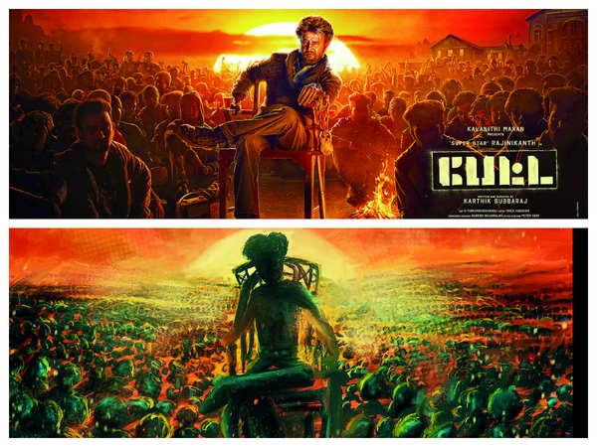

**Art as a Science**

Gopi Prasannaa’s works brim with bursts of colour and novelty. This has been evident since his first poster, which was for Thiagarajan Kumararaja’s cult film, *Aaranya Kaandam*. The designer explains that the quality of posters has ascended from desktop-publishing material to detailed science. People used to take the layout of Hollywood movie posters and change the colour combination to work with it. He adds that the design was derived, and art is subjective, but the derivation is not. Gopi began applying his marketing, branding, and gaming experiences to inject life into the posters. He has a well-oiled machine-like process, almost always starting with the film's narration. There is a story narration, and during the narration, an idea is mentally formed as to how the poster would look. He adds that he will pitch the idea to the director as mock material, then pick out the soul of the moment to create a poster. Gopi says alignment is very exciting, and the entire project starts there.

The designer, who has critical and commercial darlings including *Super Deluxe* (Figure 3), *96* (Figure 4), *Bigil* (Figure 5), *Nerkonda Paarvai*, *Game Over*, *Sarkar*, *Mersal,* and *Kaththi* attached to his name, prefers working with original and authentic artwork for the posters. If it is a photo shoot, he sketches the entire thing, detailing the smallest things, from costume and hairstyle to its colour. Gopi recalls (2019) that his eye for detail is visible, especially in *96*, which garnered a lot of appreciation for its distinctive typography, but getting there was not easy. The title art evokes memories of the 1990s with images such as the Doordarshan logo (India’s international television logo), analogue watches, liquid ink, and crayons. Gopi wanted to give the old boy-meets-girl concept a twist with its title art. The film is all about memories, and that was the soul – the memories reflected in the typography. It is tough to work with numerals because it will look simple even with attractive font or typography.

Meanwhile, offbeat films are one thing; big star films are a whole new ball game. The film’s actors, story, and target audience are essential variables. Gopi (2019) points out that every pixel of the poster should be about the star in such films. There is a limitation, and it can only work within a boundary. For example, more than *Aaranya Kaandam*, *Kaththi* opened new doors; the poster was made solely from newspaper cuttings.

**Figure 3**

*Super Deluxe*

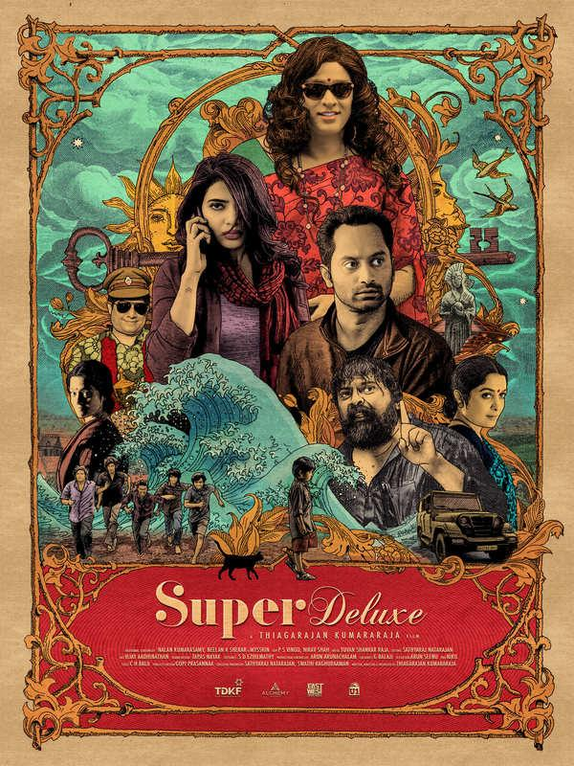

**Figure 4**

*96*

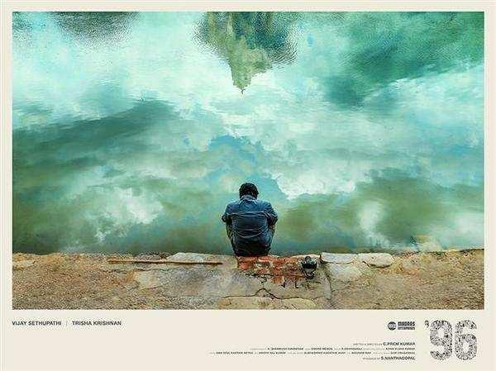

**Figure 5**

*Bigil*

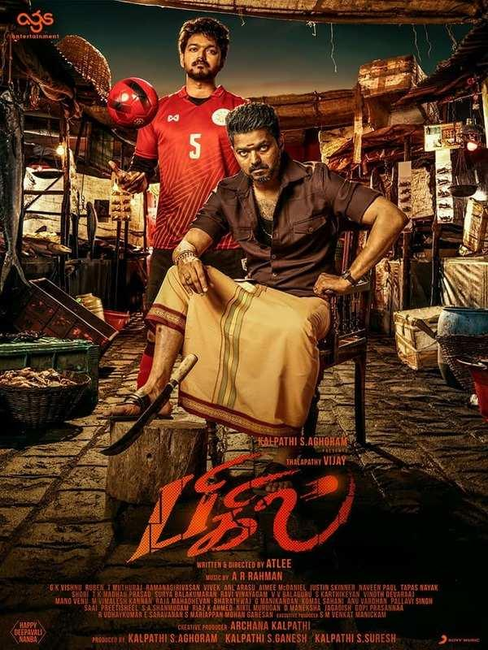

**Figure 6**

*Periyerum Perumal*

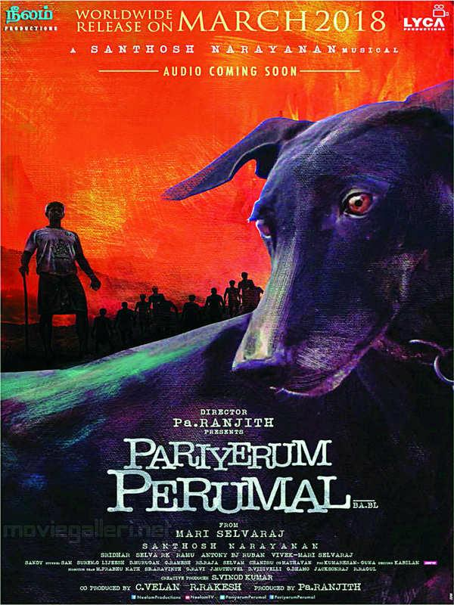

According to Sivam Kabilan (2019), the poster is only as good as the film. The young designer, who aims to crank the camera one day, has films including *Pariyerum Perumal* (Figure 6), *Aruvi*, *Peranbu,* and *Darbar* to his credit. Some directors give complete freedom to do whatever the designers want after the script’s narration. He adds that some posters are also made to spark discussions. For example, Aruvi, which took over a week to design, is a perfect example. It is a realistic film, but the posters do not reflect that. It has a lot of colours and looks very psychedelic. The poster making doesn’t involve any reference before drawings on the white canvas but just started to sketch according to the mood of the designer, for example, the glasses that Aditi (the heroin) wore on the poster were added artlessly.

Arun, the film’s editor and team, sat to make that poster and began adding elements to it, one by one. On the other hand, for *Pariyerum Perumal* (Figure 6), the artwork of Karuppi, the dog, finds prominence over the protagonist. Kabilan considers the poster to be one of his best. Not many actors or directors prefer such posters. The dog has a small part in the film. There was also hesitation over whether people might perceive it to be a film about a dog, but the director Mari agreed, he says.

Chandru Ranganathan, who has designed posters of *Sixer*, *Petromax,* and *Ratsasan* (see Figure 7), has a similar example to narrate. Right from its typography, the poster of Ratsasan is all about the villain and not the hero, turning the table on the conventional approach. Even the title, *Ratsasan*, is based on the villain. So, the designer started thinking about the villain in the film to derive ideas, Chandru (2019) explains that they realised that the connecting point between the hero and the villain was the piano. He wanted to create this effect without even revealing the face of the villain. He adds that concept-oriented artwork is the undeniable king of posters today. “The director’s point of view is everything. The designer might have different perspectives on things, and the directors might expect a better version from the designers when they narrate the story; so, as designers, we tend to think about the camera angle and colours in the scene to use in the poster’’, according to Chandru (2019).

**Figure 7**

*The Rough and Final* S*ketches of ‘Ratsasan’ by Chandru Ranganathan (2019)*

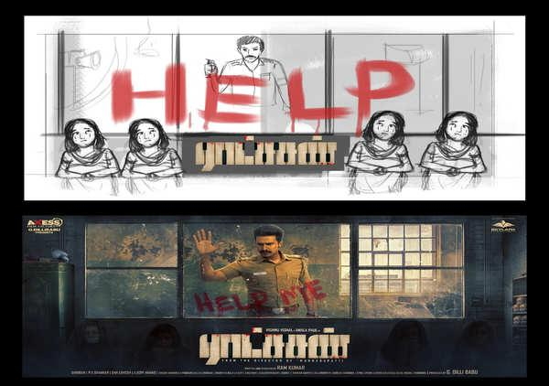

**Breaking Barriers**

As with many elements of a poster, designers are increasingly playing around with bold and exciting colour palettes, says publicity designer Prathool NT, who has sketched the posters of *Imaikaa Nodigal*, *Airaa*, *Velaikaran*, *Kaappaan,* and *Pizza II: Villa* (refer to Figure 8). The South Indian film industry is huge on colours, and designers have different colour patterns. Colour plays a huge role in ideating a concept. At one time, designers imitated Hollywood posters with monotone colours like blue, orange, or brown. However, it started breaking that concept, says Prathool (2019). Genres and target audiences are variables that can dictate a film’s colour scheme. Designers are increasingly playing around with typography and colours, but that should not be done at the cost of symmetry and readability. Meanwhile, he observes that illustration is integral to designing, and art is not what a poster is all about. Prathool (2019) adds that apart from art, a good poster is about text arrangements, aesthetics, and smart utilisation of available content. Mirroring Prathool’s views is Tuney, who points out that not all great posters necessarily have to have top-notch artwork. Art and design are two different things. When designing, designers need a solid idea. A designer who is an artist will have art-heavy work, but a designer does not need to be an artist.

**Figure 8:**

*The Rough and Original Sketches of ‘Pizza II: Villa’ by Prathool (2019)*

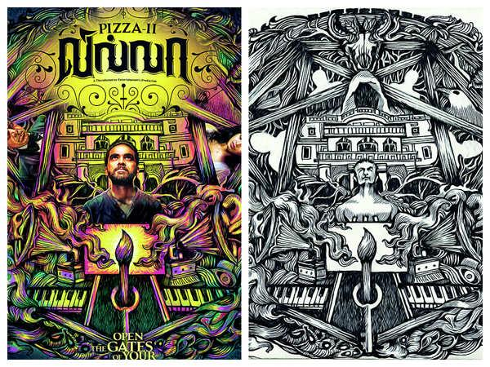

**Theoretical Framework: Textual Analysis**

This study is affiliated with the study of textual analysis and the semiotics research area. Textual analysis begins with signs, symbols, and icons. Peirce (1860) identified index, icon, and symbol signs. Thus, three sign identification methods are applied in the literary analysis to represent the sign through an iconic and symbolic interpretation to which the film study is similar. The textual analysis introduces theoretical stage 1; indexes, icons, and symbols can identify sequences and imagery in the film. Metz (1974) upgraded the matter, substance, and form of expression and content to six dimensions, including cultural factors, to introduce the second theoretical domain. Film expression is complicated and varied. Music, speech, linguistic structure, noise patterns, and other text drivers have also changed. Filmmaking technology determines a narrative’s indexical dimension, which comprises identification of the lens, camera, film type, lighting, studio facilities, editing and printing procedures, colour grading, special effects, and industrial production or organisation index.

The textual analysis treats “text” as a cultural artefact or documentary evidence, according to Brennen (2013). Thus, the text creates meaning through numerous media because media, culture, and society are interconnected; qualitative research can understand novels, films, newspapers, magazines, and music. The film title (text) is analysed to learn about the formation and representation. The textual analysis focuses on the synthesis, according to Brylla (2018). Textual methods assist audiences in comprehending and discussing a film’s ideas. This part compares the film’s narrative. This study’s textual analysis of creative multimedia in movie title posters examined the text media and the tools that enhance its creation. Creative multimedia was used to investigate creative processes in title posters. This strategy also values creative people’s claims and skills and helps us identify cinema’s creative multimedia industry logic.

**Methodology**

**Research Design**

This study used a descriptive qualitative method to explore specific subjects in-depth in order to attain the aim and objectives of the study. According to Bogdan and Taylor (1992), the qualitative approach is a research procedure with descriptive data in the form of written and oral communication of individuals or their behaviour; therefore, the collected data is in the form of pictures, sentences, or words. This design is appropriate for a holistic and subjective score because it involves understanding Tamil movie titles’ morphological and textual aspects. In addition, the openness and flexibility of the method made it an effective way for data collection and analysis for thoughtful results.

**Samples and Data Collection Process**

The researchers compiled 20 Tamil movie titles from different digital platforms, including social networking websites, search engines, news articles, and online newspapers aligned with the concept of the linguistic aspect—digital platforms function as an instrument in the data collection process. The researchers decided to gather Tamil movie title posters with creative multimedia from digital media. The data collection process took place entirely using digital platforms such as Facebook, Twitter, Instagram, online newspapers, online magazines, and Tamil movie-related websites. The researchers used various digital media to filter and save the sample’s responsiveness with the aim of the study. The researchers used the purposive sampling method to gather the data because the study only focused on Tamil movie titles using creative multimedia approaches. Purposive sampling encompasses methods to collect data that have the potential to be more representative in the foreseeable future (Sugiyono, 2011). The digital platforms were used to gather sufficient samples. The data collection only focused on Kollywood movie titles and analysed creative multimedia on its poster to decode its storyline.

**Data Analysis Procedure**

Researchers conducted library research to find evidence and appropriate analytical and theoretical frameworks. The researchers analysed the morphological aspects (word-formation, text, images, symbols, and their relationship to creative multimedia approaches) and textual analysis. The textual analysis begins with signs, symbols, and icons; Peirce (1860) identified index, icon, and symbol signs. This study examined Kollywood movie titles and explored creative multimedia on its poster to decode the movie’s storyline using morphological and textual analysis. Morphological analysis is a method used in language study that breaks down a word into its parts to determine how it functions. Many words, though not all, contain more than one meaningful unit. Morphological analysis is executed to determine the storyline of the Tamil movie title to define its meaning. The collected samples from various digital platforms were documented according to their word-formation. The researchers used morphological analysis (digital dictionaries) to determine the meanings of the Tamil movie titles and textual analysis. Moreover, the researchers used morphological and textual analysis to interpret the meaning using digital dictionaries, determining the storyline with the help of creative multimedia approaches on the poster designs. This study’s first research aim was answered by textual analysis of creative multimedia use in selected movie titles. Qualitative techniques define “text” as a printed document, written text, and poster. Empirical studies can help filmmakers and academics blend narrative and aesthetic aspects, allowing filmmakers to understand their audience, including prejudices and clichés. This method is error-prone, mainly when the relational analysis is utilised to interpret. Creative multimedia is sometimes hard to code or interpret, so analysis is more descriptive and causal. The textual study of film is to inform viewers, according to Berelson (1952). Neuendorf (2002) said that this inference process requires an integrated strategy and should be supported by audience research (Macnamara, 2005).

**Findings And Discussion**

**Table 3**

*Creative Multimedia Approaches with Examples*

| **Creative Multimedia Approaches** | **Descriptions** | **Examples** |
| --- | --- | --- |
| *Typography and Fonts* | Typography is one of the primary elements of any movie title poster. Tamil movie posters often employ diverse fonts that reflect the film’s genre, mood, or period. Sans-serif fonts are commonly used in modern and action-packed movies, while elegant serif fonts are used in historical or period films. | Typography can be observed in the title posters of movies like *Kaala* (2018) for its bold, rugged font and *Pariyerum Perumal* (2018) for its traditional yet stylised font. |
| *Colour Palette* | The colour palette plays a significant role in eliciting emotions and setting the tone for the film. Tamil movie title posters utilise vibrant and contrasting colours to attract attention. | The title poster of *Vikram Vedha* (2017) combines intense red and dark blue, indicating conflict and suspense. |
| *Visual Elements and Graphics* | Creative multimedia approaches often integrate visual elements and graphics symbolising the movie’s theme or characters. Abstract designs, illustrations, or even character illustrations are incorporated to make the title poster visually engaging. | The title poster of *Mersal* (2017) effectively uses graphics to represent multiple facets of the lead character, played by actor Vijay, emphasising the film’s theme of vengeance. |
| *Photo Manipulation and Montage* | Many Tamil movie title posters employ photo manipulation techniques to combine multiple images to create a visually captivating montage that hints at the storyline or showcases the main leads. | The title poster of *Kabali* (2016) exhibits photo manipulation, blending the lead actor Rajinikanth’s past and present avatars, connecting to the film’s plot. |
| *Use of Visual Effects* | With advancements in digital technology, Tamil movie title posters have started incorporating visual effects, enhancing the overall visual appeal. These effects can range from simple enhancements to complex, eye-catching animations. | The title poster of 2.0 (2018) showcases advanced visual effects, with the protagonist’s towering figure amidst a cityscape, creating a futuristic and larger-than-life ambience. |
| *Incorporating Regional Cultural Elements* | Certain Tamil movies leverage regional cultural elements to connect with the audience and reinforce the film’s identity, adding authenticity and relatability to the title poster. | The title poster of *Kadaikutty Singam* (2018) incorporates traditional village elements and agrarian symbols, reflecting the rural setting and theme. |

Movie posters are prominently exhibited on billboards, movie theatre lobbies, the Internet, and bus sides because they are ads to sell the film. The movie title is bold on the poster, with the actors usually shown to remind viewers that the film stars significant celebrities. Designs, colours, and fonts represent the film’s atmosphere and tone, and the poster incorporates a snappy line or slogan to pique viewers’ interest and intrigue the plot. Movie posters transmit significant messages visually, and the best posters make audiences eager for the release. The worst may not persuade. By analysing movie posters, one can learn what attracts moviegoers and sells the story before seeing it.

**Data Analysis**

**Movie 1 – Doctor**

**Figure 9**

*Doctor*

The synopsis of the **‘DOCTOR’** movie (Figure 9) is that a military doctor (played by the actor Sivakarthikeyan) tracks down his fiancée's niece kidnapped and discovers a complex human trafficking ring in Goa. Then, he weaves an intricate trap to capture the perpetrators. It is a black comedy thriller movie.

**Table 4**

*Creative Multimedia Approaches in Doctor Movie*

| **Creative Multimedia Approaches** | **Descriptions** |
| --- | --- |
| *Typography/ Fonts* | Vintage Fonts Collection is used in the poster showcasing slashed surgical knives, which relate to how the doctor handles the situation in the story. |
| *Iconography* | The intercalation of the medical symbol (⚕) and surgical tool reveals the story of the medical crime using child trafficking. The letter /t/ in the word ‘*doc****t****or*’ is substituted with the medical symbol to depict a medical theme. The white font colour of the title defines the white colour of crime. |
| *Colour Palette* | The series of surgical knives in the background—support that the doctor got from his army to defeat medical crime gangsters (child trafficking). |
| *Visual Elements and Graphics* | It is a neat and professional poster with the right execution of surgical tools as his background (a shield of a surgical knife) describes the storyline of how the doctor defeats the child-tracking crime with the help of his military team. |
| *Incorporating Regional Cultural Elements* | The title poster incorporates formal attire (coat suit) elements and medical symbols, reflecting the doctor’s profession. |

**Movie 2 – LEO**

*Leo* movie is yet to be released with huge budget demand, starring Thalapathy Vijay and is awaiting release soon. In general, *Leo* ♌ is one of the horoscopes and symbolises the lion and even the first look title motion teaser (motion title poster link: https://youtu.be/qN3wfuPYTI4) shows the hero working quietly in a bakery (with the dark backdrop with dim light) sharpened a sword, dipped in chocolate, and uttered 'bloody sweet' after tasting it. That dialogue became trending, making the viewership cross millions within 24 hours, creating a massive impact among the fans and YouTubers. It can be predicted and decoded that the storyline of *Leo* is a continuation of LCU (**L**okesh **C**inematic **U**niverse), the series of an Indian shared universe of action thrillers by Director Logesh Kanagaraj created in the last two back-to-back movies (*Kaithi*, a prisoner in 2019 and *Vikram*, in 2022). This movie, Leo, will be the third installation with high expectations for 2023 that Tamil cinema predicted for massive opening in the theatre and box office collection with the title poster creativity. From the beginning of the motion title teaser, with bloody sweet [tasting chocolate], the hero is sharpening the weapon – presuming an action for a more significant scale.

**Figure 10**

*Leo (Motion Title Teaser)*



**Figure 11**

*Leo (Second Poster)*



**Table 5**

*Creative Multimedia Approaches in Leo Movie*

| **Creative Multimedia Approaches** | **Descriptions** |
| --- | --- |
| *Typography/ Fonts* | Times Roman capitalised (LEO), was used in the poster. In the first look, the title was designed as an emblem – gold colour with two swords and dialogue of ‘bloody sweet’ which he uttered in the title movie teaser. |
| *Iconography/symbolism* | The horoscope Leo (lion) created an image to presume about the global mafia. In Figure 11, the poster reveals that the hero is all set to hunt for blood, which can be seen on the previous gold title emblem drenched with blood. ‘Leo’ also uses the dominant colour, red, reflecting anger. The title can also refer to a gang mafia where a ‘Leo’ is called the boss. The hero’s fierce facial gesture reflects the roughness, brutality, and wildness of the killing setting of the movie. |
| *Colour Palette* | Blue (cool and calm) – cold-blooded murder, depicting the hero killing in a way that seems especially cruel because it shows no emotion, assuring an action-packed movie. |
| *Slogan* | On the emblem, the slogan bloody sweet – depicts the taste of blood (the satisfaction of killing). |
| *Visual Elements and Graphics* | Then, in the second look (Figure 11), the hero with his hair looks and fiercely roaring gestures like a lion. |
| *Photo Manipulation/ Montage* | The hero in front (killing like a lion, Leo) is montaged with the hyena behind (showing fierce), comparing both the hero and hyena symbolising predators. |
| *Use of Visual Effects* | The second poster (Figure 11) shows the background in hills and snow, depicting cold, maybe cold-blooded murders with the sword. |
| *Incorporating Regional Cultural Elements* | This movie poster incorporates a hill station and a cold, thick forest reflecting wildness, hunting, blood, prey, and predator. |

**Movie 3 – RRR**

RRR is a fictional story set in the 1920s and is a period drama that revolves around the lives of two freedom fighters, Alluri Sitarama Raju and Komaram Bheem. It showcases their journey before they became legendary freedom fighters. The movie is set against the backdrop of the pre-independent era and promises to be an action-packed entertainer with high production values and spectacular visual effects. Initialism or abbreviation (RRR), the title was taken from the audience, the director of the movie asked the audience to name the film, and the director humorously mentioned to the media that RRR is the initials of the three of them; the director [**R**ajamouli] and both actors [**R**am Charan and Junior NT**R**]. Rise – roar – revolt [multiple meanings given for this title], and because of this, after the release, many viewers are seen giving their one-word review as supeRRR! – which has given a series of RRR franchise blend words on social platforms. The title also shows the image of Ram Charan as a rise, the symbol of India and the NTR revolt, summarising the movie-themed patriotism (Figure 12). The joining hands of both characters collaborate to defeat the enemy of the country, the British, as freedom fighters. In Figure 12, the first /R/, the riser, Ram Charan, denotes the fire – the angry young British officer working to get weapons for his people in the village to fight against the British. The second /R/ roaring story combines these powerful characters by the director, SS Rajamouli. The story is a wild and humongous storm of water clashing with fire as a clash of titans. The third /R/ is a wild man who faces challenges to save the child from his tribe, from the British, as an enslaved person.

**Figure 12**

*RRR*

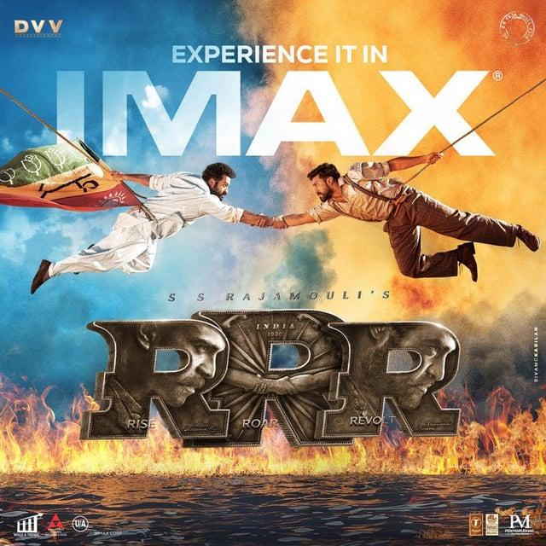

**Table 6**

*Findings of Creative Multimedia Approaches in RRR Movie*

| **Creative Multimedia Approaches** | **Descriptions** |
| --- | --- |
| *Typography/ Fonts* | Typography/ font is given the centre of attraction, where the story and main leads are imprinted within the font creatively with meanings behind each initialism of the title. For example, R (rise) with the picture of **R**am Charan, both characters Rs arranged to front, putting the story behind which the leads are holding hands together to bring independence for India, and the wheel (on India flag). |
| *Colour Palette* | Blue vs orange means water vs fire (calm vs anger). |
| *Visual Elements and Graphics* | Fire on the water shows how these two elements (the related characters) join hands to achieve the goal of chasing the British. |
| *Photo Manipulation/ Montage* | The poster employs photo manipulation techniques within the font (RRR), combining the main leads with the words related to the character creatively to create a visually captivating montage which hints about the storyline or showcases characteristics of the main leads with a core of the theme, patriotism with togetherness by holding hands together. |
| *Use of Visual Effects* | The *roar* [the scene in the movie where NTR will be seen against the tiger and roaring, each showing the character’s power]. |
| *Incorporating Regional Cultural Elements* | This movie poster incorporates traditional/ tribal village elements and the British regime, reflecting the ruling period of the British and the patriotism of freedom fighters, reflecting rural settings and the pre-independence period. |

**Conclusion**

The creative multimedia approach in a Tamil movie poster plays a crucial role in captivating the audience’s attention and setting the tone for the film. The poster can effectively convey the movie’s themes, genre, and key elements by incorporating various artistic elements, such as graphic designs, motion graphics, and visual effects. The ultimate goal is to entice the viewers to watch the movie by generating curiosity and excitement. The poster’s design and imagery often hint at the movie’s storyline. Clever use of visuals and symbolism can offer subtle clues about the characters, conflicts, and overall narrative. For instance, the colour palette, typography, and placement of characters on the poster can provide insights into the movie’s mood and genre. Visual cues can hint at the plot’s time, location, or fantastical elements. However, it is essential to remember that while the poster hints at the storyline, it often leaves much to the viewers’ imagination. A well-crafted poster can pique interest and generate anticipation, but it is the movie’s content, storytelling, and execution that ultimately determine its success.

In conclusion, the creative multimedia approach in a Tamil movie poster is a powerful tool in the marketing and promotion of the film. Through a strategic combination of graphic design, visual effects, and symbolism, the poster can effectively communicate the movie's essence and generate curiosity among the audience. While it may offer glimpses into the storyline, the real magic lies in experiencing the complete cinematic journey while watching the film. The current study has a few limitations, such as the samples were gathered only in the Tamil movie context, focusing on English. This is the first to introduce morphological aspects, multimedia approaches and textual analysis using digital data. Therefore, the researchers recommend that further studies be carried out on the other languages borrowed from other countries. This is an interesting topic for further studies with larger samples for extended periods since this is time-consuming.

**Acknowledgement**

I would like to express my deepest appreciation to the Multimedia University (MMU) which opened the opportunity for us to participate in the competition. I am deeply indebted and I would also like to extend my deepest gratitude to Dr Ong Shyi Nian (supervisor at University Malaya) who encouraged and supported me to start writing academic papers and joining this competition. I am extremely grateful to my family who always supported me throughout my academic journey, from where I extracted new ideas to do research.

**References**

Alzubi, A. *(2022).* Impact of New Digital Media on Conventional Media and Visual Communication in Jordan*. Journal of Engineering, Technology, and Applied Science. 4. 105–113.*

Bogdan*, R. &* Taylor, S*. (*1992)*.* Pengantar Metode Kualitatif. *Surabaya: Usaha Nasional. Basari, Hasan. The Social Construction of Reality.*

Ganguly, D. (2010). Orbits of desire: Bollywood as creative industry in Australia. In A. Hasam & M. Paranjape (Eds.), Bollywood in Australia: Transnationalism and cultural production (pp. 159–175). *Crawley, WA: UWA Press.*

Ganti, T. (2004). Bollywood: A guidebook to popular Hindi cinema. *New York: Routledge.*

Gehlawat, A. (2010). Reframing Bollywood: Theories of popular Indian cinema. *New Delhi: Sage.*

Haarlem Campus (2023): Creative Multimedia Retrieved from: https://haarlem-campus.com/what-is-creativemedia/?gclid=CjwKCAjwhdWkBhBZEiwA1ibLmBqsejfgjedz6wjqozalvAsTFbLwDJVLbMb3p4YsAZyyfKasqYLlHhoC8iEQAvD_BwE

Hashim, H. (2019). Techno-creativity vs Narrative Techno Enhancement: Comparative Case Studies on the Usage of Digital Visual Effect in Malaysia, India and Australia. Thesis Doctor of Philosophy. *School of Social Science Discipline.* Retrieved from: https://api.researchrepository.uwa.edu.au/ws/portalfiles/portal/70072604/TH20_2_THESIS_DOCTOR_OF_PHILOSOPHY_HASHIM_Hasrul_2019.pdf.

Hu, Z., Yan, H., Yan, T., Geng, H., & G. Liu, G. (2020). Evaluating QoE in VoIP networks with QoS mapping and machine learning algorithms. *Neurocomputing*, Vol. 386, pp. 63–83, 2020.

Kumar, D. & Vats, A. (2018). Demonetisation impact: Media, entertainment, animation and visual effects industry. *Communication Today*. April-June. 81-87.

Liu, W. (2021). Research on the Application of Multimedia Elements in Visual Communication Art under the Internet Background. *Mobile Information Systems*, Vol. 2021. DOI: https://doi.org/10.1155/2021/5525648

Mooij, T. (2006). The new Bollywood: No heroines, no villains. *Cineaste,* *31*(3), 30-35.

Menon, G. (2017). Indian animation and VFX industry is getting bigger and better. Retrieved from http://economictimes.indiatimes.com

O’Neill, P. (2013). Imagining global India: Bollywood’s transnational appeal. *Journal of Media and Cultural Studies*, *27*(2), 254–266.

Paliwal, S. (2016). Overview of the VFX industry. Retrieved from http://www.franchiseindia.com/education/Overview-of-the-VFX- industry.10509.

Patton, M. Q. (2002). Qualitative research & evaluation methods (3rd ed.). *Thousand Oaks, CA: Sage.*

Prasad, M. M. (2008). Surviving Bollywood. In A. P. Kavoori & A. Punathambekar (Eds.), Global Bollywood (pp. 41-51). *New York: New York University Press.*

Mooij, T. (2006). The new Bollywood: No heroines, no villains. *Cineaste, 31*(3), 30-35.

Menon, G. (2017). Indian animation and VFX industry is getting bigger and better. Retrieved from http://economictimes.indiatimes.com

O’Neill, P. (2013). Imagining global India: Bollywood’s transnational appeal. *Journal of Media and Cultural Studies*, *27*(2), 254–266.

Roy, A. G. (2012). Introduction. In A. G. Roy (Ed.), The magic of Bollywood: At home and abroad (pp. 1–13). *New Delhi: Sage.*

Sugiyono, P. D. (2011). Metode Penelitian Pendidikan Pendekatan Kuantitatif, Kualitatif, dan R & D. *Bandung: Alfa Beta.*

Times of India (TOI), 2019. The real poster boys of Tamil Cinema. Retrieved from: https://timesofindia.indiatimes.com/entertainment/tamil/movies/news/the-real-poster-boys-of-tamil-cinema/articleshow/71820517.cms.

Samaras, E., & Johnston, A. (2018). Fleeting film: Using story to seek archival permanence in the transitory and globalised digital visual effects industry. *Preservation, Digital Technology & Culture*, 47(1), 12–22.

Schaefer, D. J., & Karan, K. (2012). Bollywood and soft power: Content trends and hybridity in popular Hindi cinema. In A. G. Roy (Ed.), The magic of Bollywood: At home and abroad (pp. 57-80). *New Delhi: Sage.*

Sengupta, S. (2005). Reflected readings in available light: Cameraman in the shadows of Hindi cinema. In R. Kaur & A. J. Sinha (Eds.), Bollywood: Popular Indian cinema through a transnational lens (pp. 118–140). *New Delhi: Sage.*

Shafeeq, M. (2017). The visual effects industry in India has a bright future. Retrieved from http://theweek.in

Virdi, J. (2017). A national cinema’s transnational aspirations? Considerations on ‘Bollywood’. *South Asian Popular Culture*, *15*(1), 1–22.

Wei, J., Yang, X, & Dong, Y. (2021). User-generated Video Emotion Recognition based on Keyframes. *Multimedia Tools and Applications*, Vol. 10, pp. 1–19, 2021.