A Cross-Cultural Pragmatic Study of Online Complaints by Japanese and Malaysian Hotel Guests in English

Hariyani Madon
Universiti Teknologi MARA, Malaysia
hariyani.madon@gmail.com

Kuldip Kaur Maktiar Singh
kksekhon@uitm.edu.my
Universiti Teknologi MARA, Melaka, Malaysia
Orchid ID: 0000-0001-5663-7658
(Corresponding Author)

Abstract
This study examined the rhetorical moves of complaints and the complaint strategies used by Japanese and Malaysian hotel guests between two cultural groups. Swales's (1981) move analysis was applied to identify and analyse the moves, while Trosborg's (1995) taxonomy of strategies was employed to analyse the speech act of complaints. The study's objectives are to investigate the communicative moves used by Japanese and Malaysian when expressing their regret through TripAdvisor and to analyse the complaint strategies used by Japanese and Malaysians when performing complaints online. The descriptive qualitative research method was employed, and data comprised 40 negative reviews towards hotels in Langkawi. The study used online reviews from TripAdvisor's website, to examine the negative feedback from Japanese and Malaysian guests in the English language were posted. The findings showed that the complaints' communicative moves had six moves: Opening, Dissatisfaction, Explanation, Recommendation, Closing, and Compliment, which were adapted from Morrow and Yamanouchi (2020). Moreover, findings of the move frequencies revealed that both the Japanese and Malaysian hotel guests would elaborate their frustration in detail as the 'Explanation' move. However, Malaysian travellers indicated more reasons and sequences of frustration than Japanese travellers. Furthermore, the sequence of the moves is not in a proper structure of conveying a complaint on TripAdvisor, whereby the 'Compliment' move was found either in the beginning, in the middle or in the ending parts of the text. Taxonomy of the complaint strategies by Trosborg (1995) was verified as follows: 1) 27.5% of No Explicit Reproach, 2) 35% of Disapproval Expression, 3) 22.5% of Accusation, and 4) 15% of Blame. In summary, the findings revealed that the two groups have comparable approach selections but differ in terms of complaint moves, complaint strategies, and language phrases for expressing frustration. Thus, knowing cross-cultural similarities and differences in speech acts can help avoid possible intercultural miscommunication, and managing negative customer reviews is pertinent for the hotel industry to improve intercultural communication.

Keywords: speech act of complaints, communicative moves, complaint strategies, cross-cultural pragmatic
Received 1 September 2022 Accepted 26 December 2022 Published 30 January 2023


Introduction

The importance of communicative competence has been widely claimed in the field of language teaching and learning. Language should be appropriately implemented to achieve the target communicative goals by mastering the strategies while considering the cultural background of speakers. Cross-cultural pragmatic awareness is critical to building an individual's skills to converse with people from different cultures in any speech act, including complaints. The act of complaining is usually defined as an expression of disappointment or disapproval towards a situation for which the speaker considers the recipient responsible and for which the speaker may expect some solution or compensation (Trosborg, 1995). Complaints occur across languages and cultures, in which some may relay unhappiness with a particular expectation, in various ways, including politeness to express their feelings to seek a response and satisfaction for the issues.
The present study uses online reviews from TripAdvisor's website, to examine the negative feedback from Japanese and Malaysian hotel guests in the English language that has been posted and shared. Alrawadieh and Law (2018) agreed that the negative feelings expressed by guests online tend to be greater than verbally expressing their dissatisfaction to the hotel management or mentioning it in person to the frontline staff. With regards to the failure of management to handle the negative reviews, it may go viral endlessly (Stevens et al., 2018) and reflect poorly on the hospitality industry. TripAdvisor is known as one of the most influential websites with review ratings and among the largest travel communities in the world (Jeacle & Carter, 2011). TripAdvisor is trusted and gives users access to reviews on hotels, sights, and other related tourism services. Sann, Lai and Liaw (2020) examined TripAdvisor’s review rating patterns across different traveller profiles. Mate, Trupp and Pratt (2019) utilised TripAdvisor reviews to explore the strategies employed by Hotel Managers in responding to negative reviews and discussed the impact of a bad reputation that has been published online. Likewise, Sann, Lai and Chang (2020) also tapped into TripAdvisor reviews as a data source while analysing the behaviour of Asian and non-Asian hotel guests who had posted negative hotel reviews to voice their dissatisfaction towards a selected set of hotel service attributes. As such, hotels must respond appropriately to online complaints because it affects their reputation. In other words, Malaysian hotels must correctly address the pragmatic and communicative moves to avoid misinterpretation, especially when handling Japanese tourists.
Problem Statement
Recent studies have examined online complaining behaviour influenced by cultural background (Sann et al., 2020). However, most have focused on comparing the communicative practices of Asian and non-Asian guests. They have failed to consider the differences within Asian communities, specifically comparing Japanese and Malaysians' communicative practices and strategies when complaining. To bridge the research gap, this study focuses on Japanese and Malaysian guests as the model culture of comparison.
Research Objectives
- To investigate the communicative moves used by Japanese and Malaysian hotel guests when expressing their regrets through TripAdvisor.
- To analyse the complaint strategies used by Japanese and Malaysians when performing complaints online.

Research Questions
- What are the communicative moves used by Japanese and Malaysians when they are complaining in the English language?
- What are the strategies used by Japanese and Malaysians when they convey their frustration in their complaints?
Literature Review
The related theories for the present study are discussed in this section. The theoretical framework for this study is drawn primarily from the genre theory and speech act theory. The genre theory is necessary to investigate the rhetorical moves of complaints. The speech act theory is a subfield of pragmatics that examines how words are used not only to present information but also to carry out actions.
Genre Theory
Swales (1990) defined genre in terms of its potential and responsibilities in the discourse community:
Genre comprises a class of communicative events, the members of which share some communicative purposes. These purposes are recognised by the expert members of the parent discourse community and thereby constitute the rationale for the genre. This rationale shapes the schematic structure of the discourse and influences and constrains content and style choices (p. 58).
This description may be split into sections to explain the term genre further. To begin, genre is a category of communication occurrences whose members have a communicative goal of meeting the needs of community members. The common purpose is the most important criterion for determining a genre. To put it another way, to be classified as a genre, the members must agree on a common aim.
Second, "these purposes are recognised by the expert members of the parent discourse community, and thereby constitute the rationale for the genre" (Swales, 1990, p.58). That is, individuals discern communicative intents within communities by using genres. The parent discourse community lacks the ability to achieve communication goals, while the sub-community (established members) can. Hotels reviews, for example, cannot be classified as a genre because there are no communication goals. Within the community of hotel complaints, a variety of genres may be found. Complaints and responses, for example, are handled differently in various ways. Even though they are part of the same parent discourse, there is a noticeable distinction in the replies to critical and favourable assessments.
Third, "this rationale shapes the schematic structure of the discourse and influences and constrains choices of content and style" (Swales, 1990, p.58). The logic that creates genre is derived from the accomplishment of goals. Take, for example, hotel reactions to complaints. Property responses to complaints are structured to largely apologise to guests and save the hotel's reputation. One of the arguments for sending this sort of communication is that the answers will be more predictable, and the conversation will likely continue. On the other hand, the justification for responding to good reviews is that the message is unexpected by consumers, and the contact appears to stop after the response. The logic then shapes the textual structure, lexical choices, and syntax. For example, in their study, Morrow and Yamanouchi (2020) used Spencer-Oatey's (2008) rapport management framework to compare hotel apologies to customers in English and Japanese. The data comprised 200 hotel responses to bad TripAdvisor reviews. Apologies and related moves were identified using Rhetorical Move Analysis. In contrast to popular belief, the frequency of apologies and the inclination to be ambiguous about admitting blame for a service failure in English and Japanese were comparable. The usage of a corporate voice was likewise comparable, although there were disparities in the frequency and application of Explanation, Repair, Opening, and Closing actions to improve rapport. The frequency of Apologies and the frequency and sequencing of the moves that accompanied them were revealed using Swales' move analysis. Meanwhile, Taw et al. (2021) examined the rapport management tactics employed by 30 Malaysian hotels to reply to online evaluations from the Rapport Management Model discourse domain. The genre analysis moves were used to investigate hotel answers' opening and closing move structures (Bhatia,1993). Purposeful sampling was used to obtain answers from Malaysian hotels with five-, four-, and three-star ratings from TripAdvisor, the world's largest online travel website. These hotels are located in tourist hotspots around Malaysia, including the capital, Kuala Lumpur, as well as in the states of Selangor, Pahang, Melaka, and Penang. The findings rectified salutation and greetings were recognised as two sub-moves in the Opening move structure. The four sub-moves described in the Closing move structure were complementing closure, name, job title, and affiliation. Compared to the four-star hotels, the five-star hotels preferred to use salutations and greetings in responding to online evaluations in the first step. The data showed that the writing styles differ in terms of formality. To maintain rapport with reviewers, the five- and four-star hotels tended to use a more professional writing style, whilst the three-star hotel management chose to employ a somewhat casual writing style.

Speech Act Theory
J.L. Austin initially proposed the notion of speech act in 1962 to demonstrate that a speaker does not just generate utterances to transmit information but also to do something or cause others to do something (Tabatabaei, 2015). Spoken actions are speech acts used to express an apology, promise, request, refusal, complaint, and others. Speech actions, in other words, entail saying something meaningful to do an action. According to Tabatabaei (2015), the universality of speech actions is a point of contention. However, according to scholars such as Austin, Searle, and Leech, the speaking act has a purpose based on the universal pragmatics principle. Researchers have suggested that certain characteristics of speech actions are not universal and differ between languages. Furthermore, Searle (1979) divided speech activities into five categories: Representative speech acts, Directive speech acts, Commissive speech acts, Declarative speech acts, and Expressive speech acts are all examples of different types of speech acts. Acts of threatening, accusing, cursing, and reprimanding are all examples of this type of complaint behaviour (Leech, 1981). As a result, it is meant to produce an offence that poses a serious threat to the interlocutors' social connection. To put it another way, the direct objection is never expressed in the statement (Trosborg, 1995).

Complaint Moves

The study of text discourse structures, as well as interactions between texts and members of the discourse communities that generate and consume those texts, is known as genre analysis (Martin, 1985; Bhatia, 2002; Swales, 2004). The current study starts with John Swales' (1981) concept of "moves," which he coined to characterise the basic structure of a research paper. The study of moves has been a fruitful technique for comprehending the rhetorical structure of diverse genres, having been adapted for the description and analysis of additional text forms (Swales, 1990; Connor, 1996; Martin, 2003). A top-down technique for examining texts indicative of a given genre has been termed as move analysis. Biber and Conrad (2009) explained in their study that the text is described as a succession of 'moves' where each move represents a stretch of text having a specific communication purpose. In addition, they mentioned that a move analysis is frequently done with a limited corpus or a group of texts indicative of a certain genre.
For example, scholars Au et al. (2014) revealed that hotel customer feedback is crucial for successful service recovery and improvement. Their research mainly aims to evaluate the link between culture and other variables that influence the intention to complain online about hotels in Mainland China. From TripAdvisor and Ctrip, 822 complaints against hotels in key Chinese cities were analysed for content. Customers' complaints from China and non-China were analysed, and 11 main complaint categories were discovered. Moreover, a two-way contingency table analysis revealed that the traveller's age, the hotel's price, and the travel companion substantially impacted the number of online complaints submitted. The genre theory is related to the current study as it explores the rhetorical moves of complaints.

Complaint Strategies

Taxonomies of speech act strategies are often based on the dual characteristic between direct and indirect strategies and/or on the distinction between various levels of directness. In the case of complaints, complaint resolution solutions have been broadly classified using a directness scale, with no clear distinction made between direct and indirect strategies. Two of these scales have proven highly influential in work on complaints: the directness scale developed by House and Kasper (1981) in their paper on complaints and requests in German and English and the directness scale developed by Trosborg (1995) in her book on requests, complaints, and apologies in native and non-native English.
Trosborg (1995) pointed out that one can complain in a variety of ways. A complainer may not explicitly complain by formulating an indirect complaint to show his or her awareness of the offence but without mentioning the exact cause to avoid a conflict when revealing dissatisfaction, such as "It worked properly yesterday". A complainer may also express his or her dissatisfaction or disapproval clearly because of a specific event or circumstance in which the complainer suggests that the receiver should take responsibility but avoids expressly naming the complainee as the responsible party, for example, “Oh! This will make me lose my job”. There is a wide range of complaint utterances utilised by the complainer.
Complaining strategies were discussed by Trosborg (1995), who divided them into four categories: I) No explicit reproach, II) Disapproval, III) Accusation, and IV) Blame. Moreover, another eight sub-strategies were proposed: 1) Hints, 2) Annoyances, 3) Ill consequences, 4) Indirect accusations, 5) Direct accusations, 6) Modified blame, 7) Explicit blame (behaviour), and 8) Explicit blame (person). The theoretical framework by Trosborg (1995) is related to the present study that investigates the strategies of complaints.
Previous Cross-cultural Studies
As shown in the literature, researchers have conducted studies related to mono-cultural, cross-cultural, and interlanguage studies on the communicative behaviour of complaints (Ayeh et al., (2016); Yarahmadi and Fathi (2015); Hussein and Al-Mofti (2014); Orthaber and Marquez-Reiter (2011); Farnia, Buchheit, and Bintisalim (2010); Henry and Ho (2010); Chen (2009); Monzoni (2009); Önalan (2009); Ruusuvuori and Lindfors (2009); LaForest (2009); Prykarpatska (2008); Yian (2008); Umar (2006); Eslami, Rasekh and Fatahi (2004); Oh (2003), Boxer (1993); Schaefer (1982); Bonikowska (1988); Drew and Holt (1988); Bayraktaroğlu (1992)). Consumers' perspectives and behaviour towards the satisfaction of certain services and products differ based on cultural backgrounds and origin (Ayeh et al., 2016). In addition, clients' cultural backgrounds and language differences hold different perceptions and reactions as well (Schuckert et al., 2015). A study by Sann et al. (2020) mentioned that cultural differences in the hotel industry could be segmented into four classes: differences of perspective in services, differences in delivery, differences in demand emphasis and complaints. Cultural differences, according to Ayeh et al. (2016), always lead to different perceptions of service quality, plans to repurchase the same product, and the manner, quality, and frequency with which those services are recommended to others; as a result, significant differences exist when it comes to experience evaluations. In their study, Hsieh and Tsai (2009) sought to understand the cognitive differences between tourists from different cultural areas in terms of service quality. Their findings revealed that cultural differences caused Taiwanese and American guests to have different perceptions of hotel service quality. Consumers in the United States are less concerned about overall service quality than in Taiwan. Furthermore, when it came to reliability, reaction, assurance, and empathy, Taiwanese and American consumers had vastly different perspectives, which seemed to indicate that Taiwanese customers were more concerned than Americans about these four dimensions (Hsieh & Tsai, 2009).
Consumers from various cultural origins have been proven to have dramatically diverse expectations (Schukert, 2015). When Sann et al. (2020) evaluated a study on Asian and non-Asian tourists' opinions of hotel service features in U.K. hotels, they discovered that both Asian and non-Asian tourists place a higher value on ‘Bookings and Reviews' when writing negative comments online in the TripAdvisor website. Sann et al. (2020) found that Asian clients complain more about service experience, value for money, and security when comparing online complaints from Asian and non-Asian hotel visitors. Non-Asian travellers, on the other hand, had greater issues with cleanliness and hotels. The study's shortcoming is that it only looked at unfavourable online reviews written in English, which means the results have limitations where they do not highlight the communicative moves in the complaint. No doubt, focusing on English written text may not differ much as it only focuses on the two categories of the region but not on specific ethnic backgrounds.
According to Armstrong et al. (1997), travellers from various cultures have varying expectations in terms of hotel service quality. Travellers from the United Kingdom scored the highest overall anticipation rankings for hotel facilities, employee appearance, hotel services, and employee kindness, followed by visitors from the United States, Australia, Taiwan, and Japan, respectively. They discovered that Japanese tourists had the lowest expectations for them and performed the worst in terms of empathy. Mattila (2000) also investigated how Asians' and Westerners' cultural prejudices influenced how they rated service experiences in hotels and restaurants. The data revealed that customer evaluations of service encounters might be culturally constrained, with Asian travellers rating service providers much lower in both instances (hotel check-out and fine dining). When comparing perceptions of fairness and satisfaction levels regarding hotel room pricing among members of two distinct culture groups (U.S.A.: individualistic culture; and Korea: collectivist culture), the results revealed that U.S. consumers preferred equitable outcomes over better or worse pricing. Furthermore, providing information about the hotel's price policy had a more favourable influence on Korean guests than on American travellers. Malaysian, Asian, and non-Asian hotel customers were compared in another study measuring service quality and customer satisfaction in Malaysian hotels. While none of the guests was satisfied with the service quality, Asian and non-Asian guests were happier than Malaysian guests, who had the lowest expectations and perceptions of the three (Mey et al., 2006).
Customer happiness is linked to hotel personnel's service attitudes, according to Kuo (2009), and different sectors of a target tourist market demand different customer service emphases. The study's findings revealed how Taiwanese tourists love friendliness and excitement, Japanese tourists value courtesy and propriety, and American tourists favour immediacy and efficiency. For Taiwanese, Japanese, and American travellers, hotel frontline employees should establish training tactics stressing empathy, gracious problem-solving, and prompt personalised attention. The Importance Performance Analysis (I.P.A.) method can identify critical features of good service and suggest managerial tactics to help them be implemented (Kuo, 2009). He highlighted the experience of Taiwanese customers in a 2006 study, who emphasised the significance of personnel treating clients properly regardless of their dress. Employees treated them unfairly, they claimed, since they anticipated tips from well-dressed clientele. "American visitors are simple to fulfil in terms of employee services; Japanese tourists have the highest expectations and are very difficult to meet; Taiwanese require a reasonably high quality of service attitude," the researchers concluded. Complaint patterns have been demonstrated to fluctuate dramatically from culture to culture, particularly when dealing with unfair services (Schuckert, 2015).
In terms of actions taken by hotel guests on their dissatisfaction with the services, studies conducted showed that it differed among the different nationalities. Huang et al. (1996) used the concept of national character to explain why guests from Japan and the United States have different complaints. According to the findings, American guests were more inclined to expressions used by both groups. The study used Discourse-Completion Tasks' (D.C.T.) analysis. It revealed that the complaints strategies used by both groups have eleven elements: opting out, general annoyance, direct threat, accusation, prayer, advice, irony, rejoinder that shows no disapproval, exclamation, request for repair, and request for an explanation. In conclusion, both groups used various complaint strategies, manifested in the speech, to show politeness when performing face-threatening complaints.
A mono-cultural pragmatic study examines a single speech act performed by native speakers of a single L1 or non-native speakers of a single language. Schaefer (1982) investigated how English as a foreign language (EFL) students conducted the complaint speech act. Students from the University of California, Los Angeles, represented Japan, Mexico, Spain, and the United States. They were given 20 hypothetical circumstances in which they had to react orally to questions about status, closeness, and authority roles. He discovered nine semantic formulations of complaining in English from the elicited complaint samples: 1) introduction; 2) orientation; 3) act statement; 4) speaker's justification; 5) addressee's justification; 6) remedy; 7) threat; 8) closing; and 9) valuation. The study found that sociolinguistic characteristics like age, status, and intimacy, as well as contextual variables like the severity of the situation, influenced the choice, order, and frequency of seven important semantic formulae. In the individual semantic categories, a wide range of syntactic patterns were used.
An independent, pragmatic performance of a speech act performed by at least two groups of native speakers in their respective L1 is compared in a cross-cultural pragmatic study. Li et al. (2006) looked at the elements that determine the severity of complaints made by native speakers of Chinese and native speakers of American English (such as education, age, and gender of the speaker). Three groups of native Chinese speakers and a group of American students were asked to respond to a three-scenario situation with a view to social distance and social power using the Discourse-Completion Tasks' (D.C.T.) questionnaire. The first group consisted of 41 undergraduate students (14 males, 27 females), and the second group was 30 M.A. students (24 males, 6 females), while the third group had 30 PhD students (20 males, 10 females). The fourth group comprised 52 American students (18 males, 34 females). The data were evaluated using Olshtain and Weinbach’s (1987) proposed five-level severity system. According to the findings, the four groups tended to use expressions of irritation or disapproval, verbal complaint and accusation, and warnings. In the first and third instances, Chinese undergraduates and M.A. students were not substantially different from the American group; however, the Chinese doctoral students differed considerably from the American group. The data also demonstrated that the younger the respondent, the more serious their complaints were and the higher their expectations of others. No significant difference was found in gender.
As shown in the literature, only a few studies have explored complaints by hotel guests in the local context. Hence, the present study examines the rhetorical moves in complaints and the type of strategies employed when lodging complaints online on social media.
cease using the hotel, complain to hotel management, and alert relatives or friends about poor service than Japanese respondents, who were likelier to do nothing. In such circumstances, Ngai et al. (2007) proposed a partial explanation for differences in behaviour, concluding that Asian visitors were less likely to complain to hotel management for fear of losing face and were also less familiar with the channels for filing complaints. Asian customers, on the other hand, were more inclined to participate in private complaints, such as spreading unfavourable word-of-mouth about their unpleasant hotel experiences to friends and relatives. Japanese customers, for example, were found to be more forgiving of poor service than American customers, despite giving excellent services lower ratings. A study of the previous literature reveals that diverse cultural origins and languages can lead to variances in complaint behaviours. However, no systematic qualitative investigation of the potential variations in the online complaint behaviour of Asian and non-Asian visitors has yet been undertaken, specifically for those who have opted to use online TripAdvisor travel websites to voice their outrage towards hotel service attributes.
A previous study by Meier (2010) found that identifying cross-cultural differences in linguistic expressions and pragmatic norms of the communicative act would help reduce cross-cultural communication problems. Al-Khawaldeh (2016) showed interest in investigating the cultural style and politeness strategies used by Jordanian native speakers of Arabic and native speakers of English to express complaints. He compared the linguistic
Research Methodology
This study adopts a qualitative approach design where the data was collected from a TripAdvisor-listed hotel in Langkawi Island. To analyse each mining data in terms of the communicative moves, text coding was used to analyse the rhetorical move developed by Swales (1981) and replicated in past studies by Morrow and Yamanouchi (2020). Besides, the frequency of the communicative moves that occurred in the data was listed and compared between the review text from the Japanese and Malaysian hotel guests. In addition, for the complaint strategies analysis, a theoretical framework by Trosborg (1995) was adopted, and it consists of four components: 1) No Explicit, 2) Disapproval, 3) Accusation, and 4) Blame.
The conceptual framework of this study is shown in Figure 1.
Figure 1
Conceptual Framework
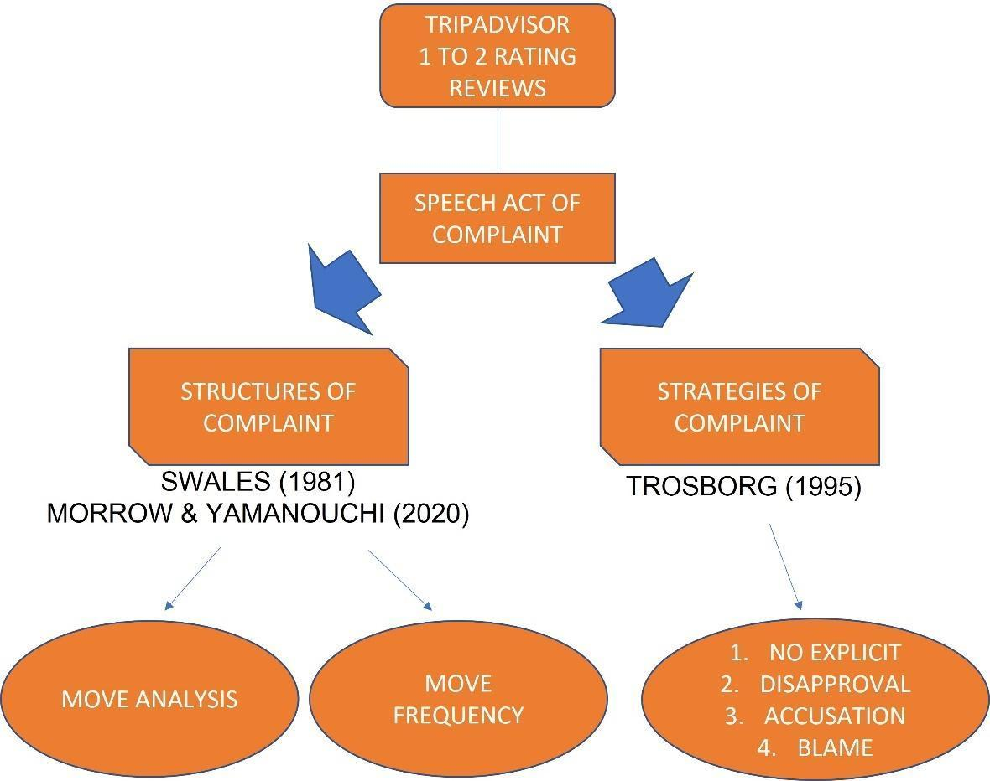
The information used for analysis in this research is derived from negative reviews made on the TripAdvisor.com website by disappointed Japanese and Malaysian hotel guests. Ho (2018) states that hotel guests are believed to be unsatisfied when their rating is one for 'Poor' or two for 'Terrible'. TripAdvisor is an American online travel company and operates a website with user-generated content (Wikipedia). TripAdvisor was selected as the primary data source due to several reasons. Firstly, complaint texts extracted from TripAdvisor were able to furnish a wide range and a huge number of potential samples of biased-free reviews. Liu et al. (2007) assert that TripAdvisor is able to achieve a high level of external validity. Secondly, TripAdvisor also provides 28 language interfaces and indicates the nationalities of the guests who post the reviews on the platform, making the information accessible. Finally, TripAdvisor distributes detailed client reviews of hotels, ranging from "Terrible" (1 star) to "Excellent" (5 stars) and also the review system has options for clients to raise their opinions towards a variety of different hotel attributes, including "Location", "Cleanliness", "Service", and "Value". As a result, despite the fake reviews attack, TripAdvisor has provided the researchers with plenty of data to conduct a multivariate analysis of how guests of different cultural backgrounds and experiences respond to different hotel attributes differently (Gao et al., 2018). As shown in Figure 2, each hotel page on TripAdvisor displays the total reviews from the guests, with the specific 'Traveller Rating' selections. TripAdvisor publishes the reviewer's details, including the date when the writer wrote or posted the comment.
The data sample for this study was collected from TripAdvisor.com. Targeting one of the popular tourist spots in Malaysia, Langkawi Island has been specifically selected as the data collection in this study. Mohd Shariff and Zainol Abidin (2020) state that most tourists come to Langkawi Island to enjoy the island's natural resources and historical sites; the primary reason for these travellers to come to Langkawi Island is to have a simple, relaxed vacation. Furthermore, their findings are congruent with other studies on tourists' motivations to visit tourist destinations (Ndlovu, 2015; Pantouvakis & Patsiouras, 2016). This is most likely owing to the promotion of Langkawi Island as a unique island rich in stories and legends. Even though Langkawi Island is a duty-free destination, tourists do not regard shopping as a primary objective or activity. Kasavan, Mohamed, and Abdul Halim (2019) reported that Langkawi is a Malaysian island off the coast of the northern state of Kedah on the west coast, which was designated as a member of the UNESCO Global Geoparks in June 2007, making it the first Geopark in Malaysia and Southeast Asia, as well as the 52nd in the world. The UNESCO Global Geopark of Langkawi is also a duty-free island that has long been a popular tourist destination for both international and domestic visitors. Langkawi is surrounded by a cluster of small islands. It is one of Malaysia's most popular tourist attractions, offering a tranquil and divine experience for a terrific vacation for both business and pleasure. Langkawi has long been a prospective tourism destination, with early signs of improvement appearing in 1948 and gaining traction in the mid-1980s. With the transformation from a beautiful tropical island used for travelling and agricultural activities to a contemporary island for tourists, the island has developed fast over the previous four decades (Irwana Omar et al., 2014). Furthermore, Langkawi Development Authority (LADA) provided statistical data on the number of total visitor arrivals of 3.6 million in 2014, which increased to 3.9 million in 2019 (Fauzi et al., 2020), which shows Langkawi's popularity as a holiday destination.
As of August 2021, there are 727 properties registered under TripAdvisor.com, which are spread among six sub-districts (such as Kuah, Padang Mat Sirat, Ayer Hangat, Bohor, Ulu Melaka, and Kedawang), with just 146 of the total accommodation comprising hotels and resorts. Thus, the target data is narrowed to only the previous ten years of negative reviews. The complaints indicated as ‘Poor’ and ‘Terrible’ reviews are being recorded. In a study by Li et al. (2017) and Huang et al. (1996), Japanese tourists were found to be more prone than their American counterparts to remain mute and take no action in reaction to poor services. Given the growing number of outbound travellers from Asia in the global tourism business, the difficulty of hotel managers receiving and responding to complaints from dissatisfied Asian tourists is critical. Similarly, in the present study, there were initially very limited Japanese reviewers, comprising 20 'Poor' and 'Terrible' reviews in English. As such, for the purpose of cross-cultural study and comparison, 20 reviews in English by Malaysian travellers were collected as the complaints data text as well.
Fortunately, TripAdvisor has several user-friendly features for various activities, including hotel queries. In addition, optional choices of hotel's status are sorted by 1) Traveller Ranked, 2) Best Values, 3) Price and 4) Distance to the city centre. Therefore, the result of this search is likely to give a list of Traveller Ranked hotels. Again, the term 'hotel' used in this study refers to any accommodation offered on TripAdvisor (e.g., resort, motel, or hostel).

Figure 2

Langkawi Hotels and Places Searching by Traveller Ranked on TripAdvisor

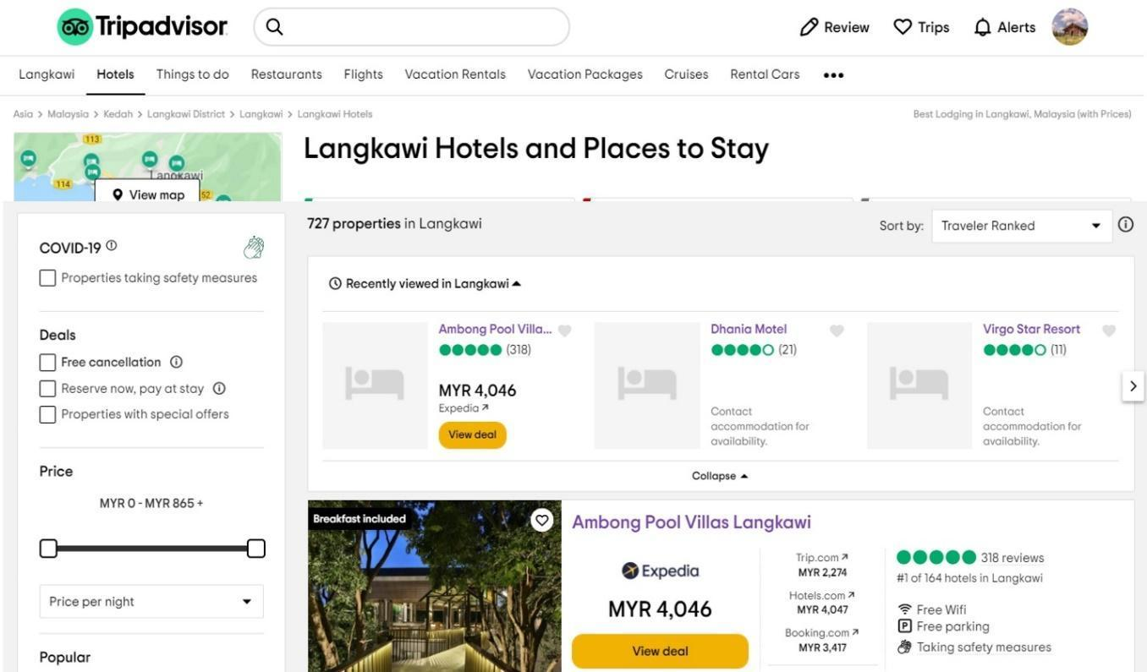
The rating system in the review section is divided into five categories, ranging from excellent to terrible. This study used the terrible and poor section as a data source to ensure that the reviews were complaints from hotel guests. Furthermore, the language chosen was English.
Figure 3
Traveller Rating Section on TripAdvisor

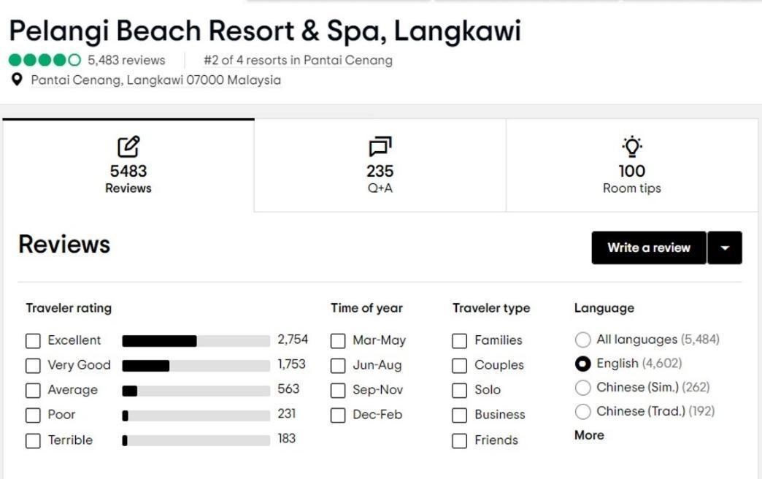

Figure 4
Example of a Customer's Review with a Terrible Rating on TripAdvisor
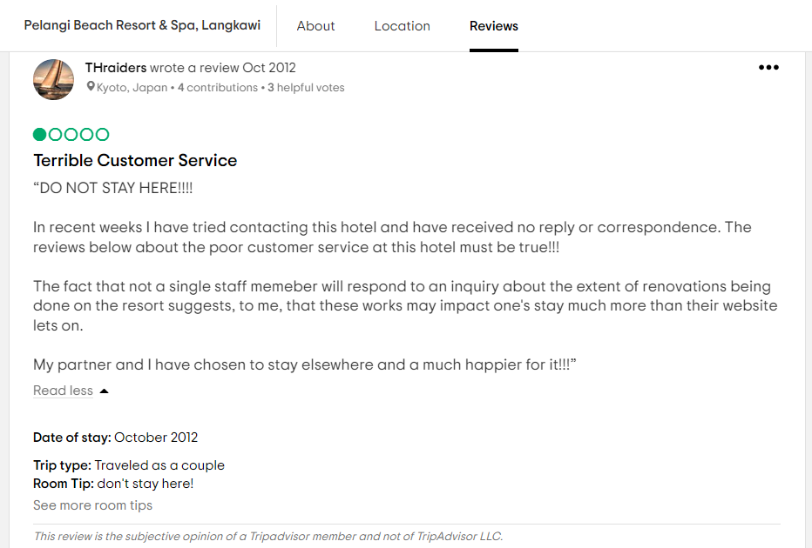

This study adopted Swales's (1981) move to analyse the communicative moves of negative review texts and Morrow and Yamanouchi's (2020) move structure of 'Apologies' to hotel guests as an initial coding technique to determine the frequency of each move and step. The framework gives thorough explanations for motions and phases, which is why this framework was adopted in the present study. Next, to identify the complaint strategies from the data collection, 40 negative reviews were analysed and classified by referring to four major complaint strategies from the framework introduced by Trosborg (1995). However, the sub-strategy was not included in this study.
Due to the subjective nature of manual coding, which involves the researcher's personal opinion, the coding's reliability must be assessed (Biber, Connor, & Upton, 2007). The current study, like many prior top-down move-based studies (Kanoksilapatham, 2005), involved a lecturer who has a PhD as an inter-coder to check the reliability of the moves identified and to assess how well they agree with the coding descriptions and communicative unit identification.

Results and Discussion
This section presents the result based on the research question, 1) What are the communicative moves used by Japanese and Malaysian when they are complaining in the English language? Referring to the Conceptual framework in Figure 1, this study examines the rhetorical structure of complaints. Addressing the first research question, there are six moves indicated, which were adapted from a previous study by Morrow and Yamanouchi (2020), who used Swales' rhetorical move analysis to identify the 'Apologies' and accompanying moves in response to the online complaint on TripAdvisor. As the coding progressed, a new strategy known as Compliment evolved. This action is self-contained and consists of expressing gratitude and validating the hotel's quality. In terms of names and functions, certain stages were tweaked to fit the current study. In addition, the 'Compliment' moves were found in irregular sequences, where both groups of hotel guests mentioned it in the opening part of the text, or in the Explanation move and even at the end of the complaints itself.

Table 1
Moves of Complaints in TripAdvisor
Move | Coding theme
- Opening | Stating reason of stay
- Dissatisfaction | Expressing regret/grievance
- Explanation | Explaining causes of the incident
- Recommendation | Suggestion to hotel/online reviewers
- Closing | Expression of the whole experience during stay
- Compliment | Expressing gratitude

As presented in Table 1, the 40 guests' complaints on TripAdvisor have six categories of communicative moves. The consumers expressed their dissatisfaction due to unfulfilled customer expectations in terms of the products or services that the hotel had promised.

Moves Frequencies
According to the frequency analysis, a total of 141 communicative moves were discovered. The frequency of making a complaint and the frequency and sequencing of the moves that accompanied them were revealed using move analysis.

Table 2
Frequency of moves from 40 negative reviews

Moves | Frequencies
 | Percentage | Total (40) | Japanese | Malaysian
- Opening (M1) | 27.5% | 11 | 3 | 8
- Dissatisfaction(M2) | 100% | 40 | 20 | 20
- Explanation (M3) | 92.5% | 37 | 17 | 20
- Recommendation (M4) | 35.0% | 14 | 5 | 9
- Closing (M5) | 45.0% | 18 | 10 | 8
- Compliment (M6) | 52.5% | 21 | 12 | 9

Table 2 above shows the frequency of moves and the number of texts in which each move was identified. Most of the reviews (20 Japanese and 20 Malaysians) contained the 'Dissatisfaction' move, followed by the 'Explanation move'. Although not all the guests would elaborate on the details of their complaints, some put in details such as the reasons they expressed their grievances and the details of the incidents that happened to them. Surprisingly, the third most frequent move revealed from the results was the 'Compliment move' with 52.5%. As shown in the findings, nearly all the complaints contained some positive comments, which are 'Compliment' moves and 'applauds' apart from the frustration messages.

Moves Analysis
This study's rhetorical move analysis of the 40 online complaints revealed six communicative moves.
Move 1: Opening of the Complaint
In general, delivering a good complaint text requires making the aim of the whole statement apparent from the start. However, the complaint messages in this study contradict a study by Thumvichit and Grampper (2019). Without proper salutation and greeting at the beginning of the reviews, most of them started the negative post by mentioning their purpose of stay or the reason why they chose the hotel.
Excerpt 1: Japanese Reviewers
a. | “One of the many reasons we wanted to visit the Langkawi Island was so that we could go snorkelling in Payar Island." | <JP6>
b. | “We booked three rooms at this hotel for New Year’s Eve.” | <JP7>
c. | “I stayed at this hotel on company business thus shouldn't be complaining, but had I had a choice, I would've checked out in less than an hour.” | <JP15>

Excerpt 2: Malaysian Reviewers
a. | “We stayed here because our friends were getting married here.” | <MY6>
b. | “We book a few rooms to celebrate the new year with friends, got bad experience with the services over there!” | <MY16>
c. | “…I stopped by to take a look at The Datai Langkawi after hearing so much of its great stories from friends and over the internet” | <MY20>

As per underlined in the statements above, for example, the guests from Japan <JP6> had clearly mentioned that they visited Langkawi Island and stayed in the hotel because they wanted to go snorkelling at Payar Island. Similarly, Malaysian reviewer <MY6> decided to stay at the hotel to attend their friend’s wedding.

Move 2: Dissatisfaction

This move is employed to unhappy clients expressing disappointment towards the hotel. All reviewers clearly stated their complaints with feelings and including regretful expressions, such as in the examples in Excerpts 3 and 4 below. Acknowledged, dissatisfaction with tourist services can be driven by negative emotions like anger and remorse (Sánchez-Garca & Currás-Pérez, 2011). It can lead to undesirable outcomes like complaining and unfavourable electronic word-of-mouth communication (Cheng et al., 2005). The underlined adjectives or phrases express the intensity of their feelings of dissatisfaction.

Excerpt 3: Japanese Reviewers
a. | “We were not seated until 920pm having arrived at 8pm we were pretty annoyed. … to our surprise the staff had let himself in to check the bar fridge??No call warning nothing, we could have been in the shower etc. Extremely unprofessional!!.” | <JP7>
b. | “Maybe we were expecting little too much as it's a new hotel, but still, this hotel made us disappointed so much, especially because of its poor service.” | <JP13>
c. | “Terrible service from the staff in reception and restaurant” | <JP17>

Excerpt 4: Malaysian Reviewers
a. | "I’ve stayed in this resort many a times being in the aviation industry but never been treated with such invasion of privacy and sleep deprivation” | <MY5>
b. | “…such a disappointing stay and we will never ever took this hotel such a waste of money” | <MY11>
c. | “We are really angry and because how they can ask us to wait in the quite environment and no light at all for 30minutes. ..this hotel is seriously bad and scary.” | <MY17>

The examples above with terrible and poor ratings shared on TripAdvisor consist of annoyance and bad evaluation phrases; annoyed, unprofessional, disappointed, terrible service, angry, seriously bad and scary. As such, the determinants of customer dissatisfaction are more specific with multi factors (e.g., poor services, facilities, noise, etc.).

Move 3: Explanation
In relation to expressing their frustration, most of the reviewers elaborated on the details of their experience in the next move, which was labelled as 'Explanation'. This move may be noticed when the guests tried to explain why a particular event had happened. In other words, the reviewers elucidated the occurrence by bringing forth facts and/or proof. This might be as straightforward as simply saying what occurred. The customers may also present a different side of the incident to show the hotel's management that the incident has a justification.

Excerpt 5: Japanese Reviewers
a. | “There were other tables open the whole time that they could have seated us at after all this is a five-star hotel. When we were seated they were still putting out the cutlery and unprepared.” | <JP7>
b. | “…we arrived, security box in our room was already locked so could not be used. We asked for clean our room the second day when we are going out, when we come back, we found the room was exactly the same as we left it.” | <JP13>
c. | “Room was dirty and noisy. Woken up staff playing radio on in the corridor right outside my room” | <JP17>

Excerpt 6: Malaysian Reviewers
a. | “This experience made me feel totally unwelcome. My friend who stayed with me was totally dismayed. He said this was the first such incident coming from a five-star facility.” | <MY5>
b. | “…we checked in around 2:40, was directed to a room playground? Looks like a dungeon, the hallway was filled with moulded carpets, and it stinks.” | <MY11>
c. | “The hotel was looks old and the linens have bed bugs. It is not clean at all. There is no apology from the receptionist | <MY17>

Excerpts 5 & 6 reviews explain the disappointment mentioned earlier in Excerpts 3 & 4. In relation to the 'Dissatisfaction' move mentioned earlier, for example, "…such a disappointing stay and we will never ever take this hotel such a waste of money”, is further very well explained with messages such as, “…we checked in around 2:40, was directed to a room playground? Looks like a dungeon, the hallway was filled with moulded carpets, and it stinks.” In short, the explanation move provides more explanation or elaboration of the hotel guests' dissatisfaction, not just merely stating the dissatisfaction.

Move 4: Recommendation
This move is intended to express gratitude for a variety of acts relating to hotel guests' stay, which do not only describe past experiences but are in some way future-oriented. This gesture may be further classified into two targets of suggestion as shown in the instances below: advice to the hotel owners or staff for better improvement in future (1), and a sharing to other tourists or targets to be aware of the unexpecting (2).

Excerpt 7: Japanese Reviewers
a. | “I think the hotel needs some kind of cleaning overhaul, and staff need some better training in customer service, front desk hardly ever smiled, and housekeeping slow to respond to our phone calls” | <JP3>
b. | “…would suggest to go look for alternatives hotels for the price offered.” | <JP15>
c. | “Avoid this place if you can as there much better options available.” | <JP17>

Excerpt 8: Malaysian Reviewers
a. | “The property should consider growing plants that drive away mosquitoes in their balconies.” | <MY2>
b. | “The staff and management have to be strict in enforcing the S.O.P.s, and gently remind guests to wear masks when going up to the buffet counters.” | <MY8>
c. | “This review is to prevent future guests to experience same bad experience and be more careful when reading description, not only 1st best review for Langkawi hotel, which is really false!!!!” | <MY10>

Based on the examples above, the first type of recommendation from reviewers is the messages from <JP3>, <MY2>, and <MY8>. Meanwhile, the example messages from reviewers <JP15>, <JP17>, and <MY10> are the second type of intention, which is to share their experiences with their peer travellers purposely.

Move 5: Closing Statement
The last move type to appear in 18 out of 40 complaints is a 'Closing' move. Among the 18 reviewers, what was included in this move were their feelings toward their experiences during the stay. Although this is a closing part of the review, it is unlike other closing pleasantries, which has the usual distinction of a specific ending, such as a personal signature, name, or title.

Excerpt 9: Japanese Reviewers
a. | “No value for money at all” | <JP1>
b. | “I will never, NEVER go back to this hotel again, the price is way too high for its poor service and quality of the hotel.” | <JP13>
c. | “I would not go back to this property and probably even to Langkawi in general.” | <JP14>

Excerpt 10: Malaysian Reviewers
a. | “Never again, Datai, even if your rooms look tempting.” | <MY1>
b. | “…we found the experience overall just too inconsistent to warrant those sort of prices at a five-star resort.” | <MY6>
c. | “I have been to Langkawi for more than 20 times and this is the worst hotel I have ever stayed in. It’s worst than all of the chalets and budget hotel which I have stayed in before.” | <MY15>

Most reviewers stated their conclusion of the unpleasant stay in this Closing move. For example, the above Excerpt 9 and Excerpt 10 clearly show how they are really disappointed. Some reviewers even mentioned (by reviewers <JP14> and <MY1>) that they would not return to that place after experiencing what they had during their stay.

Move 6: Compliment
In the present study, a new move was identified, and it was named a 'Compliment' move. Most negative comments included one or more positive words besides the complaints. Several showed a contrasting unfavourable experience with some good points and appreciation. In the present study, the 'Compliment' move was found at the beginning of the complaint, in the middle of the message and even as part of closing the negative review.

Excerpt 11: Japanese Reviewers
a. | “Pelangi Beach resort is ok, everyone is very polite, but the service is lacking. The best part of the resort for us, the pool.” | <JP5>
b. | “The location and the view were great and beautiful. I believe it was a wonderful place to just relax. The hotel itself was not modern yet the maintenance around the water was well done and the gardens were nicely organised at a daily basis” | <JP6>
c. | “One great point; hotel staff is very friendly and willing to help you” | <JP9>

Excerpt 12: Malaysian Reviewers
a. | “Let me begin with the positives: newly refurbished room, beachfront property, close to Underwater World (5minute drive).” | <MY2>
b. | “We were quite impressed by this! The grounds staff are super diligent about keeping all the pathways pristine. The beach and the water are super well kept and lovely.” | <MY6>
c. | “Beautiful resort on its own private island. Luxurious room, especially the spacious bathroom. Great view. Friendly, helpful staff. And great Asian dishes.” | <MY8>

As shown in the excerpt above, reviewer <MY2> gave a compliment at the beginning of the comment before stating his/her complaint, similar to the review by <JP6> in Excerpt 11 and Excerpt 12 as well. However, reviewer <JP5> states the compliment at the end of the comment as an overall review wrap-up.

This section presents the result based on the research question; 2) What are their strategies to convey the frustration in the complaint?

To investigate the type of strategies employed when lodging complaints, a theoretical framework by Trosborg (1995) was adopted. As presented in Chapter 2, Trosborg (1995) divided complaint types into four categories. (1) No Explicit Reproach; (2) Annoyance or Disapproval Expression; (3) Accusation; and (4) Blame. Trosborg (1995) then allocated the four types of complaints into eight sub-categories, which she referred to as strategies.

Certain people are exceptionally good at filing complaints. They appear to know intuitively how to present their situation, what to say, and what to do to obtain apologies, refunds, or other satisfying results. Meanwhile, others find that they wind up yelling their frustrations without any strategies. Therefore, it is important to highlight in this section that strategy is essential to make a complaint more effective and convey a message successfully to the other party.
In a complaint scenario, the complainer can either opt-out and not address and face the complainee or pick from a variety of complaint strategies that differ in terms of linguistic (in)directness, i.e., explicitness and implicitness. The presence or absence of either an explicit reference to the speech act (e.g., performative verb/noun) or an explicit reference to (one or more of) the constitutive component(s) of the speech act situation can be used to make the criteria for linguistic (in)directness concrete and operational for data analysis. Table 3 presents the complaint strategies employed by hotel guests of both cultural groups.

Table 3
Strategy of Complaints

Strategy of Complaints | Number of Data |  | Percentage
 | Japanese | Malaysian
No Explicit Reproach | 6 | 5 | 27.5
Disapproval Expression | 8 | 6 | 35.0
Accusation | 2 | 7 | 22.5
Blame | 4 | 2 | 15.0
Total | 40 |  | 100%

Based on the outcome in Table 3, all four strategies by Trosborg (1995) were found in the present study. 'Disapproval Expression', one of the strategy types indicated in Table 4, is the most commonly occurring strategy in Japanese complaints. Meanwhile, Malaysian reviewers used 'Accusation' strategy the most in their complaints, in contrast to only two Japanese reviewers who employed it. However, the least strategy used by Malaysian guests was 'Blame' strategy, which was only by two reviewers.

4.5.1 Category 1: No Explicit Reproach
Hints are a sub-category of this category. A speaker uses it to make indirect grievances to a complainee. It might be used to handle minor complaints, as a technique to prepare for more serious complaints, or as a stand-alone strategy. Considering the complaint to be realised off-record, as a hint, so in a fully implicit way, when there is no explicit reference to the speech act (through a verb or noun that names the speech act) and when all four constitutive components of the complaint situation are implicated; only the context, i.e., the complaint situation, gives clues as to the fact that a complaint is being performed. Only the subsequent complaints to the hotels in the following sample from the TripAdvisor corpus allows to classify this message as a complaint rather than a neutral request for information:

(1) | “The resort itself is huge and on the "paper" one might find it to have everything one needs for the perfect vacation, but it is not the case in real life” | <JP1>
(2) | “One night could have been enough for me, given the following conditions of this hotel.” | <JP9>
(3) | “Although this is the second time to stay, bad change of this hotel made us disappointing strongly.” | <JP10>
(4) | “The place lacks warm hospitality (probably because we are locals).” | <MY7>
(5) | “Totally not worth it if want to choose the biggest suite.” | <MY9>
(6) | “…not recommended to stay for the price paid.” | <MY14>

The above examples likewise illustrated the category of no explicit reproach. The samples express some dissatisfaction, and it is implied because the offending scenario is not addressed in this complaint.
4.5.2 Category 2: Disapproval
This category is used to indicate a complainer's disapproval of a complainee's behaviour. It consists of two strategies: irritation and ill consequences. Below are examples from the data collection representing the Disapproval strategy in these findings.

(7) | “During breakfast, our table was given away to other guests whilst we were at the buffet getting our food, this happened twice. Unacceptable” | <JP3>
(8) | “The fact that not a single staff member will respond to an inquiry about the extent of renovations being done on the resort suggests, to me, that these works may impact one’s stay much more than their website lets on.” | <JP4>
(9) | “There was nobody to help us collect our belongings from the flooded room and carry the over to the new one. Treading through waste matter, on the first day of your holiday isn’t quite what one expects” | <JP5>
(10) | “The pool attendant. He was rude and downright lazy.” | <MY3>
(11) | “After spending less than one day there, I checked out (two days early, the staff were that unhelpful and rude) and demanded a full refund.” | <MY12>
(12) | “The recent trip, we stayed together with 3 cockroaches which I was killed and to our amazement, housekeeping never cleared it till the day we checked out (4D3) | <MY13>

Each text example above shows how the guests made complaints regarding the behaviour of the hotel's staff. From the total strategies, both groups applied the Accusation strategy to convey their disappointment, as shown in Table 3, whereby 35% was recorded from all of the complaints.
4.5.3 Category 3: Accusation
This category includes two strategies, namely direct (1) and indirect (2). Both of them are trying to communicate certain complaint signals in distinct ways. Direct charges are typically unambiguous, but indirect allegations are unclear. Furthermore, these allegations may consider the complainers' and complainees' ties.

(13) | “The following morning my roommate and I were sitting on the balcony enjoying the morning when we heard a tap on the glass door, to our surprise the staff had let himself in to check the bar fridge??” | <JP7>
(14) | “Several things that disappointed me about this hotel. Would I stay again? Hmmmm probably not” | <JP19>
(15) | “Don't they have any policies in place that do not allow staff of disturbing sleeping guests very early in the morning especially being a 5star resort?” | <MY5>
(16) | “We checked in around 2:40, was directed to a room underground? … What made us so upset is why are we provided a room that is worse than a prison and we had to make a fuss to get a better room?” | <MY11>
(17) | “That really piss me off, so I mention to them: are you asking me to sleep on the bed full of ants?” | <MY16>
(18) | “Can you guys imagine; I was stay here before and at night the whole rooms suddenly blackout and it is scary as in the middle of jungle environment and blackout.” | <MY17>

This strategy is the most used by Malaysian guests, compared to the Japanese, as shown in Table 3, with seven complaints by a Malaysian.

4.5.4 Category 4: Blame
This is the most advanced degree of complaint strategy. The reviewers express their dissatisfaction bluntly and angrily, and they may utilise face-threatening gestures. Modified blame, explicit blame (behaviour) for accusing a harmful deed, and explicit blame (person) for blaming an irresponsible person are the three tactics utilised here.

(19) | “I BOOKED a room and PAID all amounts @Booking.com. I tried check in from 2pm. they said to me "I couldn't find your booking; we are already FULL ROOM! GO AWAY! go another place!!" They NEVER REFUND MONEY.” | <JP11>
(20) | “I will never, NEVER go back to this hotel again, the price is way too high for its poor service and quality of the hotel.” | <JP13>
(21) | “I wouldn’t checked out in less than an hour. The rooms are filthy and small, television not even worth the space taken in the room, and worst of all location.” | <JP15>
(22) | “The manager yelled at me and accused me of calling her a liar, saying I could sue them if I thought they were lying. It was the worst check-in experience of my life.” | <JP20>
(23) | “The breakfast is a shame! I have NEVER been to a hotel whereby the person in-charge of the eggs counter is LATE for breakfast!” | <MY15>
(24) | “I have asking the reception assistance to contact Expedia to check the status since they couldn’t find my booking; but I got back a response is I SHOULD CALL BY MYSELF!!! POOR CUSTOMER SERVICE. Why would I call if I have a valid booing with a confirmation number and the correct arrival date???” | <MY19>

Although Malaysian reviewers applied the smallest amount of Blame strategy, most expressed anger by using capital letters and punctuation marks to highlight their frustrations.

The results of this study showed that there are six moves identified and classified as: 1) Opening, 2) Dissatisfaction, 3) Explanation, 4) Recommendation, 5) Closing, and 6) Compliment. The moves showed that the online complaint, especially on TripAdvisor does not have a proper sequence structure, unlike letters or emails with proper sequences of moves and structures. Both groups applied all six moves in their online complaints, although most began without a proper opening, such as greetings and salutations. Instead, they mentioned the reason for choosing the hotel. In addition, most of the Closing moves were concluded with their unhappy feelings and opinions. Surprisingly, the Compliment move was identified among the bad reviews in which the guests also appraised the hotels even though they evaluated the provided poor or terrible ratings on TripAdvisor.

The findings also revealed that to convey the frustration in their complaints, four strategies were employed. As presented by Trosborg (1995), this study confirmed that both traveller groups applied four strategies. The strategies used in the present study consist of 1) No Explicit Reproach, 2) Disapproval Expression, 3) Accusation, and 4) Blame. However, Japanese travellers used fewer Accusation strategies, with only 2 negative reviews compared to 7 reviews by Malaysian travellers. Moreover, only 2 Malaysian guests used the Blame strategy in their complaints. However, 4 Japanese guests employed it.

In short, the results showed similarities in strategy selection but differences in complaint categories, complaint moves, and linguistic expressions for the same offences between the two groups.

Conclusion

To sum up, this research reacts to the growing interest in speech acts of complaints to the hospitality industry as a genre and the rise of computer-mediated contact between hotels and consumers via social media platforms, especially TripAdvisor. The current study examined the differences between two groups of cultural backgrounds whose cultures may have influenced the way guests complained to the hotel management as a cross-cultural study into the genre, which was beyond the scope of previous studies. This research goes beyond typical genre analysis, focusing on communicative moves and complaint strategies.
The 40 collected complaints on TripAdvisor identified six moves, based on Morrow and Yamanouchi's (2020) move analysis. The study also discovered that complaints commonly happened as part of a wider speech act set and that (perhaps unsurprisingly) complaints tended to co-occur more frequently with advice and recommendations rather than with other forms of speech acts like warnings or threats in this context. In other words, Japanese and Malaysian guests intended to begin the negative reviews about why they had selected the accommodation. Moreover, the complaints' closure ended with expressing their feelings toward the whole experience during their visit to the place. In contrast, the 'Opening' and 'Closing' moves by Taw et al. (2021) comprise salutation and greeting as two sub-moves in the 'Opening' move structure. However, four sub-moves described in the 'Closing' move structure were complimenting closure, name, job title, and affiliation. This implies that Japanese guests most likely posted a simple message of annoyance without further jurisdiction and details of the incident. In comparison, Malaysian travellers revealed more reasons for irritation in the 'Explanation' move.
As for the complaint strategies, four main categories described by Trosborg (1995) were classified in this study. Disapproval Expression of the strategies type is the most commonly occurring feature in Japanese complaints. Meanwhile, Malaysian reviewers used Accusation strategy the most in their complaints. In contrast, only two Japanese reviewers used the Accusation; however, the least strategy used by Malaysian guests was a Blame category, which was used only by 2 reviewers.

Implications
Labelling the characteristics of the complaint speech act will benefit both non-native language learners since it will help them not only to express complaints in line with the target culture's norms and values but also to understand this speech act correctly. Non-native English speakers who lack precise understanding in this area will not be able to apply the complaint tactics' socio-cultural competency effectively. As a result, English language learners should be able to focus their lessons on the similarities and differences between English, Japanese and Malay language complaints. As such, the learners, especially the hotel management team, would quickly gain socio-cultural competency after being exposed to the target culture. Knowing cross-cultural similarities and differences in a speech act helps the community to understand how pragmatic cultures work in other cultures. However, it also encourages them to avoid possible intercultural miscommunication due to different pragmatic norms. Furthermore, it can be included in the teaching programme in a way that can be useful for intercultural communication while conducting negotiations and understanding the messages in English. It is believed that using complaints properly as part of sociocultural competency can help to repair an offensive situation, prevent verbal conflict, and develop a cooperative and solidarity relationship between interlocutors in cross-cultural conversations. Although complaining has a negative perception, as Boxer (1993) pointed out, certain complaints are frequently negotiable and serve to strengthen interlocutors' mutual solidarity.
The conclusions of this study would provide a valuable foundation for further theoretical development of online complaint management solutions, given the little research published on communicative moves in negative reviews by Japanese and Malaysian guests on TripAdvisor. According to these findings, complaints may differ depending on a traveller's cultural background. This means that it could influence tourists' complementing behaviour, which is another subject worth investigating further. It is just as vital to know what makes them happy as it is to know what makes them unhappy. The hotel management team could identify the issues from negative reviews and utilise the information to help reduce difficult situations in cross-cultural perceptions.

Limitations and Recommendations
There are a few limitations to this study that might be investigated further in future research. The data for this study comes from evaluations of hotels in a single city from a single platform, and the data only involves data from the mid of 2021. Future research can collect multiple recent data of hotels in various areas from various channels to generalise the results. This study may be expanded with a bigger sample size by focusing on other areas or/and famous tourist attraction spots in Malaysia. This study might also include a complaint link with a potential guest's intent to revisit with a response from the hotel. In addition, cross-cultural linguistics may be used for future research to acquire perspectives from other languages based on nativity. The reviewer might employ a mixture of tactics to complain while executing a speech act of complaint.

References

Al-Khawaldeh, N. (2016). A Pragmatic Cross-Cultural Study of Complaints Expressions in Jordan and England, International Journal of Applied Linguistics & English Literature, 5(5), 197–207, http://dx.doi.org/10.7575/aiac.ijalel.v.5n.5p.197
Alrawadieh, Z. and Law, R. (2018). Determinants of hotel guests’ satisfaction from the perspective of online hotel reviewers, International Journal of Culture, Tourism and Hospitality Research, 13(1), 84–97. https://doi.org/10.1108/IJCTHR-08-2018-0104
Anderson, R.E. (1973). Consumer dissatisfaction: The effect of disconfirmed expectancy on perceived product performance, Journal of Marketing Research, 10 (1), 38–44, https://doi.org/10.1177/002224377301000106
Armstrong, R.W., Mok, C., Go, F. M., Chan, A. (1997). The importance of cross-cultural expectations in the measurement of service quality perceptions in the hotel industry. 16(2), 0–190. doi:10.1016/s0278-4319(97)00004-2
Au, N., Buhalis, D., Law, R. (2014). Online Complaining Behavior in Mainland China Hotels: The Perception of Chinese and Non-Chinese Customers. International Journal of Hospitality & Tourism Administration, 15(3), 248–274. doi:10.1080/15256480.2014.925722
Austin, T. (1998). Cross-cultural Pragmatics-Building in Analysis of Communication Across Cultures and Languages: Examples from Japanese1. Foreign Language Annals, 31(3), 326–346. doi:10.1111/j.1944-9720.1998.tb00580.x
Ayeh, J.K., Au, N., Law, R., (2016). Investigating cross-national heterogeneity in the adoption of online hotel reviews. International Journal of Hospitality Management, 55, 142–153, https://doi.org/10.1016/j.ijhm.2016.04.003
Berezina, K., Bilgihan, A., Cobanoglu, C., Okumus, F. (2016). Understanding satisfied and dissatisfied hotel customers: Text mining of online hotel reviews, Journal of Hospitality Marketing & Management, 25(1), 1–24, https://doi.org/10.1080/19368623.2015.983631
Boxer, D. (1993). Complaints as positive strategies: What the learner needs to know, Tesol Quarterly, 27(2), 277–299, https://doi.org/10.2307/3587147
Cenni, I., Goethals, P. (2017). Negative hotel reviews on TripAdvisor: A cross-linguistic analysis. Discourse, Context & Media, 16(), 22–30. https://doi.org/10.1016/j.dcm.2017.01.004
Cenni, I., Goethals, P. (2020). Responding to negative hotel reviews: A cross-linguistic perspective on online rapport-management. Discourse, Context & Media, 37(), 100430–. https://doi.org/10.1016/j.dcm.2020.100430
Chemmel, U., & Phillipe, R. (2018). The role of pragmatics in cross-cultural. Linguistics and Culture Review,2(1), 45-59. https://doi.org/10.37028/lingcure.v2n1.11
Cheng, S., Lam, T., Hsu, C.H.C. (2005). Testing the sufficiency of the theory of planned behaviour: a case of customer dissatisfaction, responses in restaurants, International Journal of Hospitality Management, 24, 475–492, https://doi.org/10.1016/j.ijhm.2004.10.006
Decock, S., Depraetere, I. (2018). (In)directness and complaints: A reassessment, Journal of Pragmatics, 132, 33-46, https://doi.org/10.1016/j.pragma.2018.04.010.
Fauzi, N. F., Ahmadi, N. S., Shafii, N. H., Ab. Halim, H. Z. (2020). A Comparison Study on Fuzzy Time Series and Holt-Winter Model in Forecasting Tourist Arrival in Langkawi, Kedah, Journal of Computing Research and Innovation (JCRINN), 5(1), 31–43, https://ir.uitm.edu.my/id/eprint/43553/1/43553.pdf
Ferguson, J.L., Johnston, W.J. (2011). Customer response to dissatisfaction: A synthesis of literature and conceptual framework Industrial Marketing Management, 40 (1) 118–127, https://doi.org/10.1016/j.indmarman.2010.05.002
Gao, B., Li, X., Liu, S., & Fang, D. (2018). How power distance affects online hotel ratings: The positive moderating roles of hotel chain and reviewers’ travel experience. Tourism Management, 65, 176–186, https://doi.org/10.1016/j.tourman.2017.10.007
Gudeman, R. H. (2002). Multiculturalism in Malaysia: Individual Harmony, Group Tension, Macalester International, 12(16), 138–160, https://digitalcommons.macalester.edu/macintl/vol12/iss1/16
He, H., Harris, L. (2014) Moral disengagement of hotel guest negative W.O.M.: Moral identity centrality, moral awareness, and anger, Annals of Tourism Research, 45, 132-151, https://doi.org/10.1016/j.annals.2013.10.002
Heinonen, K. and Medberg, G. (2018). Netnography as a tool for understanding customers: implications for service research and practice, Journal of Services Marketing, 32(6), 657–679. https://doi.org/10.1108/JSM-08-2017-0294
Ho, V. (2018). Exploring the effectiveness of hotel management's responses to negative online comments, Lingua, 216, 47–63, https://doi.org/10.1016/j.lingua.2018.10.004
House, J., Kasper, G. (2011). Politeness Markers in English and German. In F. Coulmas (Ed.), Volume 2 Conversational Routine (pp. 157-186). Berlin, New York: De Gruyter Mouton. https://doi.org/10.1515/9783110809145.157
Hsieh, A.T., Tsai, C.W. (2009). Does national culture really matter? Hotel service perceptions by Taiwan and American tourists. International Journal of Culture, Tourism and Hospitality Research, 3(1), 54–69. https://doi.org/10.1108/17506180910940342
Hu, N., Zhang, T., Gao, B., Bose, I. (2019). What do hotel customers complain about? Text analysis using structural topic model, Tourism Management, pp. 72, 417–426, https://doi.org/10.1016/j.tourman.2019.01.002.
Hu, Y. H., Chen, Y. L., Chou, H. L., (2017). Opinion mining from online hotel reviews – A text summarisation approach. Information Processing & Management, 53(2), 436–449. https://doi.org 10.1016/j.ipm.2016.12.002
Irwana Omar, S., Ghapar Othman, A., & Mohamed, B. (2014). The tourism life cycle: An overview of Langkawi Island, Malaysia. International Journal of Culture, Tourism, and Hospitality Research. 8(3), 272–289. https://doi.org/10.1108/IJCTHR-09-2013-0069
Istanbulluoglu, D. (2017). Complaint handling on social media: The impact of multiple response times on consumer satisfaction. Computers in Human Behavior, 74(), 72–82. https://doi.org/10.1016/j.chb.2017.04.016
Jeacle, I., Carter, C. (2011). In TripAdvisor we trust: Rankings, calculative regimes and abstract systems, Accounting Organizations and Society, 36(4), 293–309, DOI: 10.1016/j.aos.2011.04.002
Kasavan, S., Mohamed, A. F., Abdul Halim, S (2019). Drivers of food waste generation: Case study of island-based hotels in Langkawi, Malaysia. Waste Management, 91(), 72–79. doi:10.1016/j.wasman.2019.04.055
Kanoksilapatham, B. (2005). Rhetorical structure of biochemistry research articles. English for Specific Purposes, 24(3), 269–292. doi:10.1016/j.esp.2004.08.003
Kuo, C. M. (2009). The managerial implications of an analysis of tourist profiles and international hotel employee service attitude, International Journal of Hospitality Management, 28(3), 0–309. doi:10.1016/j.ijhm.2008.10.003
Li, P., S. Zheng, et al. (2006). Factors that influence the severity of Chinese and American University Students. Foreign language Teaching and Research, 38(1), 56-60
Liu. Y., Teichert. T., Rossi. M., Li. H., Hu. F. (2017). Big data for big insights: Investigating language-specific drivers of hotel satisfaction with 412,784 user-generated reviews, Tourism Management, 59, 554–563. https://doi.org/10.1016/j.tourman.2016.08.012
Mate. M.J., Trupp. A., Pratt. S. (2019) Managing negative online accommodation reviews: evidence from the Cook Islands, Journal of Travel & Tourism Marketing, 36(5), 627–644, https://doi.org/10.1080/10548408.2019.1612823
Mattila, A.S., Choi, S. (2006). A cross-cultural comparison of perceived fairness and satisfaction in the context of hotel room pricing. International Journal of Hospitality Management, 25(1), 146-153, https://doi.org/10.1016/j.ijhm.2004.12.003
McConachy, T., Spencer-Oatey, H. (2021). Cross-Cultural and Intercultural Pragmatics. In M. Haugh, D. Kádár, & M. Terkourafi (Eds.), The Cambridge Handbook of Sociopragmatics Cambridge: Cambridge University Press, 733–757, doi:10.1017/9781108954105.037

Meier, A.J. (2010). Culture and its effect on speech act performance. In Martinez-Flor, A. and Uso-Juan, E. (Eds). Speech Act Performance: Theoretical, Empirical and Methodological Issue. Amsterdam: John Benjamins, 75-90,
Mey, L.P., Akbar, A.K., Fie, D.Y.G. (2006). Measuring Service Quality and Customer Satisfaction of the Hotels in Malaysia: Malaysian, Asian and Non-Asian Hotel Guests. Journal of Hospitality and Tourism Management, 13(2), 144–160, https://doi.org/10.1375/jhtm.13.2.144
Mustafa, H., Ahmed, F., Zainol, W. W., & Mat Enh, A. (2021). Forecasting the Impact of Gross Domestic Product (G.D.P.) on International Tourist Arrivals to Langkawi, Malaysia: A PostCOVID-19 Future. Sustainability, 13(23), 13372.
Mohd Shariff, N., Zainol Abidin, A. (2020). TOURISTS’ PERCEPTIONS OF LANGKAWI ISLAND AS A WORLD TOURISM DESTINATION. GeoJournal of Tourism and Geosites, 32(4), 1264–1269. https://doi.org/10.30892/gtg.32411-567
Morrow. P. R., Yamanouchi. K. (2020). Online apologies to hotel guests in English and Japanese, Discourse, Context & Media, 34, https://doi.org/10.1016/j.dcm.2020.100379.
Ngai, E.W.T., Heung, V.C.S., Wong, Y.H., Chan, F.K.Y. (2007). Consumer complaint behaviour of Asians and non‐Asians about hotel services: An empirical analysis. European Journal of Marketing, 41(11/12), 1375–1391, https://doi.org/10.1108/03090560710821224
Öğüt, H., Onur Tas. K. B. (2012). The influence of internet customer reviews on the online sales and prices in hotel industry. The Service Industries Journal, 32(2), 197–214. https://doi.org/10.1080/02642069.2010.529436
Olshtain, E. & L. Weinbach (1987). Complaints: A study of speech act behaviour among native and non-native speakers of Hebrew. The pragmatic perspective: selected papers from the 1985 International Pragmatics Conference, 5, 195-208, https://www.jbe-platform.com/content/books/9789027286253-pbcs.5.15ols
Rhurakvit, M. (2012). Complaints in Thai and English: an interlanguage pragmatic study. Queen Mary University of London. (Thesis). http://qmro.qmul.ac.uk/xmlui/handle/123456789/3150
Rinnert, C., Nogami, Y., Iwai, C. (2006). Preferred complaint strategies in Japanese and English, Authentic Communication: Proceedings of the 5th Annual JALT Pan-SIG Conference,32–47. https://hosted.jalt.org/pansig/2006/HTML/RNI.htm
Sánchez-García, I., Currás-Pérez, R. (2011). Effects of dissatisfaction in tourist services: the role of anger and regret, Tourism Management, 32, 1397–1406, https://doi.org/10.1016/j.tourman.2011.01.016
Sann. R., Lai. P. C., Chang. H. C. (2020). Does Culture of Origin Have an Impact on Online Complaining Behaviors? The Perceptions of Asians and Non-Asians. Sustainability. 12(5), https://doi.org/10.3390/su12051838
Sann, R., Lai, P. C., Liaw, S. Y. (2020). Online complaining behaviour: Does cultural background and hotel class matter? Journal of Hospitality and Tourism Management, 43(), 80-90. https://doi.org/10.1016/j.jhtm.2020.02.004
Schaefer, E. (1982). An analysis of the discourse and syntax of oral complaints in English (Master’s thesis, University of California, Los Angeles, California, U.S.A.).
Schuckert, M., Liu, X., Law, R., (2015). A segmentation of online reviews by language groups: How English and non-English speakers rate hotels differently. International Journal of Hospitality Management, 48, 143–149, https://doi.org/10.1016/j.ijhm.2014.12.007
Singh. J., Crisafulli. B. (2016). Managing online service recovery: procedures, justice and customer satisfaction, Journal of Service Theory and Practice, 26(6), 764–787. https://doi.org/10.1108/JSTP-01-2015-0013
Stadler, S. (2018). Cross-Cultural Pragmatics, The Encyclopedia of Applied Linguistics, 1–8, https://doi.org/10.1002/9781405198431.wbeal0289.pub2
Stevens. J. L., Spaid, B. I., Breazeale, M., Jones, C. L. E. (2018). Timeliness, transparency, and trust: A framework for managing online customer complaints, Business Horizons, 61(3), 375–384. https://doi.org/10.1016/j.bushor.2018.01.007.
Swales, J. M. (1990). Genre analysis: English in academic and research settings. Cambridge, Cambridge University Press. https://kupdf.net/download/swales-j-1990-genre-analysispdf_5964dbcddc0d60af392be317_pdfA
Swales, J. M. (2004). Research genres: explorations and applications. Cambridge: Cambridge University Press. doi:10.1515/9783110214406-007
Tabatabaei, S. (2015). Realisation of Complaint Strategies by English and Persian Native Speakers, MJAL, 7(1)", 123–145, https://d1wqtxts1xzle7.cloudfront.net/54983661/Tabatabaei__complaint_strategies-with-cover-page-v2.pdf?Expires=1647754247&Signature=gWi0CFP77dsjD7AK8uHCssQyFvI2RU-JD212z0TjpicdL8hqmactnODeU28kWZzZWPnkHR9wxKE4SUp0iEWmYi5TlLQAizS76e5hTvCRe6mbi8h8i1mPlJ7NF~Uadp5d3K0OhIlu5CencataawbQLE8qazapEjqKpt1X9tOMtKLlSmNP6efvdqBxL29ijT6so435zuIFLXeTIqUVASORMxOr~ziRUaoHAMHpeqiRvqZzmSB39CEjZ7Gk-f7M-ea2rZHF7RYTc14B3Gz4azOMffuzYW7U8sBtY35D6jPH1TgjTI-am57EJprVMjRJXONBpkmcQw8C1ZI49qIgYm3hJg__&Key-Pair-Id=APKAJLOHF5GGSLRBV4ZA
Taw, L. W., Paramasivam, S., Libert, A. R., Darmi, R., Jalaluddin, I. (2021). Hotel Responses to Online Reviews: The Opening and Closing Move Structures in Rapport Management, 2nd Malaysian Association of Applied Linguistics International Conference (MAALIC2021) https://www.researchgate.net/publication/357366803_Hotel_Responses_to_Online_Reviews_The_Opening_and_Closing_Move_Structures_in_Rapport_Management Thumvichit, A., Gampper, C. (2019) Composing responses to negative hotel reviews: A genre analysis, Cogent Arts & Humanities, 6:1, 1629154, DOI:10.1080/23311983.2019.1629154
Trosborg, A. (1995). Interlanguage Pragmatics (Requests, Complaints, and Apologies), || 19 The teaching of communicative functions, 10.1515/9783110885286(), 467–494. https://doi.org/10.1515/9783110885286.467
UKEssays. (November 2018). Malaysia Is A Multicultural Society Media Essay. Retrieved from https://www.ukessays.com/essays/media/malaysia-is-a-multicultural-society-media-essay.php?vref=1
Vásquez, C. (2011). Complaints online: The case of TripAdvisor, Journal of Pragmatics, 43(6), 1707-1717. doi:10.1016/j.pragma.2010.11.007
Velazquez, B. M., Blasco, M. F., & Saura, I. G. (2015). ICT adoption in hotels and electronic word-of-mouth. Academia Revista Latinoamericana de Administracion, 28(2), 227e250. https://doi.org/10.1108/ARLA-10-2013-0164
Xu, X., Li, Y. (2016). The antecedents of customer satisfaction and dissatisfaction toward various types of hotels: A text mining approach, International Journal of Hospitality Management, 55,57-69, https://doi.org/10.1016/j.ijhm.2016.03.003
Yoshida, K. (1999). Socio-cultural and psychological factors in the development of bilingual identity, Bilingual Japan, 8(9), 5–9, http://pweb.cc.sophia.ac.jp/1974ky/socialcultural%20identity.pdf
Zhang, Y., Vásquez, C (2014). Hotels' responses to online reviews: Managing consumer dissatisfaction. Discourse, Context & Media, 6(), 54–64. doi:10.1016/j.dcm.2014.08.004

