The Perception of Social Media Usage on the Development of Democracy in Selangor

Mohd Hairul Anuar Razak
Multimedia University, Malaysia
hairul.razak@mmu.edu.my
ORCID iD: 0000-0001-9548-1166
(Corresponding Author)

Muhammad Aiman Sabarudin
Multimedia University, Malaysia
1181302199@student.mmu.edu.my
ORCID iD:0000-0003-2350-751X

Abstract
The main of this study is to identify the relationship between the perception of social media usage on the development of democracy in Malaysian as reference. This study used a quantitative approach and survey analysis research method. Data were collected systematically based on data structured questionnaire survey. The sample selection is based on a randomly-target focus and consists of 384 local youth in Selangor as respondents. Probability sampling is selected, and the collection of systemic information requires careful selection and accurate measurement of the unit explored for each variable to clarify the purpose of the study at the end. The study's findings show a significant relationship between social media influences towards the development of democracy in Malaysia. The relationship shows a positive correlation between the perception level of social media users and the level of understanding towards the development of democracy (r=0.838, p=0.001). Furthermore, the relationship between the level of understanding reported a strong and positive correlation with the level of attitudes of social media users towards the development of democracy in Malaysia (r=0.807, p=0.001). Meanwhile, there is a strong positive correlation between the perception level of social media users and the level of attitudes towards the development of democracy (r=0.884, p=0.001). This indicated that the respondents' perception, understanding and attitudes towards the development of democracy in Malaysia are good and correlated.

Keywords: Democracy, information and communication technology (ICT), social media, political communication & political science.
Received 22 November 2022 Accepted 21 December 2022 Published 30 January 2023

Introduction

Social media are electronic communication tools that allow users to establish online communities to exchange ideas, opinions, direct messages, and other material such as videos and pictures. Social media has evolved into a need for political involvement. At first, the Internet was used only for one-way communication between political parties and the public through websites. The new media and technologies have transformed communication forms and channels into a two-way direction. Regarding political events, internet activities promote young participation. In the diffusion of political information, the Internet and social media have become important (Alarqan, 2020). Akram (2017) mentioned that as a rising number of individuals across the globe use social media technology to promote knowledge and communication, social media have become an integrated element of political life for individual citizens. It has collectively also become an essential platform that people may utilise to organise and mobilise others with the same mentality. While social media enable the transmission of educational and mobilising messages, they also facilitate socio-political elements that raise concerns about the spread of disinformation, information divisions, and political polarisation (Gil & Chen, 2019).

Social media substantially affects the social and political learning of networked people, as stated by Kim and Chen (2016). Additionally, Kahne and Bowyer (2018) showed that social networking has a significant political effect on people in various nations. People are active consumers of new media to acquire political information, express their perspectives on it, and engage in political conversation with other citizens. The impact of social media on political activity reflects political processes. Additionally, according to David et al. (2019), the Internet encourages people to engage in politics, both online and offline, demonstrating the Internet's dual effect on political information and engagement. Major events like politics or elections get much attention from social media, showing that the platform may be a significant movement in the game. Some of the largest and most famous case studies focused on Twitter's political leadership are Barack Obama's and Donald Trump's presidential elections. Other remarkable research includes those investigating political public views, social media usage for political news and information, presidential forecasts, and anonymity and fear of exclusion in South Korea. Thus far, we have seen how social media may impact a diverse range of populations (Balakrishnan et al., 2021).

Online Social Networks (OSNs) or social media are the most frequent and popular adaptions of social networks in today's contemporary society. Social media is changing how young people interact with their parents, classmates, societies, and technology. Social media has many impacts, one of which is that it may serve as a useful tool for professionals on the positive side. They help young professionals advertise their talents and find business possibilities. Social media platforms may also be utilised effectively. The Internet is loaded with various problems linked to online communities on the negative side, such as threats of false information and misunderstanding communication, which is a kind of internet abuse (Arya, 2021). According to a Malaysian Communications and Multimedia Commission study, the proportion of Internet users in 2020 was 88.7 per cent, a 1.3 per cent rise from 87.4 per cent in 2018. While this is the smallest rise in Internet users since the monitoring started in 2012, it is consistent with the worldwide trend of decreasing growth. Half of the Internet users (50%) spend between 5 and 12 hours each day on the Internet, up 13% from 37% in 2018, and all are primarily utilising it for social reasons such as texting, chatting through voice/video, and browsing social media sites. The study was conducted during the Movement Control Order (MCO) when most users use the Internet to work remotely, obtain information, interact with others, and for pleasure. Most Internet users are socially accessible online. Text messaging was utilised by 98.1 per cent of people in 2020, up from 96.5 per cent in 2018. Social networking has risen from 85.6 per cent in 2018 to 93.3 per cent in 2020 as the second most popular online activity among Internet users (Commission, 2020).

In the same way, the connection between social media and democracy has grown even more critical in the context of the growing democratic movement that is now reversing. Political communication is considered critical in a democracy for the development of a society in which the country and its citizens have a sense of belonging (Sern, 2014). Elections are used in democracies to elect representatives. Elections are conducted regularly to avoid absolute control. However, owing to history, culture, and geographical circumstances, democracy is understood differently. Democracy and elections were established in Malaysia during the undemocratic colonial era in the lack of political parties, a consistent social structure, and economic stability (Talib, 2018). Despite the political upheaval that happened five years back that saw the change in the appointed Prime Minister and the government, Malaysia's democracy rating has been stable. Indeed, according to The Economist Intelligence Unit's (EIU) 2021 Democracy Index, Malaysia ranked 39th, up from 43rd in 2019. Malaysia was also rated sixth among 28 Australasian and Asian nations in a regional grouping. Malaysia has done well with election processes and pluralism, government functioning, political engagement, and political culture. However, Babulal (2021) said Malaysia's political stability has worsened since 2020 during the pandemic and government change.

The research objectives are to identify the relationship between the perception of social media users and understanding regarding the development of democracy in Malaysia towards the attitude of social media users on the development of democracy in Malaysia. Furthermore, the research hypotheses in this study were related to the statement between two variables that there is an effect on the social media influence in terms of the perception and understanding level towards the attitudes shown in social media regarding the development of democracy in Malaysia.

Literature Review

Political Knowledge, Democracy and Digital Media

Holbert (2005) mentioned that the political communication research field has many issues, especially how the media influences people's perspectives and knowledge and leads to many perceptions about politics and current government affairs. Based on the pioneer framework from Delli and Keeter (1996), the Internet or the digital world is a platform to get unlimited information. A person can find information of an unlimited level and according to their wishes and contexts. Prior (2007) mentioned media environment always contributes to the changes in people's motivation towards politics learning. Motivational will is part of the role in determining the level of knowledge of an individual. Even so, it is not the only motivation that helps determine an individual's understanding of politics, as media environment factors, including internet use and information reference points, play a part in determining the individual's understanding.

Learning about politics is not only focused on their motivation and knowledge but also depends on their intelligence and deep understanding of an issue. Many factors need to be considered in finding information, such as knowing the source of information, the truth in the facts, and the information's purpose. Information on social media is often created by the owner of the social media account. It has different purposes, and there are times when the information presented needs to be more accurate and verified. The news presented in social media often only shows parts of the story in providing information rather than the complete picture of the news (Brossard, 2013; Lee & Xenos, 2019). Therefore, the individual's ability to understand and know the truth in the said information must be prioritised

It is inaccurate to say that most social media users would believe the news and information they read. They still have the desire to find out and receive accurate statements regarding information. However, all this information and news is only used as a preliminary means to find out more about the truth (Matsa & Shearer, 2018). Furthermore, according to Brossard (2013), there are various assumptions and opinions that if any online information is obtained or received through social media, then it is difficult to determine the accuracy of the content of the information. They still receive the information but have little faith in the truth and validity of the information. DeVito (2017) agreed that although the news received through social media may not be accurate and comprehensive information, the news posted on social media is mainly on the personal page of the account owner and depends on the owner's purpose of posting that piece of news or information. Therefore, the information presented will be slightly different from the original source. Likewise, with other platforms, that mindset will likely prevent attempts to learn more about an issue (Shehata & Strömbäck, 2018). Undoubtedly, social media and websites are a source of dissemination and have a high acceptance rate among their users. These platforms can potentially foster a community that wants to know something new. People can now easily access their accounts anytime and anywhere as these platforms continuously feed news through various news feeds. Users start to believe that they can keep getting fed information on current events, even when they are not actively looking for any particular news, as news keeps finding people anywhere (Gil de Zúñiga et al., 2017).

Private or public figures may manipulate and control people via social media, the Internet, and other unfiltered forums for citizen expression. Citizens will have little say in who wins elections and how democracies are governed if authorities do not limit the influence of giant media companies like Twitter, Facebook, and others. The challenges to the validity of the Malaysian system of democracy may or may not be genuine. However, the feeling of uneasiness and mistrust they create must be conquered so that the process of choosing a new government or the democratic system of governance is not permanently tarnished. A compelling argument may be made to strengthen Malaysia's democratic system and governing process (Anderson, 2020). This is what Malaysian democracy looks like right now. In 2018, Malaysian voters made history by overthrowing a controversial ruling coalition that had controlled the nation for more than 60 years. However, that outcome was reversed in recent months without a fresh election or a debate in parliament (Paddock, 2020). With the assistance of the country's ruler, the former cabinet members formed a new coalition. As with autocrats worldwide and across the regions, Malaysia's new leaders exploited the coronavirus as an excuse to undermine democratic processes, suspend the rule of law, and consolidate control. Democracy refers to popular governance, representative government, participation in government, sovereign power, or any combination of the above. Politics may be conducted in any governmental structure since competition for power is involved. Democratic political systems are subjected to power struggles quite different from other political systems, such as dictatorships and single parties (Harrison, 2018). Democracy is the form of governance in which the people decide formally or informally on laws, policies, leadership, and significant state or other body developments.

Hence, the democratic system in Malaysia seemed to be flawed since the people did not get to choose their government. As a result, Malaysians were disgruntled and helpless. People's democratic rights were being eroded right before their eyes, with alliances moving like a sad comedy on a merry-go-round. There was nothing they could do but vent their rage on social media. The capacity to select one's future and have a meaningful voice in decisions that affect people is the most fundamental, core notion of democracy. This ability to participate meaningfully in decision-making has progressively diminished over decades, if not centuries until all that remains of "democracy" is ticking a few boxes every five years (Tan, 2020). Shim and Oh (2018) claim that persons with strong opinion congruence dread solitude.

Consequently, people use false names to express themselves anonymously online. They also stated that online anonymity allows people to do things they would not normally do. However, there are groups of individuals who openly express their views online or join the issues that interest them. Papagiannidis and Manika (2016) discovered that new media and other internet platforms enable political participants to become engaged in politics and express themselves freely. Personal views, their usage of digital media, and actual political engagement differ. Correlation studies revealed that the greater the level of social media usage and the more favourable views of politicians who utilise social media, the larger the degree of political involvement and engagement through social media. Expectedly, opinions about politicians on social media were not linked to offline political engagement.

While social media is open to everyone, not all users are the same; in actual fact, power elites, including governments, corporations, and media outlets have dominated social media. These elites are key players in political, social networks, engaging primarily with other elites and seldom with non-elite users or ordinary people who are not politicians, business executives, or high-ranking journalists. Additionally, postings by social media elites often have a clear agenda-setting purpose, and therefore are preferred by the broader public above those by non-elite users (Gayo-Avello, 2015). Traditional political involvement includes voting, organising others, contacting elected officials, helping in campaigns, and running for office. Alternative or controversial political activity includes riots, defying unfair laws, uprisings, and revolutions. Social media has seen both kinds of engagement. However, social media has been widely utilised in political campaigns. For example, campaign managers utilise social media to announce a candidate's nomination, empathise with the candidate, attract supporters and volunteers, raise money, motivate voters, and disseminate the candidate's message. Online political engagement by society occurs when individuals examine how political parties and political leaders argue and engage one other in political debate; the public expresses their views based on what has been disseminated online about the disputed subject. Thus, political parties and politicians must participate in discussions and interactions since they will influence their reputation in the eyes of the public (Chinnasamy, 2018).

Conceptual Framework

This research aims to determine the relationship between social media's influence on Malaysian perception and understanding level regarding the development of democracy towards the attitudes shown in social media. The independent variables, which are social media's influence on the perception level and the social media's influence on the understanding level, are two variables that contribute to the dependent variable, which is the attitudes shown in social media. Meanwhile, both variables (perception and understanding) are factors to correlate with the attitude of social media users toward the development of democracy in Malaysia. Two hypotheses can be predicted based on the expectation that will be evaluated in this research. Thus, the following hypothesis is proposed:

Ho: There is no effect on the social media influence in terms of the perception and understanding level towards the attitudes shown in social media regarding the development of democracy in Malaysia.

Ha: There is an effect on the social media influence in terms of the perception and understanding level towards the attitudes shown in social media regarding the development of democracy in Malaysia. The conceptual framework is in Figure 1 below:

Figure 1

Research Framework

IV
Social media influence on the perception level
IV
Social media influence on the understanding level
DV
Attitudes showed in social media regarding the development of democracy
NFM Perception
Social Media News Use
Political Knowledge

The model referred to is the NFM concept of perception "news-finds-me". The perception of NFM was pioneered by Gil et al. (2017). This model posits that everyone will be informed indirectly and can remain informed about public affairs in the country and abroad, even if they do not actively follow the news through the use of the Internet. In general, the individual can obtain information and be exposed to information from other people and those involved in online social networks. That means, even when they do not actively or consciously want to know or follow the news, people often assume that they are knowledgeable about current affairs because the information has reached them through their peers and social media. Gil et al. (2017 & 2019) identified and defined "news-finds-me" (NFM), which describes how social media news is used to contribute to self-perception of information rather than actual knowledge acquisition.

The perception of the NFM model is conceptualised in terms of three dimensions. First, it describes the perception that one gets good information without consciously following the news. Second, one will "seek" important information through the use of general media, interaction with peers, and social relationships, especially on social media, and third, one may not see the need to search for news and information because "the news will find me anyway" (Gil-de-Zúñiga; Weeks; Ardèvol-Abreu, 2017). Furthermore, NFM perceptions only imply a belief in being informed about the latest news through channels other than official news sources, such as being active on social media, participating in online discussions, or surfing the Internet. However, NFM perception does not preclude incidental exposure to news. NFM perception does not mean people avoid news; rather, it indicates they think it will be misinterpreted. They do not actively seek it out since it will eventually come their way. The nature of news in social media as an agent of dissemination and reception of information where news articles and other messages can be channelled directly to users may increase the perception and perspective of information because it rarely involves any active effort. However, the reason to actively try to find out and interact with the news may be reduced because most social networks' news can be found easily by scrolling through social media news feeds. Moreover, the social media ecosystem often seems to fill people with various information constantly.

Research Methodology

The research methodology is quantitative. Quantitative research is a systematic, objective, and methodical method of obtaining knowledge about any subject. A quantitative research design can help the researcher to describe and test relationships and examine the cause-and-effect relationship between variables in this research study. The target group for this study is Malaysian youth from Selangor. The sample locations are limited and concentrated only in Selangor, Malaysia. Probability samples, especially simple random sampling, have been selected for this study. This is because it is much easier to obtain respondents who can conveniently attend and gather information in a short amount of time. Researchers distribute questionnaires randomly to a recommended target group sample, in this case, youth from Selangor state, via social media. After informed consent, the young people are asked to complete a questionnaire to address the impact of social media on democratic development. The sample size influences the extent to which correlations between study variables are statistically significant. The sampling technique is determined using the Krejcie and Morgan (1970) sample size formula. Given that Malaysia has a population of over one million, the sample size for this survey should be at least 384 respondents. Therefore, a quantitative approach is used. The questionnaire is distributed using a collection of self-designed questionnaires.

The research result at the end of the study article should provide some systematic information about a phenomenon. Systematic information gathering involves the careful selection and precise measurement of the studied units for each variable to explain the research purpose of the study at the end. A structured survey is used to collect the qualitative data. The survey is divided into three categories: Demographics, Social Media Influence, and Democracy Development in Malaysia. Demographic instruments consist of seven indexes (age, gender, race, education level, occupation, most frequent social media use and lastly, hours spent on social media. Meanwhile, the instruments of social media's influence on the perception, social media's influence on the level of Malaysian understanding and attitudes shown in social media towards the development of democracy in Malaysia are created by averaging eight items for each variable.

All questionnaires in the survey have been formulated as closed-ended questions. In addition, some of the instruments in each section are phrased positively and negatively. Therefore, using a Likert scale, the respondents would answer the questionnaires based on their perception of the research objective. The Likert scale code consists of (1); strongly disagree, (2); disagree, (3); neutral, (4); agree, (5); strongly agree. The questionnaire is created using Google Forms, a questionnaire creation and distribution service provided by Google. The questionnaire is distributed through social media and communication applications such as WhatsApp, Instagram, Twitter, and Facebook. The adaption of instruments and measurement referred to three approaches that consist of social media news (Gil de Zúñiga et al., 2017), NFM perception (Gil de Zúñiga & Diehl, 2019) and political knowledge (Eveland & Hutchens, 2013). All measurement has been designed based on a Malaysia moulding.

In order to get answers to the research questions, the correlation method is used, and the first inference analysis is the Pearson correlation. This study uses Pearson's correlation and multiple linear regression to examine associations between hypothesised independent and dependent variables. First, we perform a correlation analysis to determine the significant strength and direction of the linear association between the hypothesised independent and dependent variables.

Research Finding

Table 1

Analysis of Respondents' Demographic
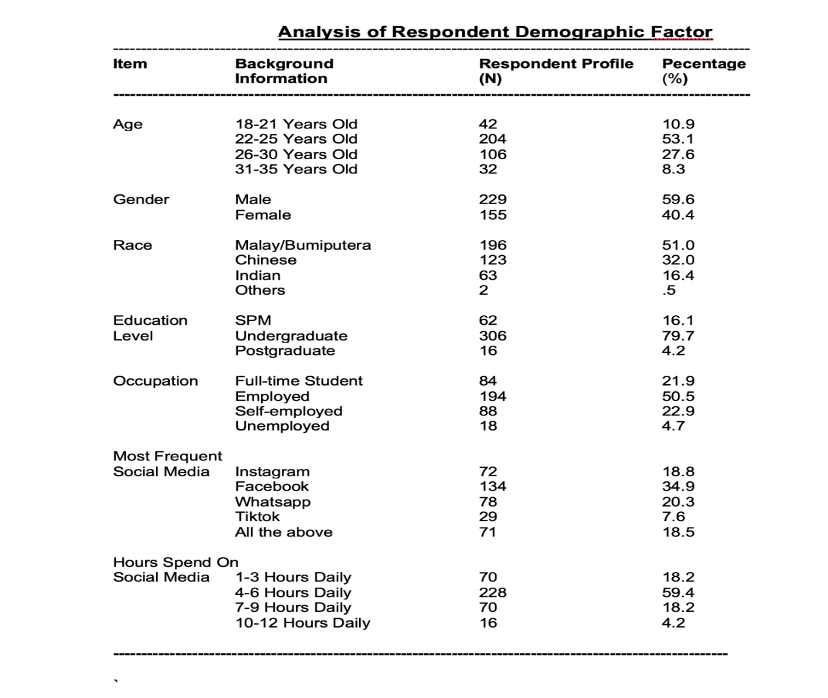

Table 1 shows the demographic item and respondent's background. Demographic variables include the majority of the respondents' age (53.1% 22-25 years old), gender (59.9% male), race (51.9%malay / Bumiputera), education level (79.7% undergraduate), occupation (50.5 employed), most frequently used social media (34.9% Facebook) and hours spent on social media (59.4% 4-6 hours daily).

Table 2

Cronbach Alpha and Mean Value

Section | Cronbach Alpha
Section B  Social media influence on the perception level of social media users towards the development of democracy in Malaysia | 0.851
Section C  Social media influence on the level of Malaysian understanding regarding the development of democracy in Malaysia | 0.888
Section D  Attitude shown in social media towards the development of democracy in Malaysia | 0.898

The above table shows the value of Cronbach alpha for the construct of the perceptions of social media users based on the social media influence towards the development of democracy in Malaysia is α = 0.851. Furthermore, for the construct of the social media influence in terms of the level of Malaysian understanding regarding the development of democracy is α = 0.888. Meanwhile, Cronbach Alpha for the construct of the attitude shown in social media towards the development of democracy in Malaysia is α = 0.898.

Table 3

Overall Mean Value for All Variables

Section | Mean (SD) | Level
Section B  Social media influence on the perception level of social media users towards the development of democracy in Malaysia | 3.12 (0.606) | Good
Section C  Social media influence on the level of Malaysian understanding regarding the development of democracy in Malaysia | 3.18 (0.617) | Good
Section D  Attitude shown in social media towards the development of democracy in Malaysia | 3.01 (0.745) | Good

The primary purpose of proving the mean classification is to categorise the study's results to certain levels and facilitate the researcher to label the study's findings. With a specific scale, the summary of the study results is more accurate and can be coordinated with other parts. The mean value tested can be categorised into three levels of mean classification level with a scale of Bad (1.00 – 2.00), Moderate (2.01 – 3.00) and Good (3.01 - 4.00). Based on the statistical analysis of respondents, as mentioned in Table 3, the data showed that the mean for social media's influence on the perception and understanding level of social media users towards the development of democracy in Malaysia and attitude shown in social media towards the development of democracy in Malaysia is good (perception m = 3.12, SD = 0.606), good (understanding m = 3.18, SD = 0.617) and good (attitude m = 3.01, SD = 0.745). With reference to the mean classification description mentioned above, the results of the statistical analysis of respondents for all variables are at a good level.

Table 4

Correlation Between Perception, Understanding and Attitude

VARIABLE | Section B – Perception | Section C – Understanding | Section D – Attitudes
 | Correlation (r) (Standard Deviation)
Section B – Perception | - | 0.838** (0.001) | 0.884** (0.001)
Section C – Understanding | 0.838** (0.001) | - | 0.807** (0.001)
Section D – Attitudes | 0.884** (0.001) | 0.807** (0.001) | -
* Significant level p < 0.01

The Pearson correlation coefficient result shows a significant correlation between the perception, understanding and attitudes of social media users towards the development of democracy in Malaysia (p<0.001). The respondents' perception level showed a strong and positive correlation with the understanding level of respondents on the development of democracy in Malaysia (r = 0.838, p < 0.01). In the meantime, the Malaysian level of understanding reported a strong and positive correlation with the respondents' attitudes showed in social media towards the development of democracy in Malaysia (r = 0.838, p < 0.01). The social media users' attitudes also illustrated a strong and positive correlation with the perception of the development of democracy in social media (r= 0.884, p < 0.01).

Table 5

Mean Score for Perception Level of Social Media Users Towards Development of Democracy

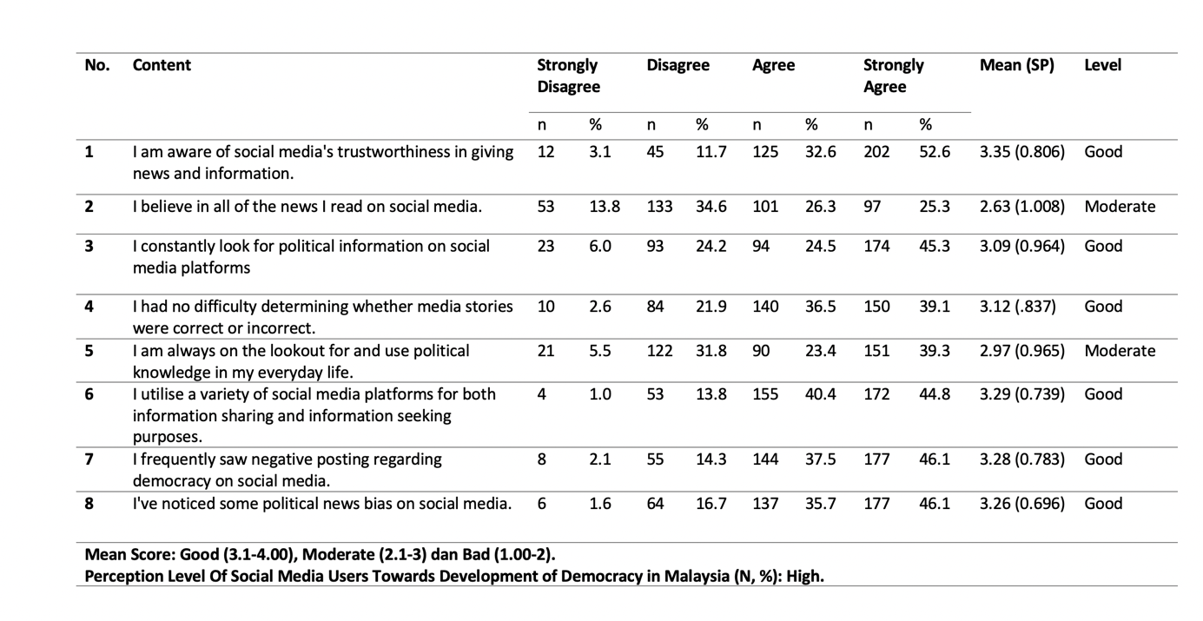

The above table 5 shows the result of the level of perception of social media users towards the development of democracy in Malaysia, which is measured by eight items. The overall mean score for this section is M=3.12 (SD=0.606). This indicates that the respondents' perception level towards the development of democracy in Malaysia is good. The first item in the section on perception has the highest mean of 3.35 (SD =0.806), with most respondents (N=202/384, 52,6%) choosing to strongly agree with item 1, " I am aware of social media’s trustworthiness in giving news and information". In addition, many respondents (N= 174/384, 45.3%) also strongly agree with item 3, "I constantly look for political information on social media platforms, with a mean of 3.09 (SD =0.964). Item 4, " I have no difficulty determining whether media stories were correct or incorrect" which results in a mean of 3.12 (SD =0.837), as responses for this item selected are "strongly agree" (N=150/384, 39.1%), followed by "agree" (N=140/384, 36.5%), "disagree" (N=84/384, 21.9%), and "disagree at all" (N=10/384, 2.6%). Meanwhile, for item 6, respondents indicate that they use a variety of social media platforms for both information sharing and information seeking (M=3.29, SD =0.739), with frequencies of responses as follows: strongly agree (N=172/384, 44.8%), agree (N=155/384, 40.4%), disagree (N=53/384, 13.8%), and disagree at all (N=4/384, 1.0%). The statement for item 7, "I frequently saw negative posting regarding democracy on social media", records a mean score of 3.28 (SD =0.783) as respondents strongly agreed with this statement (N=177/384, 46.1%). Item 8, "I have noticed some political news bias on social media," results in a mean score of 3.26 (SD =0.789), and many respondents strongly agreed with this statement (N=177/384, 46.1%). In addition, the statement in item 5," I am always on the lookout for and use political knowledge in my everyday life ", seems to have a moderate mean of 2.97 (SD =0.965), with the frequency of responses with strongly agree (N=151/384, 39.3%), disagree (N=122/384, 31.8%), agree (N=90/384, 23.4%), and disagree at all (N=21/384, 5.5%). Item 2 has the lowest mean of 2.63 (SD =1.008), as many respondents (N=133/384, 34.6%) disagree with the statement, "I believe in all the news I read on social media."

Table 6

Mean Score for Level of Malaysian Understanding Regarding the Development of Democracy

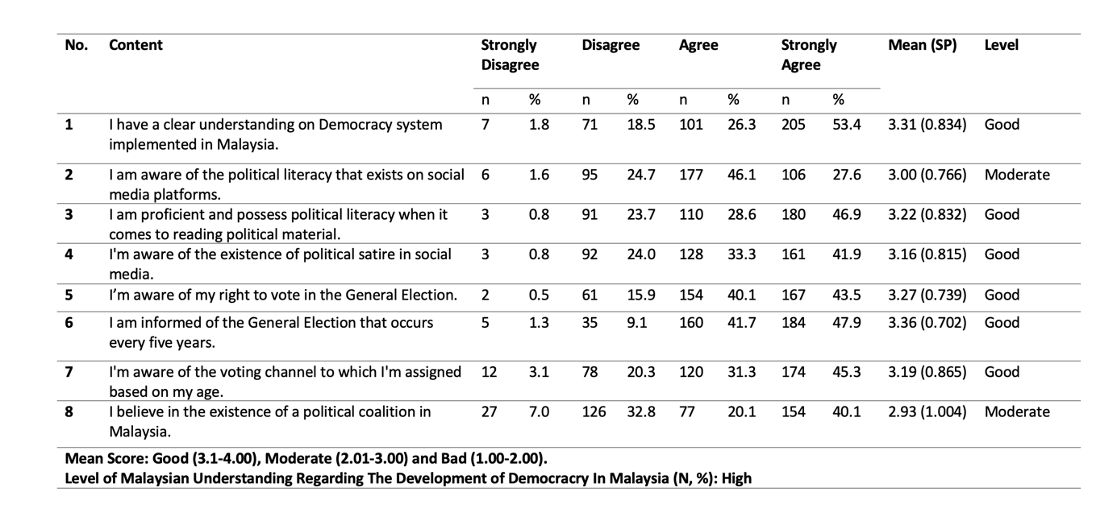

Table 6 shows the level of Malaysian understanding regarding the development of democracy in Malaysia, which is measured by eight items. The overall mean score is M=3.18 (SD=0.617), and this indicates that the respondents' understanding level of the development of democracy in Malaysia is good. The sixth item has the highest mean score of 3.36 (SD=0.702) for many of the respondents (N=184/384, 47.9%) choose to strongly agree with the statement "I am informed of the General Election that occurs every five years. Furthermore, most respondents (N= 205/384, 53.4%) also strongly agree with the first item, "I have a clear understanding on Democracy system implemented in Malaysia", with a mean of 3.31 (SD=0.834). Item 2, "I am aware of the political literacy that exists on social media platforms", records a mean score of 3.00 (SD=0.766) as the highest response to this item was 'I agree' (N = 177/384, 46.1%), strongly agree (N=106/384, 27.6%), disagree (N=95/384, 24.7%), and strongly disagree (N=6/384, 1.6%). Meanwhile, for item 3, respondents indicate that they are competent and politically literate when it comes to reading political material (M=3.22, SD=0.832 with the frequency of response as follows; strongly agree (N=180/384, 46.9%), agree (N=110/384, 28.6%), disagree (N=91/384, 23.7%) and strongly disagree (N=3/384, 0.8%). The awareness of the existence of political satire in social media statements shown in item 5 has a mean score of 3.16 (SD=0.815) since the majority of the respondent choose to strongly agree with the statement (N=161/384, 41.9%). The average score for item 5, “I am aware of my right vote in the General Election", is M=3.27 (SD = 0.739), and the highest response is "Strongly agree" (N = 167 / 384, 43.5%). Furthermore, the mean score for the statement in item 7, "I am aware of the voting channel to which I'm assigned based on my age ", is M=3.19 (SD = 0.865). The frequency of responses is strongly agree (N=174/384, 45.3%), agree (N=120/384, 31.3%), disagree (N=78/384, 20.3%), strongly disagree (N=12/384, 3.1%). Item 8 has the least mean score, with a value of 2.93 (SD=1.004), with the majority of the respondents (N=154/384, 40.1%) choosing to strongly agree followed by disagree (N=126/384, 32.8%), agree (N=77/384, 20.1%), and strongly disagree (N=27/384, 7.0%) with the statement "I believe in the existence of a political coalition in Malaysia".

Table 7

Mean Score for Attitude Showed in Social Media Towards The Development of Democracy in Malaysia
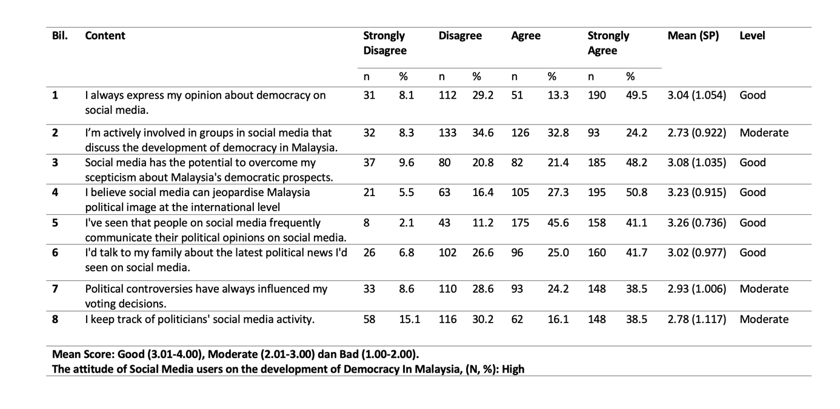

Table 7 shows the result of the attitudes of social media users on the development of democracy in Malaysia, which is measured by eight items. The overall mean score of this section is M=3.01 (SD=0.745). This indicates that the respondents' attitude in social media on the development of democracy in Malaysia is good. The fifth item has the highest mean score of 3.26 (SD=0.736) as many of the respondents (N=175/384, 45.6%) choose to agree with the statement, "I've seen that people on social media frequently communicate their political opinions on social media". Furthermore, most of the respondents (N= 190/384, 49.5%) for item 1, choose strongly agree for "I always express my opinion about democracy on social media", followed by the response of disagree (N=112/384, 29.2%), agree (N=51/384, 12.3%), and strongly disagree (N=31/384, 8.1%) with a mean score of M=3.04 (SD=1.054). Item 3, "Social media has the potential to overcome my scepticism about Malaysia's democratic prospects", has a mean score of 3.08 (SD=1.035) since the highest response for this item is strongly agree (N=185/384, 48.2%), followed by the response of agree (N=82/384, 21.4%), disagree (N=80/384, 20.8%) and strongly disagree (N=37/384, 9.6%). The respondents indicate that they believe social media can jeopardise Malaysia's political image at the international level (M=3.23, SD=0.915), with the frequency of responses as follows; strongly agree (N=195/384, 50.8%), agree (N=105/384, 27.3%), disagree (N=63/384, 16.4%) and strongly disagree (N=21/384, 5.5%). Meanwhile, item 6, "Talking to the family about the latest political news on social media", shows a mean score of 3.02 (SD=0.977), and most of the respondents choose to strongly agree with the statement (N=160/384, 41.7%). Additionally, item 7, " Political controversies have always influenced my voting decision ", has an average score of 2.93 (SD=1.006), with response frequencies of: Strongly agree (N=148/384, 38.5%), Disagree (N=110/384, 28.6%), Agree (N=93/384, 24.2%), Strongly disagree (N=33/384, 8.6%). The mean score in item 8, "I keep track of politicians’ social media activity", is 2.78 (SD=1.117 with the highest responses of strongly agree (N=148/384, 38.5%), followed by the response of disagree (N=116/384, 30.2%), agree (N=62/384, 16.1%) and strongly disagree (N=58/384, 15.1%). Item 2, "I'm actively involved in groups in social media that discuss the development of democracy in Malaysia", reports the least mean score of 2.73 (SD=0.922) as the highest response for the item comes from the disagree category (N=133/384, 34.6%).

Discussion and Conclusion

The finding showed a significant relationship between social media influence and the development of Democracy in Malaysia. Based on the results finding on perception, understanding and attitude shows that youth in Selangor have good responses on democracy; this is also supported based on the mean score for social media influence on the perception level of social media users towards the development of democracy in Malaysia M=3.12 (SD=0.606). Meanwhile, for mean level of social media influence on the understanding level of social media users towards the development of democracy in Malaysia and attitude showed in social media towards the development of democracy in Malaysia was good (understanding M=3.18, SD = 0.617 & attitude M=3.01, SD = 0.745). This indicated that the respondents’ perception and understanding level towards the development of democracy in Malaysia is good. Additionally, there is an effect on social media influence in terms of the perception and understanding level towards the attitudes shown in social media regarding the development of democracy in Malaysia.

Today, social media is a new platform for obtaining knowledge and serving as information dissemination. However, this has negatively impacted users learning about politics and government as some news/information may be false and inaccurate. This phenomenon may have more harmful effects on those who do not verify the information. Based on the findings, interests in politics are relatively good. Again, more traditional news platforms are essential corrective tools to rectify misguided ideas about how to get information or news. One of the important aspects of democracy is to give space to the community to communicate and share information. Therefore, as responsible citizens, we must identify and verify the best way to make people aware of their high dependence on social media. The news or information makes them less informed, so they should access both traditional news sources and social media news if they choose to stay informed about government and politics, especially regarding democracy and patriotism.

This research provides associate degree insight for government and opposition parties concerning utilising social media to attract voters to support them voluntarily. Apart from that, by looking into the result that has been analysed, this research helps content creators who produce political content to have an improved understanding of the variety of content that ought to be created to attract new voters, particularly young and neutral voters. Finally, the research implication provided by this research would help increase awareness amongst the younger generation regarding the importance of the Democracy system in Malaysia. Future research with similar interests should focus on youth participation across other states in Malaysia, as this research focuses only on the participation of Selangor youth. Lastly, since it has already been ascertained that social media plays a significant role in the development of Democracy in Malaysia, future researchers should research if social media influence affects the number of youths who voluntarily participate in the political field.

References

Alarqan, A. (2020). Impact of Social Media and Political Participation on Political Efficacy of Political Science Students of Al al-Bayt University. International Journal of Innovation, Creativity and Change. Www. ijicc. net, 14(8), 295-307.
Akram, W. (2017). A Study on Positive and Negative Effects of Social Media on Society. International Journal of Computer Sciences and Engineering.
Anderson, J. (2020). Concerns about democracy in the digital age. Pew Research Center.
Arya, S. (2021). The Influence of Social Networks on Human Society. arXiv preprint arXiv:2103.13187.
Babulal, V. (2021). Malaysia goes up in democracy rankings. New Straits Times.
Balakrishnan, V., Kaity, M., Rahim, H. A., & Ismail, N. (2021). Social Media Analytics Using Sentiment
and Content Analyses on the 2018 Malaysia’s General Election. Malaysian Journal of Computer Science, 34(2), 171–183.
Brossard, D. (2013). New media landscapes and the science information consumer. Proceedings of the National Academy of Sciences of the United States of America, 110(Suppl._3), 14096–14101.
Commission, M. C. (2020). Internet Users Survey 2020. Malaysian Communications and Multimedia Commission.
Chinnasamy, S., & Manaf, N. A. (2018). Social media as political hatred mode in Malaysia’s 2018 General Election. In SHS Web of Conferences (Vol. 53, p. 02005). EDP Sciences.
David, C. C., San Pascual, R. S., & Torres, E. S. (2019). Reliance on Facebook for news and its influence on political engagement. PLOS ONE, 14(3), e0212263. https://doi.org/10.1371/journal.pone.0212263
Delli Carpini, M. X., & Keeter, S. (1996). What Americans know about politics and why it matters. Yale
University Press
DeVito, M. A. (2017). From editors to Algorithms: A values-based approach to understanding story 2
selection in the Facebook news feed. Digital Journalism, 5 (6), 753–773
Doyle, J. (1999). "Rational decision making". In: Wilson, Robert A.; F. Keil, Frank C. (eds.). The MIT
encyclopaedia of the cognitive sciences. Cambridge, MA: MIT Press, pp. 701–703. ISBN 0 262 73124 X
Gayo-Avello, D. (2015). Social media, democracy, and democratisation. IEEE Multimedia, 22(2), 10-16.
Gil de Zúñiga, H., & Chen, H. T. (2019). Digital media and politics: Effects of the great information and communication divides. Journal of Broadcasting & Electronic Media, 63(3), 365-373.
Gil de Zúñiga, H., Weeks, B., & Ardèvol-Abreu, A. (2017). Effects of the news-finds-me perception in communication: Social media use implications for news seeking and learning about politics. Journal of computer-mediated communication, 22(3), 105-123.
Harrison, K., & Boyd, T. (2018). The role of ideology in politics and society. In Understanding political ideas and movements (pp. 135–153). Manchester University Press.
Holbert, R. L. (2005). Back to basics: Revisiting, resolving, and expanding some of the fundamental issues of political communication research. Political Communication, 22(4), 511–514.
Kahne, J., & Bowyer, B. (2018). The political significance of social media activity and social networks. Political Communication, 35(3), 470–493.
Kim, Y., & Chen, H. T. (2016). Social media and online political participation: The mediating role of exposure to cross-cutting and like-minded perspectives. Telematics and Informatics, 33(2), 320-330.
Krejcie, R. V. dan Morgan, D. W. (1970). Determining sample size for research education and psychological measurement. Education and Psychological Measurement, 3, 607-610
Matsa, E. K., & Shearer, E. (2018). News use across social media platforms 2018. Pew Research Center.
Paddock, R. C. (2020). Democracy Fades in Malaysia as Old Order Returns to Power. The New York Times.
Papagiannidis, S. (2016). Political Participation and Engagement via Different Online and Offline Channels. International Journal of E-Business Research.
Prior, M. (2007). Post-broadcast democracy: How media choice increases inequality in political involvement and
polarises elections. Cambridge University Press.
Sern, T. J., & Zanuddin, H. (2014). Malaysia's 13th general election: Political communication and public agenda in social media. Asian Journal for Public Opinion Research, 1(2), 73-89.
Shehata, A., & Strömbäck, J. (2021). Learning political news from social media: Network media logic and current affairs news learning in a high-choice media environment. Communication Research, 48(1), 125-147.
Shim, K., & Oh, S. K. K. (2018). Who creates the bandwagon? The dynamics of fear of isolation, opinion congruency and anonymity-preference on social media in the 2017 South Korean presidential election. Computers in Human Behavior, 86, 181-189.
Talib, K. A. (2018). Election in Malaysia and Indigenization of Democracy. Journal of Social Science.
Tan, N. (2020). Singapore: Challenges of ‘Good Governance ’Without Liberal Democracy. In Governance and Democracy in the Asia-Pacific (pp. 48–73). Routledge.

