The Song of the Kedidi: The Embodiment of a Hero in a Malay Folktale as an Intangible Cultural Heritage
Harryizman Harun
Universiti Utara Malaysia
harry@uum.edu.my
ORCHiD iD: 0000-0002-2033-7407
(Corresponding author)

Noor Aziah Abdullah
Universiti Utara Malaysia
nooraziah@uum.edu.my
ORCHiD iD: 0000-0002-0557-2409

Abstract
The present study is part of a movement to safeguard Malay folktales as an unsung intangible cultural heritage (ICH). A folktale is a representation of oral traditions and expressions. This study converges on literary folktales as a revitalised form of oral folktales. As urged by UNESCO, the viability of the ICH is achievable via scientific research, among other things. Therefore, considering the small amount of study on Malay folktales at the moment, the current study endeavours to examine the folktale The Song of the Kedidi (TSoK) of its hero embodiment as one of the dramatis personae. The framework of Propp’s dramatis personae, which is based on Russian folktales, grounds the examination. This study examines whether the heroes from the Russian folktales embody TSoK. The thematic qualitative text analysis (TQTA) was employed to examine TSoK. It was conducted in Atlas.ti environment to assure rigour and trustworthiness. The study’s findings suggest that TSoK embodies heroes from Russian folktales. However, a conundrum exists in the embodiment of the hero. There is a conflict between the dramatis personae’s role, and such an enigma calls for the involvement of other dramatis personae, which is reserved for future works. As a crusade to safeguard the Malay folktales as the unsung ICH, the findings create a platform for scholars of similar interests to pursue the examination of heroes in other Malay folktales. Most importantly, the findings are necessary for endless recreation and transmission of knowledge to safeguard the Malay folktale as a living heritage. This act echoes one of UNESCO’s formal education measures to foster society’s respect, recognition, and awareness of the ICH.

Keywords: dramatis personae; hero; intangible cultural heritage; Malay folktale; safeguarding; thematic qualitative text analysis
Received 26 January 2022 Accepted 7 March 2022 Published 30 January 2023

Introduction

Malaysia is not short of rich cultures. Even with the wave of modernity, Malaysia holds fast to the remnants of the traditional past, representing an assortment of diverse cultures and societies from many aspects (King, 2021). One of the aspects is lush traditional literature in written and verbal forms regarding animals and jokes (Koh & Ho, 2009). As a form of traditional literature that surpasses many generations of storytellers, the folktale is a collective property of a society that aims to entertain, educate, and preserve culture (Kim, 2010). It is a form of intangible cultural heritage (ICH) that personifies society’s essence in hunting for beautiful possessions and propels them to progress (Chen et al., 2021). Not just that, as a vehicle of cultural appreciation and understanding from various facets, the folktale is a form of literature that disseminates morals, principles, traditions, and cultures across generations (Nhung, 2016; Palmer et al., 2012). Even though folktale is not legitimately listed as the ICH of Malaysia, the essence of ICH as defined by UNESCO mirrors the spirit of the folktale. The ICH is the constantly fluid practices, representations, expressions, knowledge, and skills transmitted across generations recognised as cultural heritage (UNESCO, 2020). This notion is supported by the Malaysian Ministry of Information Communications and Culture (2006), where cultural heritage also appears as intangible artefacts that relate to Malaysia’s historical or modern way of living. To solidify the importance of the ICH, Target 11.4, under Sustainable Development Goal 11 (SDG 11: Sustainable cities and communities), underlines that the efforts to protect and safeguard the world’s cultural and natural heritage need to be strengthened (Department of Statistics, 2019).

However, since the world has moved into this age of globalisation, the ICH, such as folktales, has become more neglected (Juanis et al., 2022). It is also discovered that a comprehensive approach to safeguarding the ICH is inadequate, and scholars are continually urged to respond to this situation (Chan, 2018). As a result, measures to safeguard Malaysian folklore, particularly folktales, are insufficient. (Gee et al., 2022). Moreover, it is also found that the legal protection of the ICH in Asia does not include Malaysia but Japan and Korea (Petrillo, 2019).

Therefore, the need to safeguard the ICH at the national level to ensure its sustainability is evident; one of the measures is scientific study and methodologies as advocated in Article 13 of the 2003 Convention for safeguarding intangible cultural heritage (UNESCO, 2020). Likewise, Osman (2020) also underlines that safeguarding the ICH is connected to the shift in the folktale form from verbal to literary. Consequently, the current study is motivated to safeguard a Malay literary folktale by examining its dramatis personae of folktale morphology.

The folktale morphology’s dramatis personae is the main theoretical framework underpinning the present study. The folktale morphology is a firm proponent that the folktale can be examined objectively via its structure (Propp, 1968). The theory introduces function as a constant unit in the folktale. A sequence of functions represents the structure of the folktale in a determined order. The rest of the folktale’s components are variables and fluid, which renders them less significant compared to the functions. As a virtual extension of the theory, the dramatis personae are impactful variables that aid in identifying the functions of the folktale. As listed in Table 1, the dramatis personae are the performers in the folktales with seven types: the villain, the donor, the helper, the princess (a sought-for person) and her father, the dispatcher, the hero, and the false hero (Propp, 1997). The dramatis personae’s performances created spheres of action that aid in identifying the functions of the folktale. The current study leans on the dramatis personae framework to guide the examination of the hero in the Malay folktale The Song of the Kedidi.

Table 1
The Dramatis Personae of the Folktale Morphology (Propp, 1997)
Dramatis Personae |  | Sphere Of Action
1 | Hero | The seeker-hero, who sets out on a search, responds to the donor’s demands and eventually marries. Finally, the victimised-hero is responsible for everything except setting out on the search.
2 | Villain | The personage is an adversary who faces off against the hero
3 | Donor (Provider) | The personage is responsible for preparing and providing the hero with the magical agent.
4 | Helper | The personage supports, saves, solves or makes the hero a better version of themselves (transformation).
5 | Princess (a sought-for person) and her father | The personage serves as an objective in the folktale. In most stories, this personage acknowledges and weds the hero as the reward (the princess). The father torments the villain in some way. The princess and her father cannot be accurately portrayed separately from one another based on their respective functions. Most of the time, the father is responsible for providing difficult errands due to his hostile feelings toward the suitor (the hero). Additionally, he will frequently punish (or order the punishment of) the False Hero.
6 | Dispatcher | The personage is responsible for the hero’s departure.
7 | False Hero or Usurper | The personage asserts he is the hero and frequently searches and responds heroically.

The hero, one of the dramatis personae, is considered significant because the frequency of its infusion in the functions is astounding. Thus, the hero is chosen as the spotlight in the present study; the personage acts as a role model, demonstrating resistance against adversity throughout the folktale ((Allison & Goethals, 2019). The weight of the personage echoes its eminence in the folktale structure. The two types of heroes instituted in the morphology are the seeker and the victimised. The former is a brave hero who actively faces a misfortune imposed in the folktale. The latter is a docile hero that is forced to face a misfortune due to circumstances. These two types of heroes possess distinctive attributes which affect the sequence of the folktale’s functions.

Nevertheless, the hero was acquired by examining the Russian folktales. Thus, the hero embodiment in the Malay folktale is to be examined. The current study aims to examine the embodiment of the hero as a piece of the dramatis personae in the select Malay folktale. The entailing Background of Study section discovered that such an examination of the Malay folktale had never been conducted before. This study is part of the movement to safeguard the Malay folktale as a living heritage. The TSoK is the highlight of the current study. Thus far, it is one of many unfamiliar folktales that receive less scrutiny compared to other well-known folktales such as Sang Kancil, Si Tanggang, Hikayat Nakhoda Muda, and Pak Pandir and Pak Kaduk (Ab Jabar & Ghazali, 2021; Hedel & Subet, 2020; Peow, 2016; Radzi, 2015). First, the article begins with the current section (Introduction). Next, the background of the study entailed. Then, the methodology that drove the study is detailed. The analysis and findings are then exhibited, followed by their discussion. Finally, the article departs with the conclusion and references. The subsequent section expounds on the background of this study to expose the TSoK synopsis and the present study’s gap.

Background of Study

Without going into its complete narrative, TSoK recounts a tragic tale of Badik, a bird catcher, and a magical maiden, Kedidi. The tale began when Kedidi, in her magical bird form, fell into a trap set by Badik but was liberated and nurtured to health by Badik out of kindness and pity. Once he discovered Kedidi in a beautiful human form, they fell in love and married. Despite this, the light in the marriage was consumed by darkness due to mundane disputes. Broken-hearted, Kedidi (in a magical bird form) flew away from home into the wilderness, endeavouring to escape the shattered marriage. Her escape was ensued by Badik pleading for forgiveness. Unfortunately, the end of TSoK is not a typical Disney happy-ever-after. Kedidi neither offered forgiveness nor returned home, and Badik was lost in the wilderness forever (presumably dead).

Having recounted the synopsis of TSoK, the following paragraph reviews seven previous studies on the hero as one of the dramatis personae. The studies are reviewed to display the present study’s gap and showcase the stature of heroes in folktales and other folk literature.

The first study examined how Confucian values are described in Chinese, Japanese and Indonesian folk literature (Haryono & Ummah, 2022). It aimed to look for forms of implementation and violation of Confucian values and consequences. The examination was conducted from two facets: the folktale morphology and the dramatis personae. The folk literature of Ama no Hagaromo, Niúlángzhīnǚ, and Jaka Tarub were examined. Even though the morphology was used, the dramatis personae were utilised in the end to judge how well the principal personages followed core Confucian values. The principal personages were the false hero, the hero, and the princess and her father.

The second study analysed the morphology of the Gorontalo folk literature Perang Panipi based on Propp’s morphology and dramatis personae (Lantowa, 2021). The study sought to understand the morphology of folk literature. However, similar to the first study, the dramatis personae were paramount to be identified because the spheres of action determine the morphology. The dramatis personae associated were the hero, the villain, the false hero, and the helper. The study’s findings again show that the hero is integral in folk literature.

The third study investigated the folk literature Ensera Wat Bujang Sugi for its narrative structure using Propp’s folktale morphology (Masanat & Shanat, 2021). It is a tale of a sad love story of a brave hero named Wat Bujang Sugi of the Iban people in Sarawak. Analogous to the first and second studies, the seven dramatis personae of the folk literature were identified before the narrative structure investigation. Then, the spheres of action of each personage identified, including the hero, were applied to nail the narrative structure showcasing the significance of the dramatis personae.

The fourth study investigated the Scandinavian and Old Icelandic folklore narratives (Matveeva, 2016). The folk narrative sought to reveal and grasp Odin’s influence (old Norse deity) on mortal heroes. Therefore, themes representing Odin’s influence were analysed in the chosen folk literature without involving Propp’s hero.

The fifth study was collaborative action research from the education domain (Hawkins et al., 2015). Although the literary West African folktales study lacked the application of Propp’s hero, it explored young students’ interpretation of villains or tricksters as unconventional hero figures. The portrayal of heroes with the message imbued among the young students is imperative because folktales are social transference tools that can shape their moral compass. Therefore, the teachers were suggested to monitor the young students’ understanding of the message conveyed by the said heroes due to subjectivity in interpretation.

The sixth study examined the heroes and villains in modern high fantasy narratives employing Propp’s dramatis personae (Čabartová, 2014). The focus was on determining the vicissitudes in the dramatis personae and the socio-cultural factors that promote the change. The change was mainly regarding the amalgam of the heroes’ and the villains’ qualities, complicating the distinction between the two personages.

The seventh study is analogous to the fifth, but it exploited Propp’s dramatis personae as an analysis tool (Prykhodko, 2014). It explored the creation and reader’s appealing factors of non-traditional negative heroes (trickster and thief) in Russian and German folktales. Besides, the study also conducted cultural contrast between the two folktales to discover remnants of shared moral values and national mindset.

As attested by the seven studies reviewed, the hero is a substantial personage regardless of the backdrop and form of folk literature. It demonstrates the hefty value the personage inculcates that renders it noteworthy. Nevertheless, only some studies engaged Propp’s hero as the personage in understanding the diverse aspects of heroes in the respective folk literature. In addition, it is acknowledged that the investigations of the heroes were scarce in the Malay folktales context, especially TSoK. Thus, such a circumstance sets a gap for the present study to examine the hero embodiment in the Malay folktale TSoK. The following section extends the study’s methodology.

Methodology
TSoK was chosen as a unit of analysis in the form of a literary document (Billups, 2021; Puteh & Said, 2010). Parts of TSoK that assisted the study in interpreting the types of hero existed in the folktale meaningfully were the units of coding; the context units were the portion of the surrounding tales required to comprehend the meaning of the units of coding established to determine the heroes in TSoK (Schreier, 2012, 2013). Because the study aims to examine how the hero is embodied as one of the dramatis personae in TSoK, the sample size was limited to just that one folktale. Consequently, the folktale was sampled using purposeful sampling to provide context-rich and detailed accounts responding to the study’s inquiry (Ravitch & Carl, 2021). The sampling’s key criteria to warrant TSoK is indeed a form of folktale instead of a myth or legend, as presented in Table 2. (Bascom, 1965; Ritchie et al., 2014). Table 3 summarises the units and sampling of the study accordingly.

Table 2
The Five Key Criteria of the Folktale’s Definition (Bascom, 1965)
Key Criteria | Explanation
Belief | The folktale is not historical or factual. As a result, it must be fiction.
Time | The folktale lacks a specific distant and relatively recent timeline, date, or year of occurrence.
Place | The folktale’s incident is not linked to any specific remote or relatively recent locations. Moreover, even if there are locations in the tale, they are entirely fictitious.
Attitude | The folktale is also considered devoid of religious, ritualistic, or sacred intentions. On the contrary, it can only provide amusement and moral value.
Principal Character | The folktale describes the adventures and journeys of human or nonhuman characters. Human characters can take many forms, as can nonhuman characters.

Table 3
The Units and Sampling of the Study
Units and Sampling
Sampling Technique | : | Purposeful Sampling
Unit of Analysis | : | The chosen folktale (TSoK)
Unit of Coding | : | The sections of TSoK that aided the study in meaningfully interpreting the types of heroes present in the folktale
Unit of Context | : | The section on the surrounding tales is necessary to comprehend the significance of the coding unit used to identify the heroes in TSoK.

The investigation was performed via the thematic qualitative text analysis (TQTA), deeming the folktale’s literary nature (Kuckartz, 2014; Schreier, 2013). Meanwhile, Atlas.ti was utilised to execute the TQTA to proliferate the overall rigour and trustworthiness of this study’s findings (Clarke et al., 2021; Friese, 2020; Hwang, 2008). The TQTA consists of seven recursive phases (as depicted in Figure 1) that were adjusted to the milieu of the current study. The phases are elucidated using Atlas.ti’s jargon necessary to address the examination flow.

Figure 1
The Adapted TQTA Process (Kuckartz, 2014)

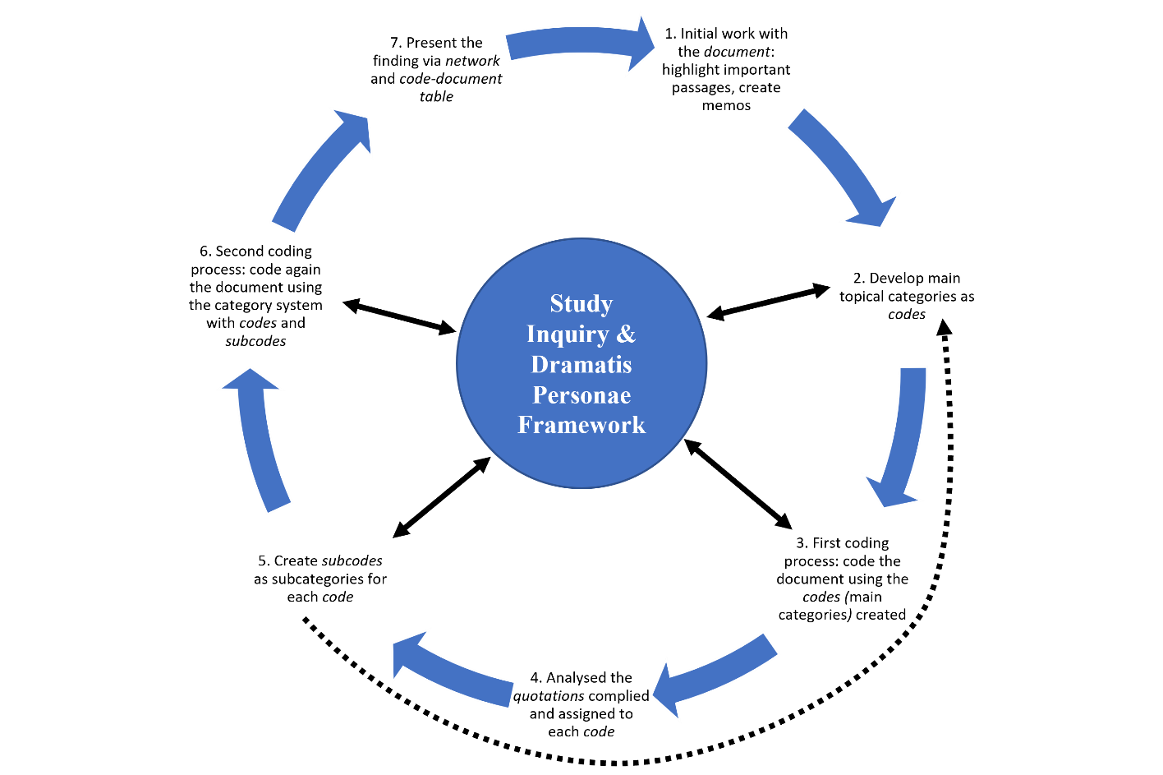

First phase: In this phase, TSoK was transferred from Microsoft Word into Atlas.ti as a document. Hereafter, TSoK was referred to as the document. The initial work with the document began to emphasise essential passages and compose memos. The document was carefully read, and significant text passages were observed and highlighted. Memos were also created to record interesting or relevant things and any ideas that might occur regarding the analysis. In the next phase, the thematic categories were defined.

Second phase: The second phase denoted the development of main topical categories as codes in the code manager. The actual content of the document acted as an analysis category. The codes were derived deductively from the study inquiry and dramatis personae framework. At this phase, heroes were employed as the code. It was apt since the study inquiry and dramatis personae framework impacted how TSoK as the document was analysed. New, unexpected topics might have been unearthed through careful reading of the document. Anything that seemed relevant or peculiar at first was recorded. The first coding process entailed this phase.

Third phase: The document was coded using the heroes code in the third phase. The first coding process was designed in a convenient sequential order. The document was examined section by section and line by line from beginning to end to assign text quotations to categories. The quotations were sections of the document relevant to answering the study inquiry. The topics addressed in the quotations were determined and assigned to the appropriate category. Quotations that did not contain information on the pre-determined topics were irrelevant to the study inquiry and remained uncoded. The entire document was coded during the first coding process. The study inquiry determined the size of the individual coding units (the text segments to be coded). The subsequent two phases involved collating quotations and forming subcategories as subcodes.

Fourth and Fifth phases: In the fourth phase, all quotations identified and assigned to each of the codes were carefully analysed as a preparation to generate subcodes. As the bridging phase between the first and the second coding process, subcodes were created in the fifth phase for each code formed in phase two. Raw subcodes were formed initially, and more abstract subcodes were eventually fabricated. The abstract subcodes were deductively created from the dramatis personae framework. Two subcodes were formed: Seeker-Hero and Victimised-Hero. Definitions were formulated in the comment for each subcode based on the quotations coded in phase three to ground them close to the data. The definitions aimed to safeguard and maintain a consistency of the subcodes’ understanding throughout the entire analysis. During this phase, the Seeker-Hero and Victimised-Hero subcodes were promoted as codes to contain more subcodes deductively created from the dramatis personae framework. The Seeker-Hero subcode contained four subcodes: “A call for help is given, with the resultant dispatch”, “The hero is dispatched directly”, “The hero is allowed to depart from home”, and “Misfortune is announced”. The Victimised-Hero subcode encompassed three subcodes: “The banished hero is transported away from home”, “The hero condemned to death is secretly freed”, and “A lament is sung”. All these subcodes were tools to aid in examining the heroes embodied in the document. Besides, for completeness and in case wildcard quotations were founded, all codes were included with an extra subcode as a residual category entitled Miscellaneous. New types of heroes not addressed in the dramatis personae framework were coded to the Miscellaneous subcode. The next phase was the second coding process.

Sixth phase: In the second coding process, the document was coded again using the detailed category system containing the newly constructed codes and subcodes, as portrayed in Figure 2. This phase required the study to analyse the document all over again systematically. The quotations within each code were coded again and assigned to the recently defined subcodes—the subcodes’ definitions in the comment aided in determining the coding of the right subcodes to quotations. Once completed, the last phase was the presentation of findings.

Figure 2
TSoK Category System
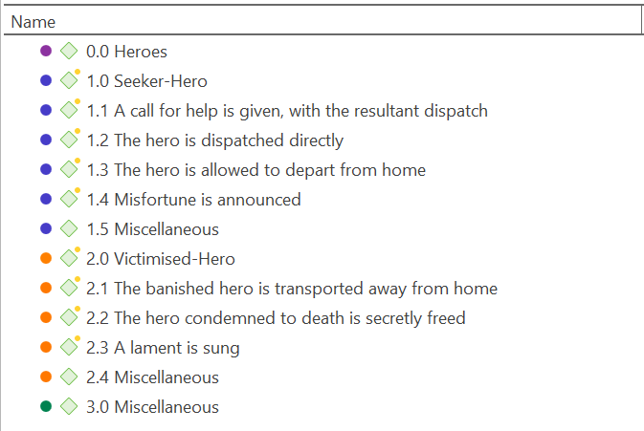

Seventh phase: The study presented the findings via graphical representation (visualisation) and tables. They were used to illustrate the analysis’s outcome better. The graphical representation was done using the network and its relations to represent the findings visually. The table was generated via the code-document table. Ultimately, category-based analysis of the codes and subcodes were represented as assumptions and interpretations of the study to answer the study inquiry and achieve the objective. Further information on the findings is available in the consequent analysis and finding section.

Analysis and Findings
The analysis of TSoK revealed the heroes embodied in the folktale, as illustrated in Figure 3. Table 4 (generated with the code-document table in Atlas.ti) presents the quotations coded to the TSoK category system. Gr stands for groundedness, which reflects the quotations coded to the codes and subcodes.

Figure 3
The Hero as the Personage in TSoK

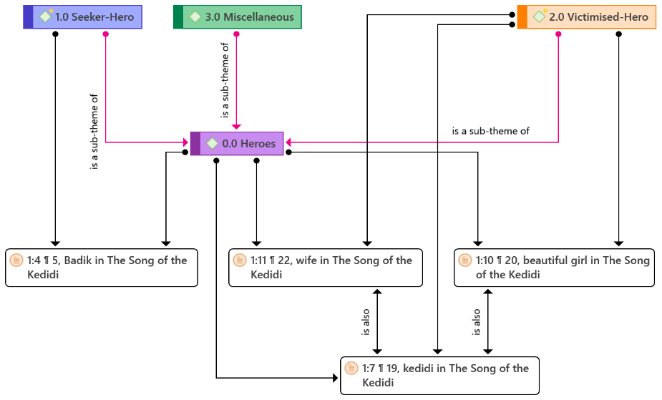
Table 4
The Quotations Coded to the Category System

 | The Song of the Kedidi (TSoK)  Gr=11 | Totals
● 0.0 Heroes  Gr=4 | 4 | 4
● 1.0 Seeker-Hero  Gr=1 | 1 | 1
● 1.1 A call for help is given, with the resultant dispatch  Gr=1 | 1 | 1
● 1.2 The hero is dispatched directly  Gr=0 | 0 | 0
● 1.3 The hero is allowed to depart from home  Gr=1 | 1 | 1
● 1.4 Misfortune is announced  Gr=0 | 0 | 0
● 1.5 Miscellaneous  Gr=0 | 0 | 0
● 2.0 Victimised-Hero  Gr=3 | 3 | 3
● 2.1 The banished hero is transported away from home  Gr=0 | 0 | 0
● 2.2 The hero condemned to death is secretly freed  Gr=0 | 0 | 0
● 2.3 A lament is sung  Gr=2 | 2 | 2
● 2.4 Miscellaneous  Gr=0 | 0 | 0
● 3.0 Miscellaneous  Gr=0 | 0 | 0
Totals | 12 | 12

The findings corroborated that the heroes originated from the Russian folktales are embodied in TSoK, the selected Malay folktale in the current study. Nevertheless, it can be deduced that the hero embodiment in TSoK is not forthright. The folktale has three dramatis personae: Damak, Badik, and Kedidi. Nevertheless, the role of Damak (father to Badik) as a personage is beyond the scope of the examination. As depicted in Figure 3, two heroes were identified in TSoK: Badik and Kedidi. The former is a seeker-hero, and the latter a victimised-hero. As shown in Table 4, two subcodes were coded to the former: “the hero is allowed to depart from home” and “a call for help is given, with the resultant dispatch”. The subcodes are the forms of seeker-heroes that render Badik as one. The latter was coded to a single victimised-heroes subcode: “a lament is sung”; such coding portrays Kedidi as the victimised-hero.
It can also be perceived that Kedidi has three forms: a songster magical bird (sandpiper), a beautiful girl, and a wife. Therefore, all three forms are inferred as the victimised-hero. That explains the Gr for the Heroes code and Victimised-Hero subcodes, respectively, in Table 4. The Gr for Heroes is four, even though there are only two heroes in TSoK. Badik and the three forms of Kedidi rounded the Gr to four. The Victimised-Hero’s Gr is three despite Kedidi being the only victimised-hero in TSoK, considering her three different significant forms. As for the subcode “a lament is sung”, the Gr is two, unlike the Gr for the Seeker-Hero’s subcodes. It owes to the fact that in TSoK, Kedidi used a lament twice to liberate herself from two different shapes of predicaments.

At the risk of trespassing the scope of the current study, it is worth mentioning that TSoK lacks a tangible villain from the beginning of the narrative. It is a unique and peculiar circumstance because heroes and villains hold inextricable symbiosis relationships in a narrative (Pradiptha, 2018). However, for the lack of a villain, it is suspected that Badik simultaneously assumes a dual role of a personage (hero and villain) at two different times in the TSoK narrative structure. Nevertheless, the present study does not pursue this notion further in the current context. Additionally, no new emergent dramatis personae were discovered; hence the residual category (Miscellaneous) was not required. The following section discusses the findings.

Discussion

In the TSoK narrative structure, Badik was a bird catcher. He left home to catch birds in a jungle when he met Kedidi, the magical sandpiper bird. His act of leaving home on his own accord, which led him to encounter Kedidi, signifies the subcategory of the seeker-heroes: “the hero is allowed to depart from home”. Nonetheless, he managed to trap Kedidi in her magical bird form amidst the jungle. As an act of emancipation, she sang a song crying for help, and out of kindness and pity, he released and nurtured Kedidi back to health. This act of Badik reacting to Kedidi’s cry for help resonated with another seeker-heroes subcategory: “a call for help is given, with the resultant dispatch”. Therefore, it is clear that Badik is the seeker-hero in TSoK. Figure 4 visualised Badik’s role as the seeker-hero of TSoK, supported by the quotations.

Figure 4
The Seeker-Hero Visualisation

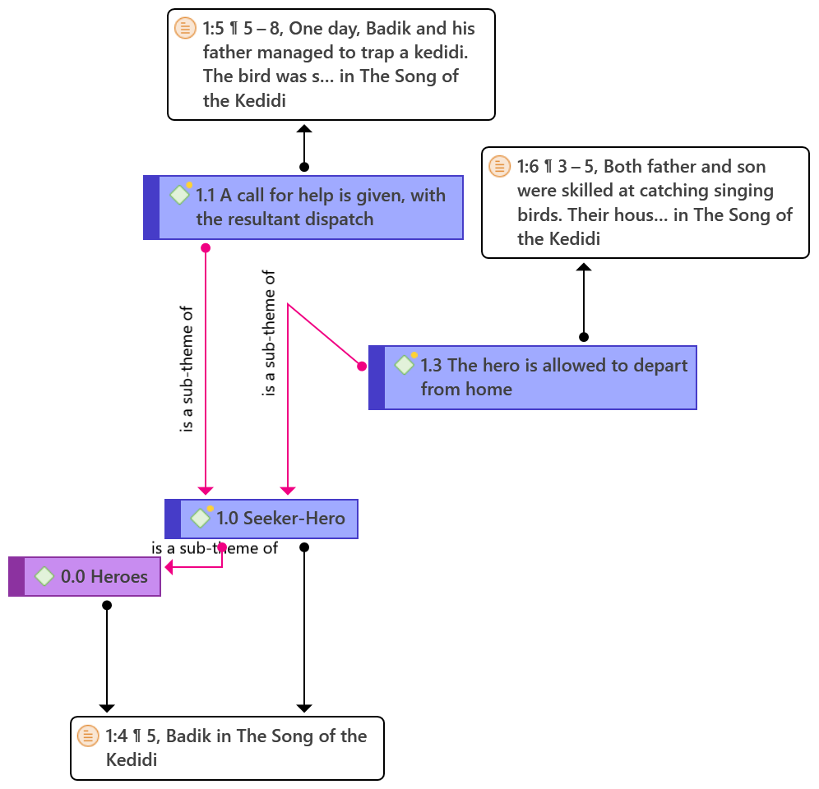

From Kedidi’s perspective, she was caught in Badik’s trap in a magical bird form, and she freed herself by singing a lament to invoke kindness and pity in Badik. That was the first time she used her spell song to free herself from the trap set by Badik. In the TSoK context, the lament is a song expressing sorrow and grief (Bartlett, 2020). Rosand (1979) expresses that the lament is a soliloquy of emotional climax as intense manifestation is followed by a resolution of the action within a narrative structure. Therefore, the subcategory “a lament is sung” of the victimised-hero was applied to Kedidi. It was discovered that she sang the lament twice in the folktale, a similar but distinctive lament which unfettered her from two different complications. Figure 5 shows that the first lament employed the phrase trapped, and the second ensnared. Both phrases carry analogous connotations. The former represents the use of a trap to capture, but the latter alludes to the use of trickery to lure into a trap (Writing Tips, 2019). The current study interprets that Kedidi felt in her magical bird form that she was caught in the trap literally. However, as a wife, she sang the lament for the second time to escape an undesirable situation that upset her deeply. It is believed that Kedidi felt she was tricked into a situation she considered a metaphorical trap. The metaphorical trap that caged Kedidi explains the ensnared phrase used in the second lament. In the later structure of TSoK, Kedidi became the wife of Badik, the man who freed her from the literal trap the first time. Nevertheless, Badik was a different man in the marriage, tormenting her emotionally and causing her to feel trapped in the marriage. Thus, the first lament was to free Kedidi from the literal trap and the second lament was from a metaphor trap of the marriage.

Figure 5
The Victimised-Hero Visualisation
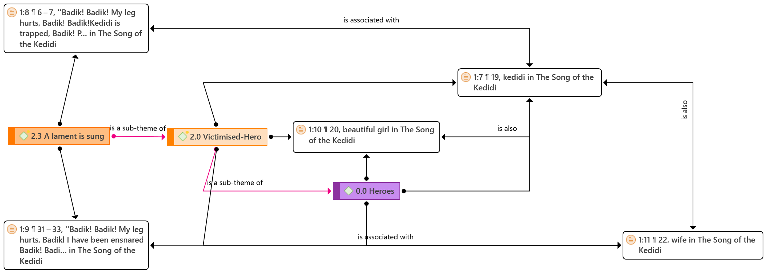

The current study is not free from limitations. The embodiment of the dramatis personae attained in TSoK is not thorough because the emphasis is merely on the heroes. Considering seven dramatis personae that exist, as Propp (1968) proposed, the scope of the present study barely scratches the surface. For instance, Badik’s father, as one of the dramatis personae, is omitted from the examination though he did have a role in the folktale. In addition, the heroes of TSoK assumed more than one personage role. For instance, in her beautiful human-girl form, Kedidi can also be interpreted as a donor to Badik and Damak. Kedidi has three forms (refer to Figure 5): the songster magical bird (sandpiper), the beautiful girl, and the wife. Her role as the victimised-hero is linked to all three forms. Nevertheless, her middle form, the beautiful girl, can also reflect the donor as a personage. This limitation is associated with the challenge faced by this study.

Understanding the hero embodiment in TSoK is a challenge in itself. It is due to the two types of hero presence and the lack of genuine villains in the narrative. Badik’s personage role reversal made the examination more exigent. His early performance as the seeker-hero in TSoK changed mid-story when he married Kedidi in her beautiful human-girl form. Then, his behaviour was inclined towards the negative features of a villain. Since TSoK is missing the villain, Badik could also be interpreted as the villain. However, the present study reserves the notion for future work.

Since this study emphasises a single Malay folktale, the findings cannot be generalised. Moreover, generalisation was never the intention of this study, but it is to discover the embodiment of the hero as the dramatis personae in TSoK. This research aims to affirm safeguarding the Malay folktale as the unsung ICH. It is deduced that the heroes originating from the Russian folktales are indeed embodied in TSoK. Moreover, they help the study comprehend that the embodiment of the dramatis personae is never clear-cut. It is not always a case of hero versus villain. Folktale imitates life (Ajayi & Iwuagwu, 2012). Similar to life, not everything is divergent, black and white. Blotches of grey paint life sporadically. It is now understood that the role reversal in the dramatis personae occurs in the Malay folktale and that two heroes can occupy a sole folktale narrative in the Malay folktale context.

As an implication, the knowledge of the hero, which embodies TSoK, prepares scholars with a similar interest in discovering various embodiments of such dramatis personae in other Malay folktales. Moreover, given that folktale is a valuable ICH that personifies the spirit and evolution of people (Chen et al., 2021), understanding the dramatis personae embodiment assists in understanding the behaviour of a particular society. Notably, the findings are judged essential for the endless recreation and transmission of information to preserve the Malay folktale as a living tradition. This gesture mimics one of UNESCO’s formal education initiatives to promote respect, acknowledgement, and knowledge of the ICH among the general public. The last section completes the article.

Conclusion

The current study is motivated by UNESCO’s urge to safeguard the ICH via scientific research. The inquiry initiated the present study regarding the embodiment of the hero as one of the dramatis personae in the Malay folktale TSoK. TSoK was examined, and the findings assuaged the inquiry. The heroes derived from Russian folktales also embody the Malay folktale. Uniquely, the findings revealed two heroes coexisting in TSoK: the seeker and the victimised. There was also the distinctive role reversal situation where one personage transformed into another: hero to villain.

Additionally, the findings contribute as a preliminary platform for scholars with a comparable interest to investigate the hero embodiment in other Malay folktales. Moreover, they also become a safeguarding initiation of the Malay folktales as a living heritage. Besides, as an added value, since folktales mimic life, the knowledge of the hero embodiment facilitates understanding the reflection of the pertaining society.

In future works, the involvement of the rest of the six dramatis personae is a must in this study to obtain a broader picture of the dramatis personae embodiment in TSoK. The role of Damak, the father, and Kedidi, the beautiful girl, should be examined in their personages. Besides, the role reversal conflict of Badik as one of the crucial dramatis personae in TSoK should be examined further. It will pave the way to answer the enigma of TSoK lacking a corporeal villain and the undesirable situation that saddens Kedidi greatly (which compelled her to sing the second spellbinding lament).

References

Ab Jabar, N., & Ghazali, M. F. M. (2021). Komunikasi bahasa sindiran dalam seloka Pak Pandir dan Pak Kaduk. Jurnal Komunikasi: Malaysian Journal of Communication, 37(1), 364-378. https://doi.org/https://doi.org/10.17576/JKMJC-2021-3701-21
Ajayi, A., & Iwuagwu, S. (2012). Reflection on moral education in Igbo folktale. Journal of Qualitative Education, 8(2), 1-6. https://www.globalacademicgroup.com/journals/qualitative%20education/Ajayi4.pdf
Allison, S. T., & Goethals, G. R. (2019, February 9). Hero stories give us wisdom. https://blog.richmond.edu/heroes/tag/hero-stories/
Bartlett, A. (2020). Response. Mothering bodies and sensations: The sound of lamentation—Hearing maternal academic subjects. In L. Henderson, A. Black, & S. Garvis (Eds.), (Re) birthing the Feminine in Academe: Creating Spaces of Motherhood in Patriarchal Contexts (pp. 129–137). Palgrave Macmillan.
Bascom, W. (1965, 01/01). The forms of folklore: Prose narratives. The Journal of American Folklore, 78(307), 3-20. https://doi.org/10.2307/538099
Billups, F. D. (2021). Qualitative data collection tools: Design, development, and applications (Vol. 55). Sage Publications.
Čabartová, K. (2014). The evolution of the hero and the villain [Bachelor thesis, Charles University]. Charles University Digital Repository. https://dspace.cuni.cz/bitstream/handle/20.500.11956/69881/BPTX_2012_2_11210_0_344586_0_140400.pdf?sequence=1
Chan, C. S. C. (2018). Sustainability of indigenous folk tales, music and cultural heritage through innovation. Journal of Cultural Heritage Management and Sustainable Development, 8(3), 342–361.
Chen, Z., Huang, J., Dai, H., & Liu, J. (2021). Development route analysis of intangible cultural heritage industry of China based on data mining. Journal of Physics: Conference Series, 1848(1), 12-40. https://doi.org/10.1088/1742-6596/1848/1/012040
Clarke, S. O., Coates, W. C., & Jordan, J. (2021). A practical guide for conducting qualitative research in medical education: Part 3—Using software for qualitative analysis. AEM education and training, 5(4), e10644.
Department of Statistics, M. (2019). Sustainable Development Goals (SDG) indicators Malaysia. https://www.epu.gov.my/sites/default/files/2021-02/Sustainable-Development-Goals-%28SDG%29-Indicators-Malaysia-2019.pdf
Friese, S. (2020, December 11). Visualising relationships in networks. https://atlasti.com/2020/12/11/visualizingrelationshipswithnetworks/
Gee, L. L. S., Pangayan, V. B., & Kordmodanlou, D. (2022). Kimaragang folklore game app development:’E’Gadung’. Journal of Management Information and Decision Sciences, 25, 1-13.
Haryono, H., & Ummah, N. W. (2022). Confucian values in Chinese, Japanese, And Indonesian folklore (morphological analysis of Vladimir Propp folklore) First International Conference on Literature Innovation in Chinese Language (LIONG 2021), Purwokerto, Indonesia.
Hawkins, J. M., Agnello, M. F., & Lucey, T. A. (2015). Villain or hero: Student interpretations of African trickster tales. Multicultural Education, 22(3/4), 20. https://files.eric.ed.gov/fulltext/EJ1078682.pdf
Hedel, N. E. F., & Subet, M. F. (2020). Strange events in folklore “Hikayat Nakhoda Muda”: Inquisitive semantics analysis. Asian People Journal (APJ), 3(2), 147-160. https://doi.org/http://dx.doi.org/10.37231/apj.2020.3.2.193
Hwang, S. (2008). Utilising qualitative data analysis software: A review of Atlas. ti. Social Science Computer Review, 26(4), 519–527. https://doi.org/10.1177/0894439307312485
Juanis, B., Saleh, Y., Ghazali, M., Mahat, H., Hashim, M., Nayan, N., Hayati, R., & Kurnia, R. (2022). Knowledge, attitudes and practices of youths towards the intangible cultural heritage elements of Dusun ethnic in Malaysian environment. IOP Conference Series: Earth and Environmental Science,
Kim, H.-r. (2010). The role of folktales today. http://asianfolktales.unescoapceiu.org/pdf/The%20Role%20of%20Folktales%20Today.pdf
King, V. (2021). Malaysia: The essential guide to customs & culture. Kuperard.
Koh, J., & Ho, S. (2009). Culture and customs of Singapore and Malaysia. Greenwood Press.
Kuckartz, U. (2014). Qualitative text analysis: A guide to methods, practice and using software. Sage.
Lantowa, J. (2021). The morphology of the Gorontalo folklore Perang Panipi: A study of Vladimir Propp’s narratology Prosiding Seminar Nasional dan Internasional HISKI, Palu, Indonesia.
Masanat, F. E., & Shanat, M. B. (2021). Character analysis of Ensera Wat Bujang Sugi through morphological analysis theory of Vladimir Propp. NVEO Natural Volatiles & Essential Oils Journal 8(4), 10291-10299.
Matveeva, E. (2016). Reconsidering the tradition: The Odinic hero as saga protagonist University of Nottingham]. http://eprints.nottingham.ac.uk/33637/1/phd_matveeva_2.pdf
Ministry of Information Communications and Culture. (2006). Malaysian national heritage act 2005. The Commissioner of Law Revision, Malaysia. Retrieved October 20 from https://www.heritage.gov.my/v2/images/akta_warisan_kebangsaan/Act%20645.pdf
Nhung, P. T. H. (2016). Folktales as a valuable rich cultural and linguistic resource to teach a foreign language to young learners. International Journal of Education, Culture and Society, 1(1), 23-28.
Osman, S. A. (2020). Re(con)figuring the nenek kebayan through folktale adaptation: Malaysian folktales as literary and cultural heritage. In S. P. Gabriel (Ed.), Making Heritage in Malaysia (pp. 163–184). Palgrave Macmillan, Singapore. https://doi.org/https://doi.org/10.1007/978-981-15-1494-4_6
Palmer, B. C., Sun, L., & Leclere, J. T. (2012). Students learn about Chinese culture through the folktale. Multicultural Education, 19(2), 49-54. https://files.eric.ed.gov/fulltext/EJ1001526.pdf
Peow, S. H. (2016). A comparative study of Malay and Chinese trickster tales: Sang kancil, the rabbit and the rat. Kajian Malaysia, 34(2), 59-73. https://doi.org/http://dx.doi.org/10.21315/km2016.34.2.3
Petrillo, P. L. (2019). The legal protection of the intangible cultural heritage: A comparative perspective. Springer.
Pradiptha, A. P. (2018). The role of the villain as a determinant of the existence of the main character. E-Structural (English Studies on Translation, Culture, Literature, and Linguistics), 1(01), 24–38. https://doi.org/doi.org/10.33633/es.v1i01.1823
Propp, V. (1968). Morphology of the folktale (2nd ed.). University of Texas Press.
Propp, V. (1997). Theory and history of folklore (A. Y. Martin & R. P. Martin, Trans.; 4th ed., Vol. 5). The University of Minnesota Press.
Prykhodko, D. (2014). Slackers, fools, robbers and thieves: Fairy tales and the folk imagination http://summit.sfu.ca/item/14172
Puteh, O., & Said, A. (2010). 366 a collection of Malaysian folk tales (12th ed.). Utusan Publications and Distributors Sdn Bhd.
Radzi, S. B. M. (2015). Si Tanggang moden dan perubahan makna dalam cerita bermotifkan anak derhaka. Jurnal Komunikasi: Malaysian Journal of Communication, 31(2), 247-261. https://doi.org/https://doi.org/10.17576/JKMJC-2015-3102-16
Ravitch, S. M., & Carl, N. M. (2021). Qualitative research: Bridging the conceptual, theoretical, and methodological (2nd ed.). Sage Publications.
Ritchie, J., Lewis, J., Elam, G., Tennat, R., & Rahim, N. (2014). Designing and selecting samples. In R. Jane, L. Jane, N. Carol McNaughton, & O. Rachel (Eds.), Qualitative research practice: A guide for social science students and researchers (2nd ed.). Sage Publications Inc.
Rosand, E. (1979). The descending tetrachord: An emblem of lament. The Musical Quarterly, 65(3), 346–359.
Schreier, M. (2012). Qualitative content analysis in practice (1st ed.). Sage Publications.
Schreier, M. (2013). Qualitative content analysis. In F. Uwe (Ed.), The SAGE handbook of qualitative data analysis (pp. 171–183). SAGE Publications Ltd.
UNESCO. (2020). 2003 Convention for the safeguarding of the intangible cultural heritage. Retrieved October 22 from https://ich.unesco.org/doc/src/2003_Convention_Basic_Texts-_2020_version-EN.pdf
Writing Tips. (2019, December 12). Catch vs capture vs trap vs snare vs entraps vs ensnare vs bag. https://www.writingtips.cc/catch-vs-capture-vs-trap-vs-snare-vs-entrap-vs-ensnare-vs-bag/

