Written Text on Pakistani Vehicles: A Critical Discourse Analysis

Sidra Mahmood

Virtual University of Pakistan, Pakistan

e-mail: [sidra.english@gmail.com](mailto:sidra.english@gmail.com)

(Corresponding author)

**Abstract**

Linguistically, the word ‘language’ has shifted into ‘discourse’ which is a social phenomenon not only to express the thoughts but also to reflect the mindset and contexts of a specific community. The purpose of this study is to examine the slogans written on Pakistani automobiles and to understand the logic behind the social and cultural affiliations of these slogans. Pakistani culture of the art of making pictures and written phrases, poetic verses and imperative sentences on vehicles is famous all over the world. The study has analysed the writings found on vehicles, and although these writings might look trivial on the automobiles, they address various social issues. The Three-Dimensional Model of Critical Discourse Analysis (CDA) by Fairclough (2001) is used as a theoretical framework that explains the study at three levels: lexical, syntactic patterns, interpretations, and social practices. The discourses written on the vehicles are characterised into different categories, which are life’s mission statements, loud messages, mind baffling messages, everyday life annoyances, provoking statements, and religious looms. Twenty images and pictures have been captured from vehicles as a random sample of this study. The results reveal the mindset behind these discourses. They are used to highlight social issues which Pakistan faces, being a developing country. In short, the study discloses the strong link between the vehicles and the people using them to convey messages to the society which can bring harmony among the public. The current study is limited to only Pakistani motor vehicles.

**Keywords:** Critical Discourse Analysis, culture and society, ideologies, Three-Dimensional Model, vehicles

**Received** 11 March 2021 **Accepted** 24 June 2021 **Published** August 2021

# Introduction

Written text on different vehicles including public and private vehicles is a common phenomenon in Pakistan. It can be easily noticed while traveling on Pakistani roads. It usually catches the attention of the readers, and they are in different forms; for instance, poetic verses, famous slogans, quotations, advice, suggestions, funny statements, religious quotes, etc. Now, this is becoming a new trend to write some phrases or ideas on the vehicles. This shows the specific interest of the people, their thinking, and the message that they want to convey. Indeed, this is an open way of conveying messages to a larger audience.

The purpose of using Critical Discourse Analysis (CDA) to examine the linguistic aspects of phrases, lines and quotes found on vehicles in Pakistan is to delve into the mindset and the ideologies behind these writings. Pakistan is famous for the quotes and arts on vehicles which in turn is one of its attractions. This study is an attempt to understand the ideologies that are depicted and conveyed through writings on vehicles and how the art represents Pakistani cultural heritage. Slogans or phrases on the vehicles deliver a pragmatic aspect of language by revealing a background that allows people to deduce meaning from it. Hajer (1995) highlights that discourse is social connections involving society and people. People are categorised by the discourses as to the type of values, practices, and attitudes that they have.

In Pakistani society, cars, apart from being an asset, serve as means of depicting social and cultural affiliations. Caring about their vehicles like a family member, they also associate various names with their vehicles, for example, jet, rocket and power horse, etc. The decoration of automobiles with slogans from different regions exhibits a representation of culture. There are different types of quotations, phrases, chunks, poetic verses, warnings, advertisements, and stickers displayed that express the socio-cultural and political closeness of the people. It is also common for the people to showcase the social groups they belong to, i.e., *Chaudhry, Jutt, Kashmiri, or Waraich* (Urdu words for caste) Automobiles serve as means of transportation alongside representing ideologies embedded in the writings over them. Certain slogans are depicted by pasting stickers over the vehicles about social, political, military, and sports contexts. Conveying light-hearted messages, these banners, phrases, slogans, and quotes on the vehicles act as appealing and enchanting aspects of automobile art. The exciting nature of the slogans and verses on the automobiles make them relatable and appealing and at times, they even render some information. One other dimension of these writings is the communication of religious ideologies. Clearly, the variant and attractive slogans on the vehicles manifest the art in Pakistan.

This study is significant in terms of the portrayal of socio-cultural ideologies via writings on vehicles as it helps the masses to comprehend the political, social, cultural and religious aspects relevant to the Pakistani community. It is substantial for future researchers in terms of the aesthetic and emphatic pleasures of vehicles’ writings. Furthermore, it will try to increase the interpretation of social and cultural values. Apart from being a status symbol, the writings on automobiles communicate the owner’s cultural and traditional values. The written messages on the vehicles could be associated with the representation of socio-cultural depiction of interpretational meanings.

**Research Objectives**

This current research has three main objectives.

* To explore the intrinsic discourse elements at work in the written messages on Pakistani vehicles.
* To discover the basic socio-cultural ideologies disseminated by such texts on vehicles.
* To identify the regional diversity from the written messages on Pakistani vehicles.

**Research Questions**

Based on the research objective, the current research also has three main research questions.

* What discursive elements have been used in the writings on Pakistani vehicles?
* What are the embedded ideologies behind these quotations or phrases?
* What socio-cultural identities are communicated by such texts on vehicles?

**Literature Review**

According to Wodak and Meyer (2009), Critical Discourse Analysis (CDA) is a qualitative approach used to critically explain, interpret, and evaluate data (written and spoken) on how it constructs, maintains or legitimises social disparities. CDA, like discourse analysis (DA), explores how discourse happens and restrains social and psychological singularities; hence, CDA's major focus is on the role of discourse as a power resource (Willig ,2014). CDA has emerged as a valuable methodological approach and is drawn on to explore the discourses of power abuse, unfairness, and unequal power relations in society (Wodak & Meyer, 2009; Van Dijk, 1993, 2007). Tamatea (2008) postulates that CDA is a multidisciplinary subject and is a valuable approach for the educational field; it can ascertain the relationship between teaching, learning, syllabus, and identities across time and situation. It further explores the societal representations in coursebooks and the impact of teachers’ perception and standpoint on the teaching methodologies (Llewellyn, 2009; de Los Heros, 2009). Critical Discourse Analysis depends on the collection of procedures for the study of language use as a socio-cultural practice (Fairclough, 2001). Critical Discourse Analysis can be used to comprehend and find out the issues with any theory or model which is applicable. Defining research purpose and its relevance are important as well as finalising the procedures, methods, and processes (Wodak & Meyer, 2009; Fairclough, 2001; Van Dijk, 2007). Critical Discourse Analysis “is in a dialogical relationship with other social theories and methods, which should engage with them in a ‘transdisciplinary’ rather than just interdisciplinary way” (Fairclough, 2001:121). It is also interested in linguistic appearances of power, and the exercise of power which affects information, ideologies, norms, and uncovers the “hidden power relations” in language.

According to McGregor (2004,) discourse is a creative use of language as a social practice and it consists of talk and text. There are many forms of discourse, for instance, narrative, course book materials, speeches, images, videos, etc. (Wodak & Meyer, 2009). In CDA, the role of discourse is very vibrant; it is an “integral component of social processes” and it further reinforces and challenges the status quo (Fairclough, 2001; Wodak & Meyer, 2009). Van Dijk (1993) notes that discourse can be used to justify the imbalance by combined balanced strategies. Such strategies are positive for ‘self’ and negative for ‘others’.

Carling (2004) is of the view that any spoken or written medium should communicate a specific message about any theme through a concise linguistic interpretation. Willing (2008) defines discourse as a distinct way of language categorisation. Studies relevant to discourse analyse conversations in spoken or written form alongside the cultural and social backgrounds where they are generated. The absence of cultural and social affiliations means no production of discourse as language is an integral part of society. The primary function of language is to communicate sensibly. Van Dijk (1995) says that ideologies attain and retain positions according to the messages they carry. Ideologies might vary among individuals based on the construction of communication in the form of discourse.

Fee and Fairclough (1992) define discourse as a systematic concept in the production and function of texts with the ways these texts are interpreted socially and culturally. The discourse generated in the context of automobiles deposits a repository of knowledge about people's trends, ethics, ideas, and social perception, henceforth, exhibiting power, support, harmony, resistance, love, and affiliation. Jamal. J. Elias is the pioneer in the interpretation of writings on vehicles. According to him, these trucks or vehicles define the central idea underlying written discourse on vehicles (Elias, 2011). He additionally clarifies the connection between the writings and their religious, regional, and socio-cultural dimensions. He is influenced by Bourdieu in the analysis of writing by expressing an interlink of culture and society. One of Bourdieu's core points is the role of historical ideas on societal meaning. Elias has written a book in which he mentions the very first study conducted on truck art in Afghanistan in the 1970s; later, many scholars also tried to explore truck artwork around the world. However, the Afghan truck artworks ended after the Soviet invasion and a civil war that came after it. At that time, a few Afghan refugees escaped to Pakistan and bought the culture of truck art into the country. Subsequently, this artwork shifted from Afghanistan to Pakistan. This art comprises primarily of beautiful landscaping of nature, animals, and even human beings; however, it gradually includes written lines or statements.

Elias' analysis of colour distinction deployed by decorators and owners in the identification and affirmation of social and religious identities paves the way for further analysis. Previous researchers have focused on the decoration trends rather than the writings that carry ideologies, so this study has tried to cover the gap. Vehicle decoration only became in vogue in the 1960s due to the low influx of automobiles in the country.

Slowly, not only the trucks but also other public transport started adopting the tradition of writing different statements on the vehicles. People also started doing the same on their personal vehicles. These texts are written in the local, regional and national languages as well as in English which is an international language. The main text is written in languages such as Urdu, English, Pashto, Punjabi, Sindhi, and Balochi. It has become a unique concept and an interesting part of the culture of Pakistan, but at the same time, such statements have deep and silent messages.

Initially, this art which consisted of pictures, drawings, flowers, and other graffiti was counted as entertainment for the drivers of those vehicles. However, with the passing of time, the art on the vehicles changed to pictures of sportsmen, flags, and historical identities, showing the decorators' aesthetic sense and attempts to communicate meaning. This art, being attractive in itself, enhanced its ability to capture people’s attention. Due to changes in this idea over time, vehicle decoration became unavoidable, leading to the representation of cultural identity which also served as tourist attractions. Apart from conveying linguistic elements, the art on automobiles depicted feelings of amusement, sadness, love, and beauty.

People involved in this art of vehicle decoration use significant quotes, phrases, ideas, and pictures that portray their social thinking and cultural values. This art is perceived as a manifestation of traditions, showing the workers' association with cultural norms and values. Apart from its complexity, it is called the art of the people due to its expression of the mainstream thinking and everyday life of the people. Portraying religious ideologies, questioning power, conveying feelings of the people, asking help for the poor, and drawing attention towards social issues qualify it as the art of the people. This art also renders amusement to its practitioners. The focus of this research is on the writings on automobiles as representations of cultural and social ideological markers.

Cultural norms are usually shared by people who are living together and inputting the way of living (Crowell, 2014). There are two types of culture: nonmaterial and material. Non-material culture is the abstract thoughts and rules, for instance, traditions, social roles, laws, etc. They are shared by the people who are living together in a society. Material cultures are concrete objects, for instance, clothes, food, and things, etc. According to Ali (2010), there are several aspects “that have led to socioeconomic destruction of the state”, which are poor lifestyle, corruption, lack of basic life necessities, no education, unemployment, etc. The socio-economic condition of a state is a significant indicator of the country’s economic health.

There is sparse literature found in the area of written text of Pakistani vehicles. A study was conducted to report on “the use of culturally influenced language, in order to express opinions as reflected on auto rickshaws in Lahore,” a city of Pakistan (Siddique & Singh, 2017). This study was limited to only one city in Pakistan. It was a qualitative analysis of the written discourse that showed the various aspects of life of *Lahori people*, through the written texts found on auto-rickshaws. Shahzad and Bilal (2019), conducted a study on Discourse Analysis of the written text on Pakistani vehicles. Linguistic analysis was done on certain aspects, for instance, lexicalisation, over lexicalisation, extensive use of metaphors, euphemism, and personification. The findings revealed that such statements show the social and moral attributes of its language users; they also highlighted the socio-economic problems that the people are facing in the country. Furthermore, it provided a deep insight into the life of public transport drivers in the Pakistani community. Another study that examined writings on the vehicles’ wheels highlighted that people revealed their social, religious and intellectual identities through these inscriptions. The corpus of the study looked at a hundred vehicles that were found around Lahore (Hasan et al., 2020). The importance of the English language is quite significant. It is not only a way to communicate but also a reflection of the diverse social attributes of its users. The current study would help in describing the social aspects that are credited to the workers' community of Pakistani society.

**Theoretical Framework**

Fairclough’s Three-Dimensional model (2001) has been used as a theoretical framework for this current research. Janks (1997) claims that for the analysis of various discourses, different researchers have used Fairclough's 3D model as their theoretical framework. It has three key elements: the first element is the message, which is termed as ‘text’; the second element is the ways these texts are inferred, and last is the socio-cultural aspects presented in the text. The initial level discusses the core construction of analysis, either written or oral. The second level focuses on the creators of the discourse and subsequently the receivers of the discourse, i.e., the common people. It also discusses the agents, nature, and use of discourse produced. The last level concerns the type of practices of the society, the culture the text is representing and how they are interpreted. It further explains the matters relevant to power relations, ideologies, identities, and cultures embodied in and explained by these discourses. The core concept of using this model is to analyse how the text is made up, the main reasons behind the written texts, the use of linguistics features, and finally, how the text is represented. Texts are the manifestation of socially-constructed ideas and thoughts. The application of the Fairclough model is significant as it helps with the description, interpretation, and explanation of a text.

**Methodology**

The research methodology used is qualitative in nature which explores the analysis of the written slogans, phrases and quotations on the vehicles. The direct population is the vehicles moving on Pakistani roads. The data has been captured from vehicles in the form of written discourses. Due to time constraints, a small amount of data has been interpreted. The sampling technique adopted is non-probability sampling. The written data is selected based on three major languages that are used in the country; namely English, Punjabi and Urdu. The English slogans are selected because English is the official language of the country while slogans in Punjabi are looked at as Punjabi is one of the regional languages spoken in Pakistan and it represents the majority of the population. Moreover, this language is also quite similar to the Urdu language in terms of understanding. Lastly, many of the slogans selected for this study are in Urdu which is the national language of the country.

**Procedure**

The sample was collected by taking pictures and images of various vehicles. A total of 20 images were used to interpret the data. There were different types of written discourses in the vehicles i.e., slogans, verses, signs, images, stickers, quotations, chunks, and phrases, etc. The data were analysed through the use of textual, linguistic, and contextual features associated with such writings. The written data collected from the vehicles were categorised based on the discourse written on them. The study applied Fairclough’s Three-Dimensional model (2001) on how and what different ideologies were conveyed through the phrases written on these vehicles. The written discourse on the vehicles were then characterised into the categories below.

**Category 1: Life’s Mission Statements**

Such messages humorously deliver life’s statements. It is just a way to inform others what their plans are. In such statements, the language is used in a humorous manner to convey such ideologies in a mild tone. The language of the text is simple and appealing. The text, interpretation, and even the explanations are simple and logical, conveying the complete message. See appendix A where the literal translation has been done for the understanding of the readers.

**Category 2: Loud Messages**

In this category, the messages, they point out the seriousness of certain issues that are present in the society (see Appendix B for examples). Such statements are again composed in a light-hearted manner without affecting the true essence of the message. The vocabulary is very appealing and charming which gains the attention of the readers. Pakistanis are facing many issues and challenges; one of them is load shedding (electric-power outage) which is quite frequently mentioned in the writings on vehicles. Nowadays, without electricity, life simply cannot be imagined, and it is a way for the citizens to address the government that they should consider the problems of the common people. They are not only simply conveying their feelings, but are also making reference to the social issues which they are facing. Most of the time, the phrases are written in a hilarious manner so that the message can be conveyed mildly, and the people can be amused as well. It is also a way to bring a smile to the faces of the common people who are reading the messages as they can relate to the life and the challenges depicted which are faced by those living in poverty. They do not even have basic necessities, and one of them is electricity, yet they are not defeated or bitter by the harsh realities of life. Another very serious issue which is addressed by the writings on the vehicles is inflation.

**Category 3: Mind Baffling Messages**

Messages in Appendix C are perplexing and can be related to all types of circumstances. These messages are funny, and the tone of the messages could be sad, straightforward, comical etc. In a hilarious tone, writings are found at the back of a truck warning others to keep or maintain their distance so that they would not fall in love. Falling in love in this context can have two interpretations: one with the truck and another with the driver of the truck. It also means that closeness with anyone might lead to a person falling in love. The drivers use personification which makes the messages more vivid and it creates a great impact by giving human attributes to an inanimate object. In another image, it is written that “with one smile you can have my heart as I am selling it with the price of a smile”. This message is making reference to the value of love and how people might ridicule and treat it as a product.

**Category 4: Life’s Annoyances**

In Appendix D, the phrases that are used elucidate that people even express their sentiments, feelings, and problems of life through such messages. Mostly, they use poetic expressions to show their feelings. On the other hand, they also use some hilarious statements to express their emotions. The harsh realities of life are addressed beautifully by the use of language in a compact way. In one of the images, ironically, the vehicle owners try to show the association between love and salary, as if trying to say that a person with less salary has no right to love because loving someone incurs a lot of expenses. Furthermore, in another phrase, emotions about the common Pakistani issues of load shedding are expressed. Again, the issue of being betrayed in love is poetically addressed. Such phrases also point out the people’s materialistic approach and belief in issues related to love, as they fall in love with the money and not with the person.

**Category 5: Provoking Statements and Messages**

Appendix E refers to the couplets mostly found at the back of trucks. These messages are thought-provoking and highlight the seriousness of the issue which is mentioned in the couplets. The first picture (Figure 14) expresses cruelty and points out that in this world, the majority of people are selfish, as a wealthy person may attract insincere people. Moreover, another couplet is pointing to the fact that even people who are your relatives might not be sincere if you needed their help. The unfortunate dilemma of this so-called modern time is that people have become very materialistic and self-serving, as they consider their own personal interests ahead of the common good.

**Discussion**

The written language on these vehicles reveals a context and allows people to infer meanings from it. It is important to know that every piece of writing has a specific meaning which associates itself with a genre of writing. Such writings written on the Pakistani vehicles depict social and cultural contexts along with the hidden ideologies that are conveyed through these slogans. Van Dijk (1995) says that ideologies attain and retain positions according to the messages they carry. Ideologies might vary among individuals based on the construction of communication in the form of discourse. Critical Discourse Analysis depends on the collection of procedures for the study of language use as a socio-cultural practice (Fairclough, 2001). The analysis of subcategories showed that not a single piece of text is without any message or purpose. The vehicle owners highlighted their ideologies, identities and social issues which are deeply rooted in an under-developed and challenging society. The majority of the slogans send thought-provoking messages in a humorous or satirical way to highlight the issues which have created chaos in the society in the form of religious rigidity, political instability, and basic life challenges which are all problems of the common people. Currently, Pakistanis are facing many issues, i.e., load shedding, inflation, poverty, and religious extremism, etc. which are depicted and expressed through writings on these vehicles. The language is used very artistically to depict such serious issues in the fewest possible words to the people. The addition of humour and satire is not to enrage people but to express the challenges in a lighter tone. Furthermore, humour could also help them to cope with difficult and stressful situations.

All the data found on vehicles are in different languages which shows multilingualism. The statements, lines, quotes, or verses are mostly in two or three different languages. This is a very significant feature in linguistics, for being well-versed in different languages is viewed as a kind of success in Pakistan, especially when one knows the English language. Hence, the use of English words in the messages reflects the image that the drivers wish to portray in a subtle way. In short, Pakistanis express their beliefs and ideologies through unique vehicle writings; these writings also serve as a means to spread and highlight the existing problems faced as well as help create awareness among people.

**Appendix A**

**Figure 1**

*Example of Life’s Mission Statements on Vehicle 1*

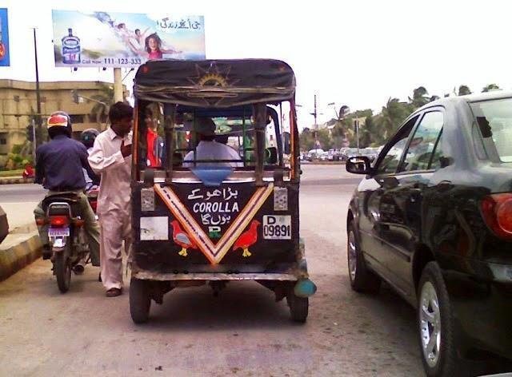

**English translation of image:** (When I grow old, I will become Corolla, a type of car); this vehicle is called auto-rickshaw; the driver tries to express his wish of having a big vehicle.

**Figure 2**

*Example of Life’s Mission Statements on Vehicle 2*

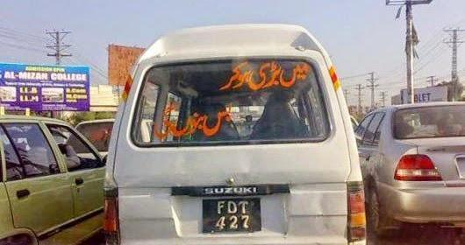

**English translation of image:** (When I grow old, I will become Bus); again, this type of vehicle is small, and the driver wishes to have a bus.

**Figure 3**

*Example of Life’s Mission Statements on Vehicle 3*

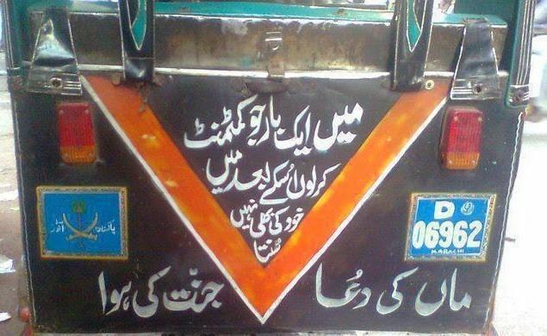

**English translation of image:** (When I get committed to something then I even do not listen to myself); it is a type of satire about stubborn people living in society. It has another slogan which means “Mother’s prayer is the ultimate guarantee of entering into Heaven.”

**Appendix B**

**Figure 4**

*Example of Loud Messages on Vehicle 1*

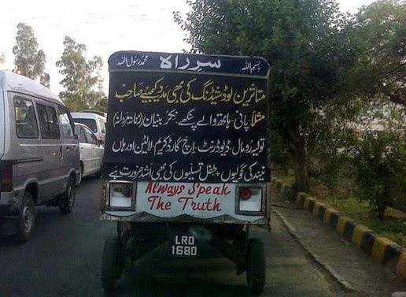

**English translation of image:** (Satire on the poor governance of government as people are badly suffering from the lack of basic needs, i.e., load shedding)

**Figure 5**

*Example of Loud Messages on Vehicle 2*

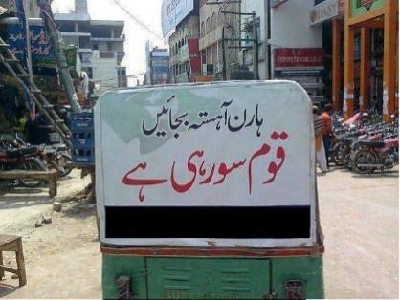

**English translation of image:** (It is a stair that uses the horn slowly as the Nation is sleeping) which means people are not serious about changing the destiny of their country.

**Figure 6**

*Example of Loud Messages*

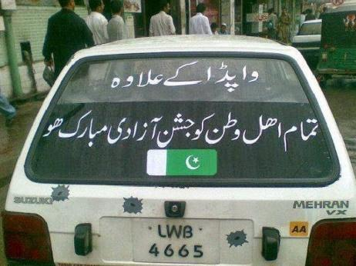

**English translation of image:** (Wishing the greetings of Happy Independence Day to the entire Nation except the WAPDA, Water and Power Development Authority which is the government’s department that provides electricity, as they are not giving electricity to people and they are suffering.)

**Appendix C**

**Figure 7**

Example Mind Baffling Messages on Vehicle 1

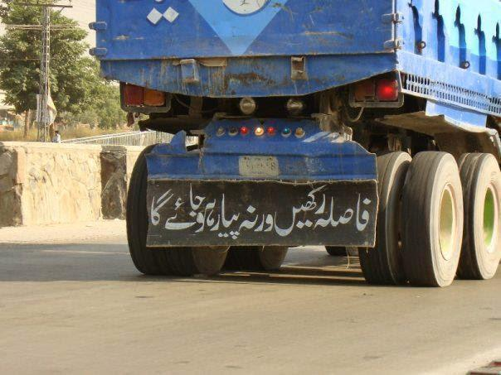

**English translation of image:** (Maintain the distance; otherwise, I will fall in love with you)

**Figure 8**

*Mind Baffling Messages on Vehicle 2*

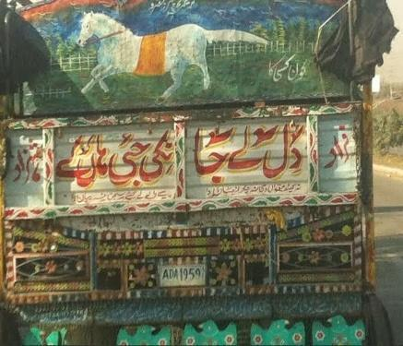

**English translation of image:** (Say YES and take away my heart, O my lover)

**Figure 9**

*Example of Mind Baffling Messages on Vehicle 3*

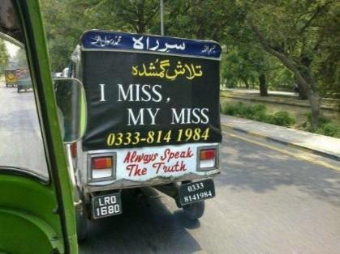

**English translation of image:** (Finding the missing one that “I MISS MY MISS”)

**Figure 10**

*Example of Mind Baffling Messages on Vehicle 4*

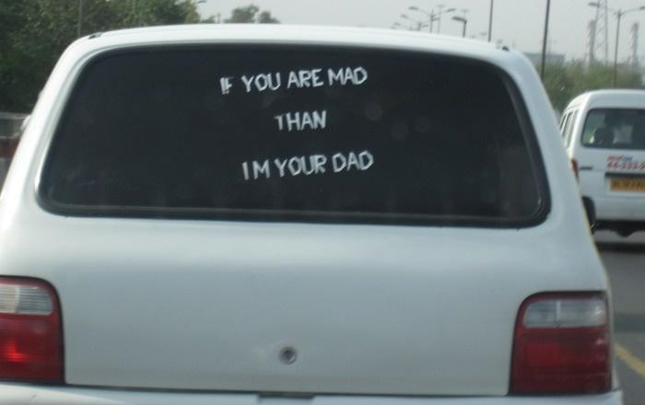

**Appendix D**

**Figure 11**

*Example of Everyday Life Annoyances on Vehicle 1*

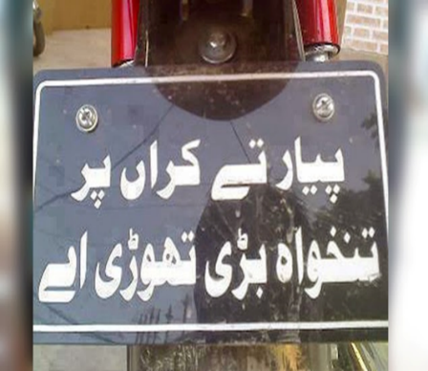

**English translation of image:** (I really love you but my income is less so don’t judge me by money)

**Figure 12**

*Example of Everyday Life Annoyances on Vehicle 2*

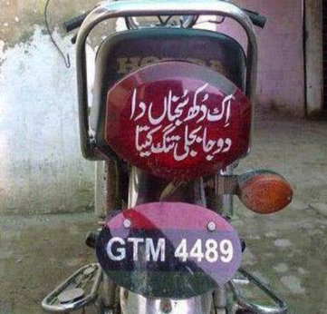

**English translation of image:** (I miss my lover which is the biggest problem/issue of my life but load shedding is also equally painful like a lover.)

**Figure 13**

*Example of Everyday Life Annoyances on Vehicle 3*

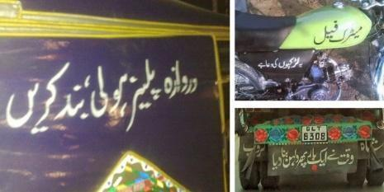

**English translation of image:** (Polite message to close the car’s door gently)

**Appendix E**

**Figure 14**

*Example of Provoking Statements and Messages on Vehicle 1*

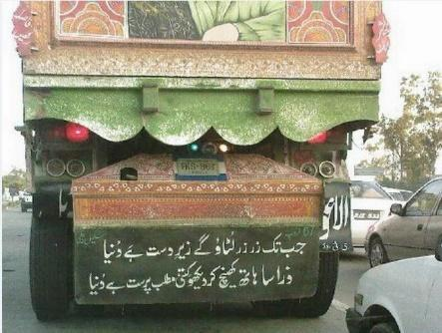

**English translation of image:** (If you have money, the world is yours and if you do not have, none will bother you.)

**Figure 15**

*Example of Provoking Statements and Messages on Vehicle 2*

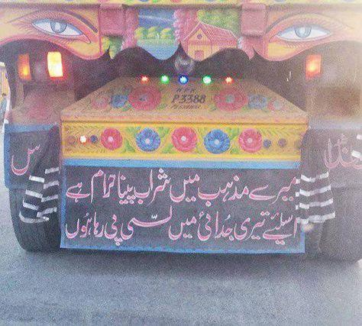

**English translation of image:** (I am missing you as wine is prohibited in my religion so I am taking ‘Lassi’ (a local non-alcoholic drink) which is equivalent to trying to forget the lover.)

**Figure 16**

*Example of Provoking Statements and Messages on Vehicle 3*

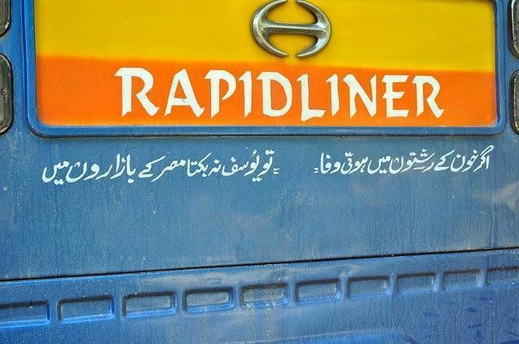

**English Translation of image:** (A satire on blood relations by pointing out one of the Prophet’s life (Prophet Joseph) whose step-brothers sold him in the market, thus saying that blood relations are fake.)

**References**