Exploring Cultural Diversity Awareness and Addressing Cultural Biases among Undergraduate Students in Online Learning Environments

Syeda Saba Hashmi

University of Karachi, Pakistan

sabanabiil.sn@gmail.com

ORCID iD**:** 0009-0003-3875-975X

*(Corresponding author)*

Maryam Jan

University of Karachi, Pakistan

maryamjaan200@gmail.com

ORCID iD**:** 0009-0007-9650-1561

**Abstract**

The growing field of online education has developed within a cultural context rooted in many forms of inherent bias. Therefore, this mixed-methods study was conducted within a sociocultural theoretical framework. The population consisted of teachers and students from various backgrounds at some universities in Karachi. In qualitative research, twelve teachers from random universities were selected using a purposive sampling method. In quantitative research, the researchers used the simple random sampling method to select one hundred students. The researchers conducted interviews and surveys. The researchers analysed the quantitative data using the statistical analysis method in SPSS. The researchers manually analysed the qualitative data through thematic analysis. The study's findings show teachers encountered challenges and biases in synchronous and asynchronous online sessions.Cultural diversity is an important element and an anticipated norm in online learning environments. Teachers should develop cultural diversity awareness in students and use teaching strategies. This study also found that students aware of cultural diversity were satisfied with their online learning experience. The findings of this study add to the literature on online learning satisfaction and provide direction for solving problems related to online learning satisfaction.

**Keywords:** cultural diversity awareness, level of satisfaction, online learning environment, cultural bias

**Received** 5 May 2024 **Accepted** 24 August 2024  **Published** 27 January 2025

**Introduction**

The COVID-19 pandemic is the reason for learning losses in traditional settings. This issue is unavoidable. This issue is a social issue all over the world. Education transitioned to online learning and teaching in response to the COVID-19 pandemic. Online learning and teaching have their advantages and disadvantages. Although online learning and teaching are more convenient than on-campus education in a traditional setting, it was still not easy to handle this issue because it happened globally in a very short time (Howard et al., 2020). The COVID-19 pandemic was a sudden phenomenon. Universities were expected to handle it as soon as possible. Universities resorted to online learning and teaching without previous preparation (Abdel-Salam et al., 2022). Therefore, people perceive that teaching and learning in the online environment is challenging (Mahoney & Hall, 2019).

Online learning and teaching are more flexible and accessible. Teachers and students can easily attend it when they have illnesses like COVID-19. It eliminates the need for commuting. However, teachers and learners could be from different cultural backgrounds in online learning courses. Therefore, cultural variations should be considered when working with multicultural students in online learning environments (Kim & Bonk, 2006). While online classes rapidly spread, the students engaged in those classes have diverse behaviours according to their cultural backgrounds (Sathakathulla & El Harouni, 2019). It created another social issue. This social issue is almost latent. People do not even consider this factor. They assume that it will be solved over time. However, this attitude is just because of a fallacy in logic. Social problems are never solved by themselves. Collective action is required to solve a social problem.

Before calling for collective action, there is a need to recognise the existence of a social problem. People should realise the prevalence and frequency of a social problem. For example, various types of bias have been developed in online education. This bias is rooted in a cultural context (Woodley et al., 2017). It is not surprising that every culture has a different set of values. It means that every social phenomenon is judged differently by different people. These judgments are based on their cultural values. Moreover, the lack of face-to-face interaction is a disadvantage of online learning and teaching. It leads to contextual misunderstanding. Therefore, cultural biases and contextual misunderstandings arise in online sessions.

Cultural biases and contextual misunderstandings can impact learning. Teachers should solve the issues of cultural biases and contextual misunderstandings. Teachers should develop cultural diversity awareness in students. Teachers should use teaching strategies, especially for students from various cultural backgrounds. Access to online learning does not ensure equitable learning experiences. Students from different backgrounds perceive things differently. Although online learning and teaching are more environment-friendly than traditional learning settings, teachers need to take the initiative to establish inclusive online learning environments (Taj, 2023) because that is what SDG 4 is all about. The success of online learning and teaching, including students from various cultural backgrounds, depends on being aware of cultural diversity and understanding how to cope with it (Yang et al., 2010).

In this research, researchers have operationalised the variable "cultural diversity awareness" (of students) as a measure of how strongly they agree with these statements: (i) They are aware of the cultural diversity among students in online learning environments. (ii) They understand that there are valid beliefs other than their own. (iii) They encourage people who are culturally different from themselves to speak out on their issues and concerns, and they validate their issues and concerns. (iv) They know others' stereotypes associated with their ethnicity. (v) They have multiple friends from a variety of cultures. (vi) They realise that people of other cultures need to support one another and connect as a group. (vii) They do not participate in jokes that are racial, ethnic or sexually offensive. (viii) They believe that cultural diversity enhances the learning experience in online environments. (x) They actively seek opportunities to learn about different cultures.

Universities have been challenged by changes in their environments, from traditional classroom environments to online environments (Sathakathulla & El Harouni, 2019). Students can get frustrated in such an environment because they are mostly not used to online learning environments. They can be unsatisfied. They can raise questions about the quality of education. The level of student satisfaction affects how well an online learning course is done. Cultural values shape learning environments. Therefore, it is not simple to define the quality of learning environments (Wolf & Avornyo, 2023). Online learning requires self-motivation. Distraction occurs in a real environment while attending an online class in a virtual environment. It decreases motivation and discipline. It can be challenging for some students. Students feel the temptation to check social media while attending an online class.

However, in this research, researchers have operationalised the variable "Level of Satisfaction in Online Learning Environments" to indicate how strongly they agree with these statements: (i) They are satisfied with the overall learning experience in online environments. (ii) They feel engaged and actively participate in online learning activities. (iii) They feel that online learning environments support the development of problem-solving skills and critical thinking. (iv) They can easily access course materials and assignments in online learning environments. (v) They feel that online learning environments support their ability to learn and retain material. (vi) They can easily interact with classmates and teachers in online learning environments. (vii) They learn more effectively online than in traditional classroom environments.

Cultural bias has numerous forms. For example, group work might involve a variety of cultural variances, with certain Western cultures strongly encouraging participation in group work and some Asian cultures encouraging individualistic work. For some, maintaining eye contact is a sign of truthfulness. However, it could be seen as disrespectful or combative in a different culture. Every culture uses gestures, which have different cultural connotations and are a crucial component of communication (Drew, 2023). That is how cultural biases could lead to contextual misunderstandings. Understanding the variables that affect student satisfaction in online sessions is crucial as online teaching and learning continue to grow in appeal and acceptance (Chitkushev et al., 2014).

The trend toward online learning has been growing day by day worldwide. Therefore, institutions are now more interested in knowing the factors that usually influence students' satisfaction in online learning environments (Hung, 2021). Students' perceptions of their satisfaction level with online learning courses have caught the attention of educational researchers (Sathakathulla & El Harouni, 2019). Students' satisfaction is significant in online learning, but few studies have explored its determinants in emerging countries (Jiang et al., 2021). Some researchers including Alharthi (2020) and Smith and Zhou (2021), have focused on measuring teachers' awareness of cultural diversity issues at the university. Several researchers such as Smith and Zhou (2021), Yousaf et al. (2022), Tian and Lu (2022), Abdel-Salam et al. (2022), and Suhandiah et al. (2022), have focused on measuring the correlation between students' satisfaction and other factors. However, there is a shortage of investigations measuring the correlation between students' awareness of cultural diversity and the level of satisfaction among students in online learning environments. Consequently, this research was conducted to discover the role of cultural diversity awareness and teaching strategies in enhancing online learning environments for undergraduate students from diverse backgrounds in Karachi, Pakistan.

Objectives

* To find out the correlation between cultural diversity awareness and the level of satisfaction among students in online learning environments.
* To find strategies to mitigate the impact of cultural biases and contextual misunderstandings in online sessions.

Hypothesis

1. The higher the cultural diversity awareness, the higher the level of satisfaction among students in online learning environments

Research Question

1. Which strategies do teachers use to mitigate the impact of cultural biases and contextual misunderstandings that may arise in online sessions on learning?

**Literature Review**

Tian and Lu (2022) have discussed their findings about international students from Africa. These findings have pointed to low levels of online learning satisfaction. Those international students from Africa were enrolled in undergraduate programmes in life sciences and medical disciplines and those studying at research-centred universities. Moreover, both studies revealed that low emotional engagement significantly predicted the dissatisfaction of international students with online learning. To enhance international students' satisfaction, universities and teachers should prioritise building student-centred online learning environments that support international students' emotional involvement.

Abdel-Salam et al. (2022) have investigated students' satisfaction with online learning. Their literature review has identified seven factors that influence satisfaction. Mean comparisons on the level of satisfaction indicated that there was no difference between females and males; nationals possessed higher levels of satisfaction, and non-STEM students possessed a higher level of satisfaction. Yousaf et al. (2022) have examined the role of course evaluation and digital platforms in students' online learning and satisfaction. The target population was students of public and private educational institutions in Pakistan. As a result, online learning influences student satisfaction. Interactive learning showed student engagement. They have highlighted the role of course evaluation and digital platforms in creating an eco-friendly environment.

Suhandiah et al. (2022) have determined student satisfaction with online learning, which is associated with perceived technological complexity, student learning experience, online learning readiness, and the presence of lecturers in online learning activities. Their results showed that online learning satisfaction is influenced by student experience, online learning readiness, and the presence of lecturers in online learning. Online learning readiness can mediate student experience and online learning satisfaction.

Leersnyder et al. (2021) have empirically tested a contextual model in which this cognitive cost is associated with cultural misunderstandings that, in turn, are associated with diversity perceptions. The quantitative analysis revealed that students in international (vs. mono-country) classrooms experience higher levels of cultural misunderstanding, which, in turn, is accompanied by lower feelings of indebtedness. Importantly, this chain of effects differed depending on whether students perceived the diversity approach as more multicultural than colour blind.

Online learning environments enable diverse participation from all around the globe. Bozkurt et al. (2021) have examined participation and engagement patterns in online learning environments. His research findings have demonstrated that most participation originates from developed Western and Anglo-Saxon cultures. The English language is dominant over other languages, and learners predominantly come from countries where English is spoken as a native or official language. The findings have indicated that there is cultural dominance as well as cultural diversity in online learning environments. According to Smith & Zhou (2021), the silence during class, the lack of interaction, and the new way of grading were and still are difficult adjustments. Teachers who have international students in their online classrooms should continue to use the following teaching practices as they create increased satisfaction and perceptions of learning: clarifying classroom expectations, being aware of diversity and inclusion, fostering a positive online learning environment, and focusing on student-centred teaching.

The study results indicate that face-to-face engagement in online courses is lower than in traditional courses. There is surprisingly little empirical research linking student satisfaction to retention, and it is generally believed that there is a positive relationship between the two. Hung (2021) administered an online assessment to assess the participants' level of satisfaction with their online learning through the four main areas or groups of factors: course content, teachers, online learning facilities and online learning support. He has revealed that the four groups are significantly associated with learners' overall satisfaction with online learning, and there is a positive retention rate during the programme.

Alharthi (2020) has indicated that teachers do not have sufficient experience with issues of cultural diversity in online learning environments. He concluded with a discussion of appropriate strategies for addressing cultural diversity in the online classroom and some design strategies for multicultural online courses through computer-supported collaborative learning environments and social network learning communities. Hence, his study might help create online classrooms using strategies like these to overcome students' cultural diversity.

Iseminger et al. (2020) have described students' development of components of intercultural competence after completing a cultural diversity course and compared degrees of intercultural competence between a face-to-face course and an equivalent online section of the same course. According to them, students gained a deeper awareness of their lack of knowledge related to culture. They have also revealed that students in the online version of the course demonstrated higher degrees of intercultural openness and cultural self-awareness than those in the face-to-face context.

While many distance learning courses expand their reach across borders, online courses are more likely to be cross-cultural. Sadykova and Meskill (2019) have examined the experiences and perspectives of a Chinese graduate student and her American teacher, specifically the accommodations made to mediate differences and mitigate these challenges. They have suggested that when both parties take differences into account and exercise thoughtful accommodations relative to both the challenges of the online medium and language socialisation, positive learning experiences can result.

Kumi-Yeboah et al. (2019) have explored the perceptions of minority graduate students about cultural diversity and the challenges they face in online learning environments. They have revealed four themes: (1) the need to recognise and use multicultural resources for knowledge building in the online learning environment; (2) the need for more diversity inclusion in online learning; (3) collaborative learning activities as an effective instructional strategy to promote cultural diversity in online environments; and (4) the lack of multicultural contents, communications, language barriers, and culturally relevant activities that hinder online learning.

Bernard et al. (2004) did a meta-analysis of the comparative distance education (DE) literature from 1985 to 2002. A total of 232 studies with 599 independent achievement, attitude and retention outcomes were examined. Overall, the results showed that the effect sizes on all three measures were nearly nil, with wide variability. This showed that many DE applications outperform their classroom counterparts, but many perform worse.

Garrison et al. (1999) have established a conceptual framework and a tool for using computer-mediated communication (CMC) and computer conferencing to assist an educational experience. The study presented a community inquiry model that consists of three fundamental components of an educational transaction: cognitive presence, social presence, and instructional presence. Analysing computer-conferencing transcripts revealed indicators (important words/phrases) for each aspect.

**Methodology**

This is basic and cross-sectional research. Both qualitative and quantitative research techniques were included in the mixed-methods study plan. The rationale for choosing these methods was that in-depth interviews are good for teachers, and surveys are good for students. The teachers are experienced enough to give in-depth answers on this topic. The students can give clear answers while having multiple-choice questions. In short, the researchers had two different types of respondents. Therefore, the researchers used the mixed-methods study plan.

Universe: In this study, the researchers’ universe was Karachi, Pakistan.

Population: The population consisted of teachers and students from different cultural backgrounds at some universities in Karachi, Pakistan.

Sample: The study sample consisted of a total of 112 respondents. The study sample for qualitative research consisted of a total of 12 respondents. Twelve teachers from random universities were selected as case studies in qualitative research. Data saturation occurs within the first twelve interviews (Guest et al., 2006). Their education ranges from undergraduate to Ph.D. Their ages ranged between 25 and 55. The study sample for quantitative research consisted of 100 students from random universities as respondents. Their ages ranged from 18 to 44.

Sampling Method: In qualitative research, the researchers used a purposive sampling method to select teachers. In quantitative research, the researchers used a simple random sampling method to select students.

Data collection: Interviews were conducted with twelve university teachers from different cultural backgrounds in Karachi via WhatsApp and in-person meetings. The researchers also performed a survey. A hundred students from random universities from different cultural backgrounds in Karachi received a list of queries in person and online.

Data collection tools: A semi-structured, open-ended form was created for the interview. Every conversation was recorded and transcribed to ensure a reliable and accurate analysis. To make sure that the data gathering was accurate, real and reviewable, the conversations were recorded. A questionnaire was created for the survey. The Likert scale was used for the questionnaire.

Data analysis: The deductive and semantic strategies of thematic analysis were used to evaluate qualitative data. In a deductive strategy, researchers approach the data with some predetermined ideas they anticipate seeing mirrored there, based on theory or previously held knowledge. The clear substance of the data was examined using a semantic approach to thematic analysis. Quantitative data was examined through the use of statistical analysis. SPSS was used for quantitative data analysis. Smart art graphics and charts were created using Microsoft PowerPoint.

**Quantitative Results**

The researchers conducted this study to find out the correlation between cultural diversity awareness and the level of satisfaction among students in online learning environments.

Hypothesis: The higher the awareness of cultural diversity, the higher the level of satisfaction among students in online learning environments.

In hypothesis testing,

Null Hypothesis (H0): There is no relationship between awareness of cultural diversity and the level of satisfaction among students in online learning environments.

Alternative Hypothesis (Ha): There is a relationship between awareness of cultural diversity and the level of satisfaction among students in online learning environments.

**Table 1**

*Karl Pearson Correlations*

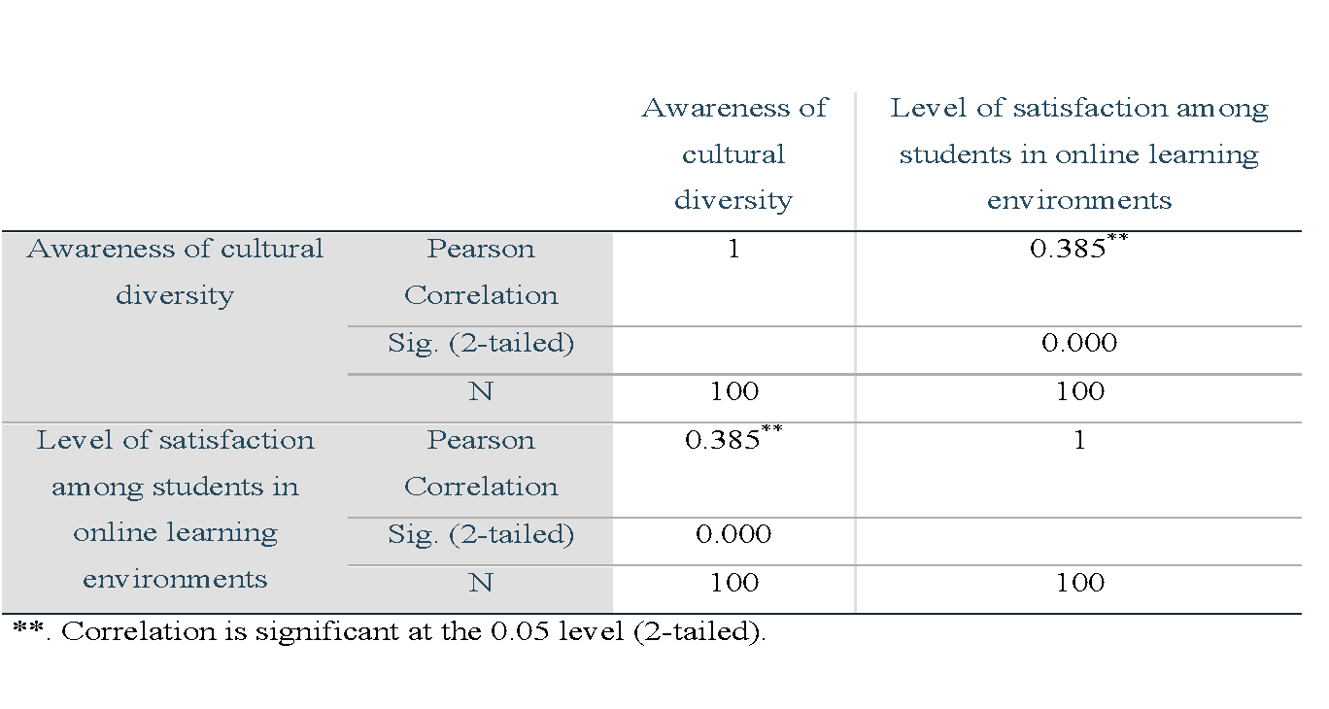

Table 1 indicated that the significance level was 0.05 (2-tailed). The correlation of a variable with itself was always 1. In the correlation between *“awareness of cultural diversity”* and *“awareness of cultural diversity," the* Pearson correlation was 1. *“Awareness of cultural diversity”* was compared with itself; the correlation was perfect. Similarly, in the correlation between *“level of satisfaction among students in online learning environments*” and *“level of satisfaction among students in online learning environments," the* Pearson correlation was 1. The correlation between *“awareness of cultural diversity”* and itself was perfect.

In the correlation between *“level of satisfaction among students in online learning environments”* and *“awareness of cultural diversity," the* Pearson correlation was 0.385. Sig. (2-tailed) was 0.000 (the p-value was less than 0.05). It indicated a moderately positive relationship between “level of satisfaction among students in online learning environments” and “awareness of cultural diversity." This correlation was statistically significant. Similarly, in the correlation between *“awareness of cultural diversity”* and *“level of satisfaction among students in online learning environments," the* Pearson correlation was 0.385. Sig. (2-tailed) was 0.000 (the p-value was less than 0.05). It indicated a moderately positive relationship between *“awareness of cultural diversity”* and *“level of satisfaction among students in online learning environments."* This correlation was statistically significant. Therefore,

* Ho is rejected.
* Ha is accepted.

**Qualitative Results**

The researchers conducted this study to find strategies to mitigate cultural biases and contextual misunderstandings in online sessions. After analysing the qualitative data, two themes emerged from the data: cultural biases and contextual misunderstandings in online sessions. Figures 1 and 2 show the codes and themes. Those two themes are:

* bases of cultural biases and contextual misunderstandings
* strategies to mitigate its impacts

Cultural Biases and Contextual Misunderstandings: Respondents shared the challenges or biases related to cultural backgrounds they encountered in synchronous and asynchronous online sessions. Bases of cultural biases and contextual misunderstandings were students' socialisation issues, linguistics interpretation and beliefs, sensitive issues discussion, rigid mindset, aggressiveness, low level of study, and denial state.

**Figure 1**

*Bases of Cultural Biases and Contextual Misunderstandings*

Case 1 recognised the importance of creating a supportive learning environment for students, especially when discussing sensitive issues. By listening to, respecting, and understanding each student, she built trust and rapport with them. She focused on mitigating it. In the words of Case 1:

*"Students socialisation issues affect student learning."*

Case 4 pointed out that students from humble sociocultural backgrounds often hesitated to interact and share their thoughts with the class. He also pointed out that students from privileged backgrounds often felt entitled to speak and say whatever they wanted. In the words of Case 4:

*“There are various situations when a class with a diverse cultural background is taught. When I was teaching a group of doctors from various cultural backgrounds, it seemed very imperative to keep the sensitivities in mind. Suppose a group of students did not like the examples from a different cultural background. It seems rude to mention the real situation.”*

Case 7 mentioned that they face rigid mindsets and language barriers in their online sessions.

*“I have already mentioned it before. I face rigid mindsets in my student language and understanding barriers rarely.”*

Case 8 faced some challenges in his online teaching, such as aggressive students, students with a low level of study, and students who were reluctant to accept anything against their beliefs. In the words of Case 8:

*“Some students are aggressive, some students have limited learning ability, and some students are reluctant to accept anything that doesn’t fit with them or their beliefs. It makes the teaching in an online session challenging.”*

Case 10 said his students were not biased towards him but showed bias towards each other outside of class. One student, in particular, failed the class and was accused of having language bias. However, he cleared up the misunderstanding, and the problem was solved. In the words of Case 10:

*“They are not biased toward me. They show bias towards each other, but outside the class. One student failed. He accused me of having language bias. However, I made him understand politely. I cleared up his misunderstanding, and the problem was solved.”*

**Strategies to Mitigate Its Impacts**

Respondents also shared their strategies for student learning in online sessions. Strategies to mitigate its impacts were counselling, a comfortable environment, equitable practices, comparison, normalising, online with original names, sensitising, raising awareness of cybercrimes, making them rethink, promoting mutual respect, working on their egos, increasing tolerance levels, clearing misconceptions, and explaining through case studies as examples.

**Figure 2**

*Strategies to Mitigate Its Impact*

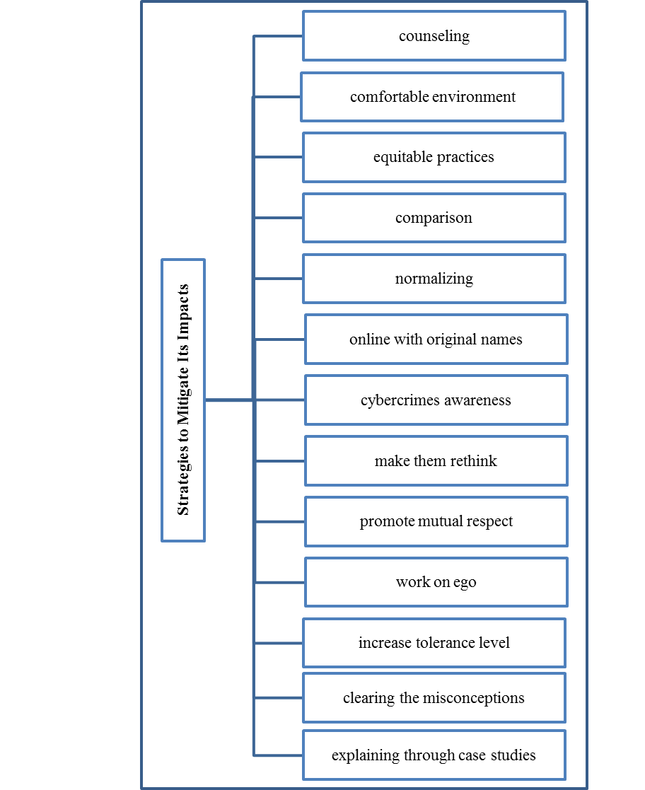

Case 1 recognised the importance of creating a supportive learning environment for students, especially when discussing sensitive issues. By listening to, respecting, and understanding each student, she built trust and rapport with them. She focused on mitigation. In the words of Case 1:

*“When I discuss sensitive issues, I listen, respect, and understand every student, then counsel them to mitigate the impact of cultural biases and contextual misunderstandings.”*

Case 2 began by defining culture as an identity and a mindset. In the words of Case 2:

*“Culture could be an identity. Everyone should become familiar with cross-cultural dimensions. It is very important in the class. I provide an environment where students feel comfortable, valued, and appreciated. I provide equitable practices for all students. Still, sometimes, cultural biases or misunderstandings arise in online sessions.”*

Case 5 acknowledged the challenges of online learning. In the words of Case 5,

*“I make sure that they are logged in with their original names to reveal their identity. I make them aware of cybercrimes as well.”*

Case 6 acknowledged and discussed how she mitigated these challenges by explaining through case studies and examples. In the words of Case 6:

*“I explain my lecture mostly through some examples and some case studies.”*

Case 7 tried to make students with rigid mindsets think again in a subtle way and found that giving them time and listening to them helped overcome language barriers. In the words of Case 7:

*“I try to make them think again in a very subtle way, and that does help. Giving them time and listening to them help me overcome it.”*

Case 8 employed some effective strategies to mitigate their impact. In the words of Case 8:

*“I promote mutual respect. I develop a mentality in them that nobody is inferior or superior. I make them work on their egos. I increased their tolerance level. Recently, while giving a presentation about Pakistani politicians and the role of law enforcement, one student argued about a specific politician, and I gave him references to books. I told him about the role that specific politician played in those books, so these examples made him rethink. I gave him guidelines to study in detail about the history and narratives of a specific politician.”*

Case 12 was aware of the potential for challenges or biases related to cultural backgrounds in synchronous online sessions. She took steps to address these challenges by normalising students and providing them with information about current research and development. She was able to handle accusations of bias politely and professionally. In the words of Case 12:

*"I normalise students by telling them about current research and development on that issue. Once, a student had some contextual misunderstandings about my lecture and accused me of bias. I politely defended myself and explained my point again."*

**Discussion**

In this convergent parallel design, the researchers collected quantitative and qualitative data and analysed them separately. After completing both analyses, the researchers compared the results to draw conclusions. There is a positive relationship between cultural diversity awareness and satisfaction levels among students in online learning environments. According to a similar study, the more students were aware of cultural diversity in online learning environments, the higher their level of satisfaction was (Tlili et al., 2021). Every learning environment should place a high value on culture. Understanding how culture affects any online learning environment is crucial, as is taking all required action to change the culture to support the online learning environment. However, it can be challenging to alter a strong, prevalent society. New technologies make it possible to design new learning environments. However, teachers also have the chance to establish the kind of community that will benefit students in an online learning environment (Yeravdekar & Raman, 2022). A study indicated that online communication tools cannot satisfy participants' demands for an effective online intercultural learning experience. Results indicated that virtual environments have the resources to satisfy participants' preferences for telecollaboration tools and have good potential for creating an effective online and intercultural learning environment (Zhang et al., 2023). A study found that videos and personalised emails, using mass distribution Excel features, helped increase student beliefs, including social belongingness and self-efficacy, and improved students' perceptions of the instructor and online learning environment (Green et al., 2023).

Many universities have adopted online learning due to its recent recognition as an efficient instructional strategy to increase student involvement (Miao et al., 2022). Social ideals, ideas, and moral principles are often not integrated. Results of a similar study showed that the acceptable behaviour of one group was introduced as valuable and distinguished from the behaviour of another socially undervalued group due to cultural bias (Yingst, 2011). In a study, the authors call online teachers into action by encouraging them to adopt an engaged instructional design praxis that builds learning environments inclusive of racial, ethnic, and gender diversity. Through culturally responsive teaching, online teachers can create spaces of counter-narratives that address curricular blindness and promote social justice (Woodley et al., 2017). Another study recommended the use of inclusive teaching methods. These methods promote effective cross-cultural pedagogies, creating learning tasks that foster reciprocal learning about cultures, expose learners to multiple perspectives, and facilitate the development of skills in global thinking and intercultural competence (Mutahi & Gazda, 2019).

A study indicated that students perceived their teachers as biased when it came to helping students in situations of bullying or other relationship challenges in online learning environments (Gran et al., 2019). Through challenging biases, teachers could result in more educational learning by enabling students to become more interested in and engaged in learning (Damon, 2023). Based on previous culture-related studies, multiculturalism is a possible solution to reducing intergroup biases, as it positively affects implicit and explicit cultural attitudes, perceptions, and behaviours. A study developed a virtual multiculturalism intervention to improve intergroup relations and combat cultural biases within the undergraduate student population. Results showed that participants in the intervention condition significantly improved multiculturalism scores, supporting incorporating a virtual multiculturalism intervention in higher education (Black & Li, 2020).

In both communicative settings, students benefited from preparation in terms of mediation skills and plurilingual and pluricultural competencies to facilitate understanding and successful communication. Examples of this include actively interpreting the meaning of others' unfamiliar words or concepts, displaying traits of openness and flexibility in working with a variety of foreign language resources, or culturally controlling information processing and learning accordingly from a critical and neutral perspective of its presentation and interpretation (Gutiérrez et al., 2022). When teachers were perceived as adopting a multicultural perspective (i.e., recognising and valuing multiculturalism), students' cultural misunderstandings decreased, reducing the negative effects of studying in international classrooms (Leersnyder et al., 2021).

**Conclusions and Recommendations**

It is concluded that teachers encountered challenges and biases in synchronous and asynchronous online sessions. Therefore, teachers employed some effective strategies in online sessions for student learning. Although English is the official language and Urdu is the national language of Pakistan, some students are not efficient in their contextual understanding of a second language. However, language is just a source of communication. Speakers will feel more comfortable interacting and communicating if teachers and students focus more on contextual understanding than accent and pronunciation. Cultural diversity is an important element (Alharthi, 2020) and an anticipated norm in online learning environments (Starr-Glass, 2021).

It has been found that students who are more aware of cultural diversity are also more likely to be satisfied with their online learning experience. Courses and workshops about cultural diversity should be conducted online to increase awareness among students and teachers. The case studies presented in this study are just a few examples, and more research is still needed to understand the influence of various cultural backgrounds on teaching and learning in synchronous and asynchronous online sessions. However, the findings of this study add to the literature on online learning satisfaction and provide direction for solving problems related to online learning satisfaction.

Acknowledgement

The researchers would like to thank the respondents for providing their insightful data.

References

Abdel-Salam, A.-S. G., Hazaa, K., & Abu-Shanab, E. A. (2022). Evaluating the online learning experience at Higher Education Institutions. *International Journal of Cyber Behavior, Psychology and Learning*, *12*(1), 1–23. https://doi.org/10.4018/ijcbpl.298692

Alharthi, M. (2020). Students from diverse cultures in the multicultural online classroom: Issues and suggestions*. Semantic Scholar.* https://www.semanticscholar.org/paper/STUDENTS-FROM-DIVERSE-CULTURES-IN-THE-MULTICULTURAL-Alharthi/5fc0d71a6ee84265c7afadfb53982c9be

b8204df

Bernard, R. M., Abrami, P. C., Lou, Y., Borokhovski, E., Wade, A., Wozney, L., Wallet, P. A., Fiset, M., & Huang, B. (2004). How does distance education compare with classroom instruction? A Meta-Analysis of the Empirical Literature. *Review of Educational Research*, *74*(3), 379–439. https://doi.org/10.3102/00346543074003379

Black, K., & Li, M. (2020). Developing a virtual multicultural intervention for university students. *Behavioral Sciences*, *10*(11), 168. https://doi.org/10.3390/bs10110168

Bozkurt, A., Yazıcı, M., & Aydın, İ. E. (2021). Cultural diversity and its implications in online networked learning spaces. *Research Anthology on Developing Effective Online Learning Courses*, 1823–1849. https://doi.org/10.4018/978-1-7998-8047-9.ch091

Garrison, D., Anderson, T., & Archer, W. (1999). Critical Inquiry in a Text-Based Environment: Computer Conferencing in Higher Education. *The Internet and Higher Education/The Internet and Higher Education*, *2*(2–3), 87–105. https://doi.org/10.1016/s1096-7516(00)00016-6

Gran, L., Petterson, D., & Mølstad, C. E. (2019). Digital Bildung: Norwegian students’ understanding of teaching and learning with ICT. *Nordic Journal of Digital Literacy*, *14*(1–2), 23–36. https://doi.org/10.18261/issn.1891-943x-2019-01-02-03

Gutiérrez, B. F., Glimäng, M. R., Sauro, S., & O’Dowd, R. (2022). Preparing students for successful online intercultural communication and collaboration in Virtual Exchange. *Journal of International Students*, *12*(S3), 149–167. https://doi.org/10.32674/jis.v12is3.4630

Howard, S. K., Tondeur, J., Siddiq, F., & Scherer, R. (2020). Ready, set, go! Profiling teachers' readiness for online teaching in secondary education. *Technology, Pedagogy and Education*, *30*(1), 141–158. https://doi.org/10.1080/1475939x.2020.1839543

Hung, L. N. (2021). Enhancing learners' satisfaction to improve retention in online classes: Current practices at a centre of Foreign Languages in Vietnam. *European Journal of Open Education and E-Learning Studies*, *6*(2). https://doi.org/10.46827/ejoe.v6i2.3936

Iseminger, S. I., Diatta-Holgate, H. A., & Morris, P. V. (2020). Describing students’ intercultural competence after completing a cultural diversity course online or face-to-face. *Teaching &amp; Learning Inquiry*, *8*(2), 114–127. https://doi.org/10.20343/teachlearninqu.8.2.8

Kumi-Yeboah, A., Dogbey, J., Yuan, G., & Amponsah, S. (2019). *Cultural diversity in online learning*. Semantic Scholar. https://www.semanticscholar.org/paper/Cultural-Diversity-in-Online-Learning-Kumi%E2%80%90Yeboah-Dogbey/9e13190003a30a2020da2cc3a2f813ba001bb6bb

Mutahi, T., & Gazda, S. (2019). Online instructional practices for racially diverse student populations in United States higher education institutions. *Handbook of Research on Cross-Cultural Online Learning in Higher Education*, 291–310. https://doi.org/10.4018/978-1-5225-8286-1.ch015

Nurhikmah, A., Syam, A. F., & AP, S. (2023). Lecturer Attitudes on Cross-Cultural Practices in EFL Online Teaching. *Elsya : Journal of English Language Studies*, *5*(1), 27–44. https://doi.org/10.31849/elsya.v5i1.11588

Sadykova, G., & Meskill, C. (2019). Interculturality in online learning:  instructor and student accommodations. *Online Learning*, *23*(1). https://doi.org/10.24059/olj.v23i1.1418

Smith, C., & Zhou, G. (2021). Engaging diverse international students: Promising online teaching practices. *London International Conference on Education (LICE-2021) and World Congress on Special Needs Education (WCSNE-2021)*. https://doi.org/10.20533/lice.2021.0002

Starr-Glass, D. (2021). Culturally responsive pedagogy, national culture, and online instruction. *Research Anthology on Culturally Responsive Teaching and Learning*, 323–342. https://doi.org/10.4018/978-1-7998-9026-3.ch019

Suhandiah, S., Suhariadi, F., Yulianti, P., Wardani, R., & Muliatie, Y. E. (2022). Online learning satisfaction in Higher Education: What are the determining factors? *Jurnal Cakrawala Pendidikan*, *41*(2), 351–364. https://doi.org/10.21831/cp.v41i2.35724

Taj, N. (2023). Toward equitable online learning: Seeing the missed opportunities. *Journal of Underrepresented &amp; Minority Progress*, *7*(1). https://doi.org/10.32674/jump.v7i1.5649

Tian, M., & Lu, G. (2022). Online learning satisfaction and its associated factors among international students in China. *Frontiers in Psychology*, *13*. https://doi.org/10.3389/fpsyg.2022.916449

Woodley, X. M., Mucundanyi, G., & Lockard, M. (2017). Designing counter-narratives. *International Journal of Online Pedagogy and Course Design*, *7*(1), 43–56. https://doi.org/10.4018/ijopcd.2017010104

 Yousaf, H. Q., Rehman, S., Ahmed, M., & Munawar, S. (2022). Investigating students’ satisfaction in online learning: The role of students’ interaction and engagement in Universities. *Interactive Learning Environments*. https://doi.org/10.1080/10494820.2022.2061009

Tlili, A., Wang, H., Gao, B., Shi, Y., Zhiying, N., Looi, C. K., & Huang, R. (2021). Impact of cultural diversity on students' learning behavioural patterns in open and online courses: A LAG sequential analysis approach. *Interactive Learning Environments*, *31*(6), 3951–3970. https://doi.org/10.1080/10494820.2021.1946565

Zhang, B., Goodman, L., & Gu, X. (2023). Telecollaboration tool preferences for online intercultural learning in higher education: Perspectives of Chinese international students. *SAGE Open*, *13*(2). https://doi.org/10.1177/21582440231180087